THE ELECTABILITY OF ISLAMIC SCHOOL
(A Study at MTs Negeri 5 Jember and SMPIT Al-Ghazali Jember)

Bahar Agus Setiawan¹, Hairul Huda², Sofyan Rofi³
¹Muhammadiyah University of Jember, ²Muhammadiyah University of Jember,
³Muhammadiyah University of Jember

Abstrak
Daya saing sekolah Islam menunjukkan perkembangan yang signifikan baik dalam prestasi maupun citra-nya. Peningkatan brand image sekolah Islam tidak lepas atas rekonstruksi pengelolaan sekolah berbasis manajemen modern. Identitas daya saing tergambar pada tingkat elektabilitas sebagai bentuk kongkrit survaivnya sekolah Islam. Daya saing tidak lagi mengerucut pada nilai akreditasi, tetapi lebih pada kualitas layanan dan kepuasan pelanggan pendidikan yang dapat diukur dari variabel sumber daya sekolah. Penelitian ini bertujuan untuk melihat principle component yang berpengaruh terhadap elektabilitas sekolah Islam dengan rumusan masalah variabel apa saja yang berkontribusi signifikan terhadap elektabilitas sekolah Islam. Analsis data penelitian ini menggunakan Principle Component Analysis (PCA) dengan instrumen angket menggunakan 9 variabel dengan 72 pernyataan pengukuran. Menggunakan 204 responden dengan tempat penelitian di MTs Negeri 5 Jember dan SMPIT Al-Ghazali Jember. Hasil penelitian menunjukkan principle component pada masing-masing sekolah Islam berjumlah satu dengan eigen value 6,3081 dan 6, 1140, sedangkan untuk pemetaan variabel yang berkontribusi signifikan dengan meneruskan analisis sampai pada nilai propotion lebih besar dari 80 persen yaitu kepala sekolah, guru dan suasana di MTs Negeri 5 Jember dan kepala sekolah, guru dan sarana prasarana di SMPIT Al-Ghazali.

Kata Kunci : elektabilitas, sekolah Islam.

Abstract
The competitiveness of Islamic schools shows significant developments both in achievement and in its image. Improving the brand image of Islamic schools cannot be separated from the reconstruction of school management based on modern management. The identity of competitiveness is reflected in the level of electability as a concrete form of the survey of Islamic schools. Competitiveness no longer cones on the value of accreditation, but rather on the quality of service and education customer satisfaction that can be measured from the variable of school resources. This study aims to look at the principle component that influences the electability of Islamic schools with the formulation of any variable problems that contribute significantly to the electability of Islamic schools. This research data analysis uses Principle Component Analysis (PCA) with a questionnaire instrument using 9 variables with 72 measurement statements. Using 204 respondents with research sites in MTs Negeri 5 Jember and SMPIT Al-Ghazali Jember. The results showed the principle component in each Islamic school amounted to one with an eigen value of 6.3081 and 6, 1140, while for mapping variables that contributed significantly by continuing the analysis until the proportion value was greater than 80 percent, namely the principal, teachers and atmosphere at MTs Negeri 5 Jember and school principals, teachers and infrastructure at SMPIT Al-Ghazali.
Keywords: electability, Islamic schools.

Introduction
Islamic educational paradigm can be defined on three things: 1. Islamic Education as an institution; 2. Islamic Education as a subject or field of study; and 3. The Islamic Education as a value (Damopoli, 2015). Referring to the definition, then the educational institution or in simpler terms Islamic school is part of the definition of Islamic Education. The Islamic schools in Indonesia show the improvement progress of competitiveness in line with the changes and innovations in the various components of the school. The increased competitiveness as an indicator of Islamic school continuity is a kind of the ability of Islamic schools itself in achieving student satisfaction in education services affected on its reputation (Wong & Woo, 2016) (Wong & Woo, 2016). The establishment of an Islamic school brand image to improve the quality of competitiveness requires complicated choices. A stagnant concept option may guarantee the Islamic schools to preserve their essential identity concerning about religious knowledge learning. Furthermore, another option is maybe following the flow of globalization, but it can give a negative impact, trapped and then lost the Islamic identity as its core value (Dacholfany, 2015). The reconstruction on school resources management systems such as curriculum, educator quality, fulfillment and improvement of infrastructure, financing and others (Herman, 2010), should be able to clearly and precisely mapped (Floreal, 2016; Cahyono, Wibowo, & Murwani, 2015; Isnaini 2012; Sukriani, et.al, 2010), so that the changes done do not lead to the aspects that are counter-productive. The risk of genuineness reduction as a challenge, has to be managed well, so that the changes and innovations made are able to boost the quality of Islamic schools. The genuineness factors of Islamic school lying on the learning dimensions of Islamic values ​​based on monotheism and morality, should be remain the essence of their orientation to form a complete human (Elihami & Martyr, 2018; Magdalena, 2017; May, 2015; Zawawi Temyati, Khadija Abdul Razak, and S.Salahudin Suyurno 2011, Halstead, 2004, 2007),
The different characteristics of Islamic schools with public schools make an Islamic school to face particular challenge in its reformation and reconstruction process. The competitiveness increasing on the one hand, and maintaining the genuineness on the other hand become major consideration to generate complex Islamic schools conceptualization which are modern, competitive, different and excellent.
The projection towards those things has to propose competitive advantage which can be done by continues quality improvement philosophy with appropriate mapping methods applied to the entire Islamic school resources. They are the key components in the process of education implementation both internal and external (Purwandari, 2015; Shojaie, Salili, and Behrooz, 2012; Sudjoko, 2017). Mapping becomes a necessity, as the first phase in the development of construction and formulation of Islamic schools. A mapping of the school potential to see the superiorities should be done carefully and precisely so that the concrete results can be a good reference for its development. The implementation of school potential mapping can be done by measuring the level of educational services provided to customers by the Islamic school whether primary, secondary and tertiary identified from customer satisfaction. Furthermore, the analysis tool that can be used in the mapping are SERQUAL, QFD and others (Abili, Narenji Thani, and Afarinandehbin, 2012; Bier & Cornesky, 2001; Browne, Kaldenberg, Browne, & Brown, 1998; Gonzalez Quesada, Gourdin, & Hartley, 2008; Mansori, Vaz, and Ismail, 2014; Sahney, Banwet, & Karunes, 2004), In short, the potential mapping can refer to the level of customer satisfaction towards all the school resource services.
The measurement of various components of the school's resources should be done continuously, so that the process of reflection and evaluation can screen the quality and main components of school resources potential into two categories namely repair or improvement. The results of this process can be used to prepare the fishbone framework, so that the repair arrangement and school resources upgrading can be done specifically (Slameto, 2016). The reformation of these elements must be able to generate a synergies movement in providing education services to produce high quality and competing output. Education reformation should be able to reach all the school's resources including internal aspects such as methods, strategies and processes of teaching and learning, and external aspects relating to the effectiveness of the organization. Additionally, education should be able to have relevance, not only to develop the cognitive aspects ansich. This reality could not be separated from the identity and Islamic education indegeousity with their three definitions related to learning characteristics which is multidimensional and multicultural, integrative-interconnected, integrative-transformative, holistic and many others (Ahjat, 2017, 2017; Arif, 2011; M. Hidayat, 2014 N. Hidayat, 2015).
The concrete dimension of service satisfaction for education customer is the quality of the produced output (Alkire, Lupton, & Lupton, 2015). Referring to this description that the quality is identical with satisfaction, therefore the changes made must be closely linked to the direction which foster customer loyalty (Heskett, 2002; Johnson, 2015; Maharjan & Khadka.Kabu, 2017). The concrete impact on the realization of these aspects can bring out into view the testimony chain affecting to the Islamic School Electability.
Electability is a level of selection adjusted with selection criteria. Electability could be applied to goods, services, people, institutions or parties. The word “Electability” is identical with the world of politics, but refer to its definition, electability can also be embedded in the service sector where education in the modern era has evolved into an institution service providers. Electability closely related to the quality so that it can be concluded that the quality will be directly proportional to the electability. Referring to the previous description, the quality which can be embedded to education sector is the quality of educational services process successfully producing qualified output.
Electability can be used as a benchmark of Islamic schools in the provision of education services. It is closely related to the fact that the higher the Islamic school electability, the more identical with the quality of customer satisfaction suggested by education customers namely students and parents. Electability as the concrete form of loyalty for education services received by students and parents formed by the trust as well as commitment (Schirmer, Ringle, Gudergan, and Feistel, 2018). Electability is the result process of the popularity and acceptability. Thus it can be understood that electability is a logical consequence of doing construction of agency/institution comprehensively on the various existing school resources components. Popularity can be understood as the image of the school attached to education customers that can be seen in public participation (Yaqin, 2016; Normina, 2016). While acceptability is a level of school acceptance that is identical with the quantity of students. Both of these components which are a small sketch of electability cannot be separated from the productivity of the schools to describe its identity in promotional activities and socialization. The installation of attribute promotion and school dissemination massively among people's lives and activity can give positive effect on the popularity and acceptability of Islamic schools. Electability as a concrete embodiment on the output preferences produced by the continuous process (MacLeod and Urquiola, 2015). The following image is a framework of process flow of electability adapted from Suwardi et.al (2016: 5):


Figure 1.
The Process Flow of Electability

The overview of Islamic schools reformation in Indonesia can be seen by the emergence of Islamic schools that performed on the basis of modern management. The traditional and conventional identity of Islamic Schools are reduced become modern progressive identity. Some of Islamic schools that can be used as a reference based on this context are Al-Furqan Islamic school (Sekolah Islam Al-Furqan), a school network of Muhammadiyah Boarding School (MBS), Integrated Islamic School Network (Jaringan Islam Sekolah Terpadu/JSIT) which are from private schools, meanwhile from the state schools are Insan Cedekia Islamic Senior High School (Madrasah Aliyah Negeri/ MAN Insan Cedekia), Islamic Senior High School with Special Program (Madrasah Aliyah Negeri Program Khusus/MAN-PK), and Islamic Junior High School (Madrasah Tsanawiyah Negeri/MTsN) (Akhiruddin, 2015; Degrees, 2018). The level of competitiveness of the Islamic schools can compete vis a vis with the public schools whether state or private, and even the level of Islamic School electability is higher with indicator of the ability and the success of the new students recruitment shown by the achievement of its quota

Research Methods
This study uses a questionnaire for collecting data using nine variables including the principal, teachers, infrastructure, cost, curriculum, accreditation, extracurricular and learning activities and also school atmosphere. The number of questions stated on the questionnaire are 72 questions. The research questionnaires given to students by using random sampling system. The questionnaire filling is conducted by giving checklist on the statements which have been prepared, socialized, and explained to the respondent.
There are 204 respondents used in this research namely 131 students from Madrasah Tsanawiyah Negeri - Islamic Junior High School (MTs. Negeri 5 Jember) and 73 students from Sekolah Menengah Pertama Islam Terpadu - Integrated Islamic Junior High School (SMPIT Al-Ghazali). The selection of these two schools as the research object was based on several reasons: first, these two schools have different accreditation level, the value of accreditation of MTs. Negeri 5 Jember is A, while the value of accreditation SDIT Al-Ghazali Jember is C. Second, both schools also have similarity in level of access that is quite difficult because there is no public transport to go there. So, we must use private vehicle. Third, these two schools have another similarity that is the quota of students’ acceptance which is achieved.
The methods of data analysis use Principle Component Analysis (PCA). Beside using the basic eigen value which is greater than one for the determination of the number of principle components, this research also see the variance value that is able to identify more than 80 percent of the explained research results variance. The basic use of the method analysis is in order to bring out the variables that construct the main component, so that the variable becoming the power of the Islamic schools can be seen explicitly. Moreover, the use of this method of analysis is for looking at the variables that really contribute significantly to the Islamic schools electability and for not returning the perspective since the beginning of the contributing variables.

Results and Discussion
Based on the result analysis of principle component output generated at Al-Ghazali SDIT Jember, the score of PC¹ is 6.1140, PC² is 0.8903 and PC³ is 0.6364 with each proportion score is 0.679 (67.9 percent), 0.099 (9.9 percent) and 0,071 (7.1 percent). The results of data analysis at MTs. Negeri 5 Jember provide 6.3081 for PC1 output score with 0.701 proportion (70.1 percent), 0.9153 for PC2 with 0.102 proportion (10.2 percent) and 0.4752 for PC3 with 0,053 proportion (5.3 percent). The results output reaching the eigen value which is greater than 1 at each school is only one principle component. Meanwhile, to reach the variance values ​​that can explain 80 percent, PC2 and PC3 are used. Based on the data, the percentage score at MTs. Negeri 5 Jember is 85.6 percent, whereas in SDIT Al-Ghazali is 84.9 percent. Here are the results of PCA output completely:
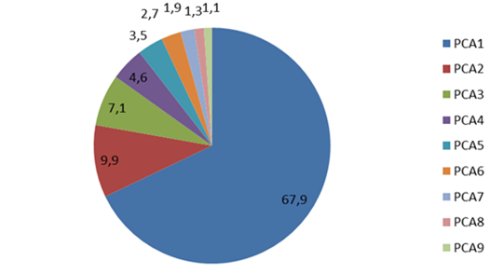
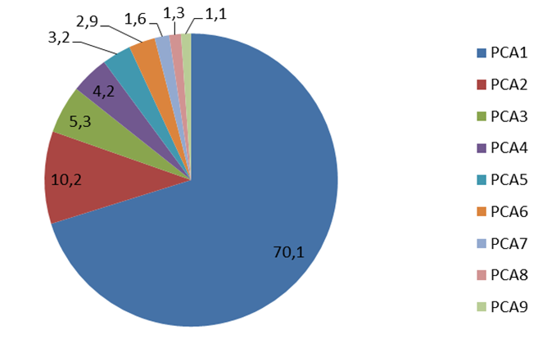

Figure 2.
Scatter diagram of PCA results in SDIT Al-Ghazali Jember and MTs. Negeri 5 Jember
As for the results of the scree plot as a principle component analysis output can be viewed as follow:

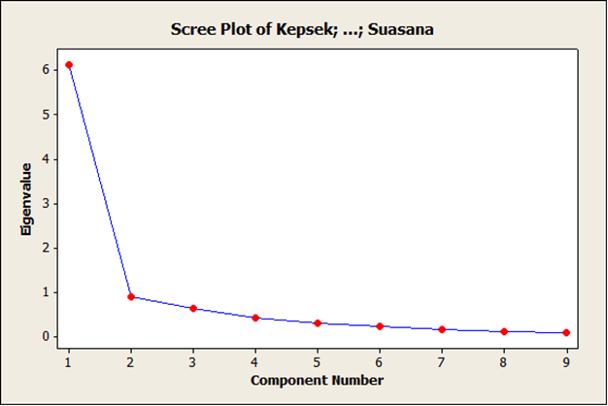
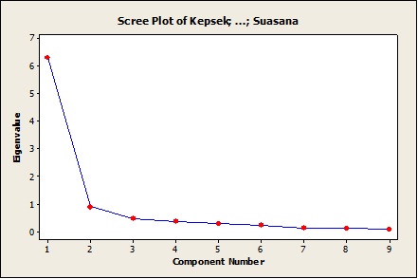

Figure 3.
Scree Plot of PCA results in SDIT Al-Ghazali Jember and MTs. Negeri 5 Jember

Based on the data above, to determine the variables having significant contribution, it must use the tabulation of varimax rotation factor:
Table 2.
Rotation Factors using Varimax method on the PCA data of
SDIT Al-Ghazali Jember and MTs. Negeri 5 Jember
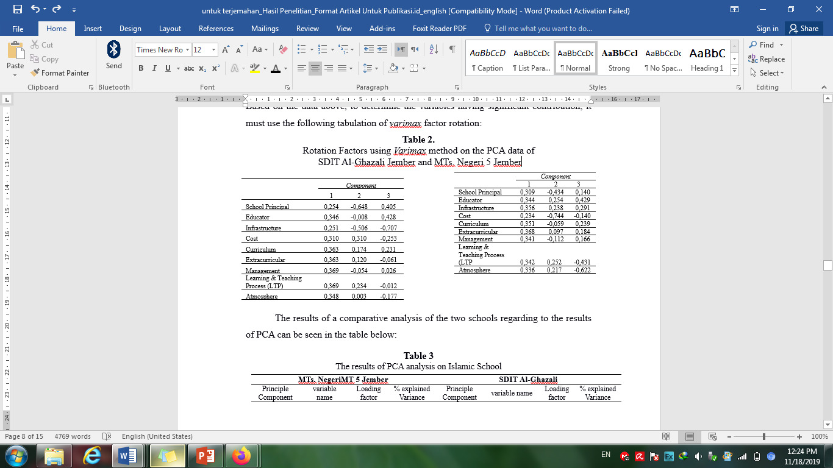
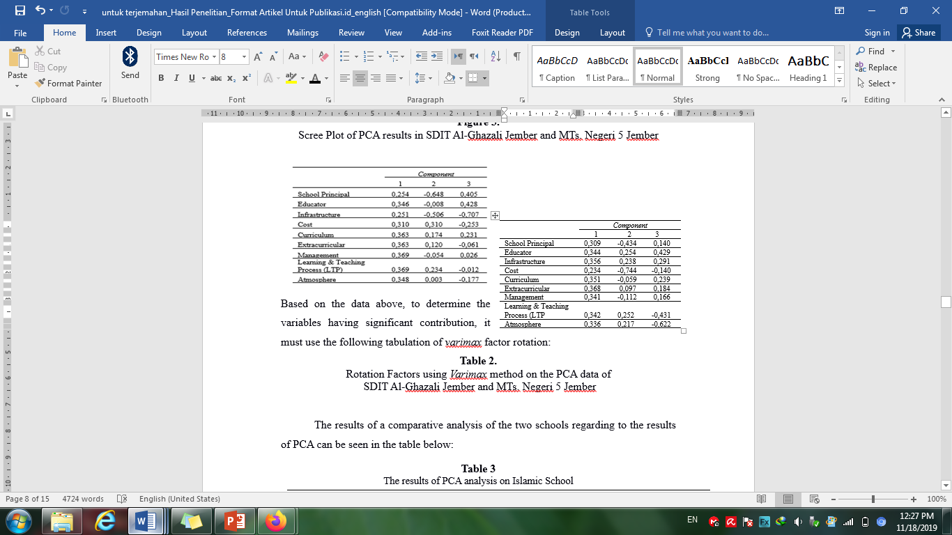
The results of a comparative analysis of the two schools regarding to the results of PCA can be seen in the table below:
Table 3
The results of PCA analysis on the Islamic School
MTs. Negeri 5 Jember |  |  |  | SDIT Al-Ghazali Jember
Principle Component | variable name | Loading factor | % explained Variance | Principle Component | variable name | Loading factor | % explained Variance
PC-1 | Principal  Educator  Infrastructure  Curriculum  Curricular  Management  PBM  Atmosphere | 0,309  0,344  0,356  0,351  0,368  0,341  0,342  0,336 | 70.1 | PC-1 | educator  Cost  Curriculum  Curricular  management  PBM  Atmosphere | 0.346  .310  0,363  0,363  .369  .369  0,348 | 67.9
PC-2 | Principal  Cost | -0.434  -0.744 | 10.2 | PC-2 | Principal  Infrastructure Cost | -0.684  -0.506  .310 | 9.9
PC-3 | educator  LTP  Atmosphere | .429  -0.431  -0.622 | 5.3 | PC-3 | Principal  educator  Insfrastructure | 0.405  .428  0.707 | 7.1
 |  |  | 85.6 |  |  |  | 84.9

Referring to the table above, mapping variables that contribute to electability can be done by looking at variables having a role in shaping at least 2 principle components. Based on the data of MTs. Negeri 5 Jember, the contributing variables consisting of principals, educators, learning and school atmosphere. As for SDIT Al-Ghazali Jember the contributing variables are costs, principal, infrastructure and educators.
The discussion on the research result related to the principal variables is that leadership factor affects the Islamic school electability. The school principal as a top leader in the management of educational institutions particularly Islamic education cannot avoid his central role as a leader. Leadership can encourage all elements of the school to effectively and efficiently improve all aspects of the school's resources including human resources consisting of students, teachers and educational staff and others. The strong leadership factor can affect positively on various development of school potential ability, so it can create a strong organizational culture (Leithwood, Harris, & Hopkins, 2008; Amanchukwu, Stanley, & Ololube, 2015). Organizational culture as a reflection of the school culture will affect the quality of educational services provided by schools that have an impact on the customer satisfaction both primary and secondary education.
The variable component of teachers is unnecessary doubt with regard to its contribution to the existence of the school. The teachers’ influence is directly affect the students which can contribute in inhibiting the shift selection and school dropout (Lessard, Poirier, and Fortin, 2010). Teacher's ability to reinforce the loyalty of students in school selection cannot be separated from the conditions and the situation experienced. A school, institutionally should be able to realize the convenience for teachers so that their tasks and functions can be performed well. The level of job satisfaction, saturation and other negative conditions will impact on the productivity of teachers that also have an impact on school performance (Bakotić, 2016). Efficacy dimensions, teachers' psychological and physical conditions may affect student satisfaction in receiving qualified learning services, so it is able to encourage the achievement of learning performance (Westley, 2011; Spilled, Koomen, & Thijs, 2011; Canrinus, Helms-Lorenz, Beijaard, Buitink, & Hofman, 2012; Kunter et al., 2013; Shen et al., 2015). A qualified learning process is the key to the successful implementation of education which impact on the reputation of the school.
In connection with the infrastructure, education and atmosphere of the school variable, they can be stated as complementary variable component in shaping principle component of Islamic education institutions electability, although they sometimes come out as a decisive factor when the education services dimensions of the various school are considered (Waluyo, 2018). The infrastructures, the cost of education and the school atmosphere factors including the ease of access and the school location can encourage the desirability / electability of the school. Regarding to the cost of education, this factor can be considered as an important variable although it is not a main aspect of the formation of the reputation and image of the school. The affordable education costs, trying to not say that it is cheap or even free, become a dimension affecting the electability of Islamic educational institutions. The institutions of modern education today for example Al-Izzah and Al-Hikmah located in Malang, Muhammadiyah Boarding School (MBS), Al-Furqan located in Jember and some other Islamic schools whose education costs are above the average have high level of electability. In connection with the variable costs as one of aspects forming the main component of SMPIT Al-Ghazali, in the research results dissemination activities, it is gained a strengthening data that the ability of the school in describing these components into a flagship program of the school give comprehensive perspective to the customers towards cost variable element. The education cost contributions determined by the Islamic school does not have a negative impact but likely to be positive in presenting perspective to the quality of services to be provided by the school.
The paradigm changes of modern school management from the school whose education cost is cheap becomes expensive make the variable of education cost becomes a factor that is no longer relevant in the consideration of customer education, namely students and parents in determining which schools that will be chosen. The cost considerations are more focused on the quality and service description that will be obtained (Togatorop 2010, Halimah, 2013). This fact is in accordance with the following picture:

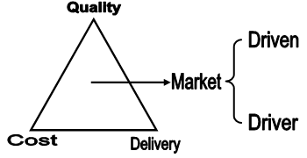

Figure 4.
The Customer Education Position in the Service, Cost and Quality of Education Services

Referring to the image above, that is clearly seen that the electability level of Islamic education institutions is determined by the quality of the school resources construction. The cost and service in the education process forming market driven understood that educational institutions can control its market share. The contribution of various school resources such as school principals, teachers, teaching, infrastructure and cost with maximum performance levels, produce a concrete level of Islamic school electability (Bayer & McMillan, 2012). Students as recipients, have the freedom to interpret the obtained educational services, so that it becomes a necessity for the Islamic school to realize the satisfaction in building its reputation and image (Wong & Woo, 2016). The success of the establishment of the educational services quality marked by customer satisfaction will determine the continuity of education or school (Lim Kok Seng & Pei Ling, 2013; Setiawan, 2018), especially for Islamic schools.
Conclusion
Based on the data analysis and the results discussion of the research discussing about Islamic School electability, it can be concluded that the principle component produced significantly by the two Islamic schools are:
- The electability or desirability at MTs 5 Jember is constructed significantly by school principals, educators, learning activities and school atmosphere variable, whereas in SMPIT Al-Ghazali Jember, it is constructed significantly by costs, school principals, facilities and educators variable.
- The variables that contribute significantly to the Islamic school electability are school principal, teachers, costs, facilities and atmosphere of school (school environment).
References

