LAMPIRAN

**Table 1.**

Deskriftif variable demographic characteristics of the women and men

|  |  |  |  |  |  |  |
| --- | --- | --- | --- | --- | --- | --- |
| Characteristic | | Women  *(n=286)* | | Men *(n=359)* | | ***χ2*** Value |
| n | % | n | % |
| Work experience | > 5th | 76 | 21.10 | 95 | 29.20 | 266.4**\*\*\*** |
| 5-10th | 113 | 45.10 | 118 | 33.40 |
| >10th | 108 | 33.80 | 124 | 37.40 |
| Job-status | PNS | 235 | 68.90 | 268 | 70.50 | 57.69**\*\*\*** |
| Non | 73 | 31.10 | 69 | 29.50 |

*Note: *** p <0.001.*

**Table 2.**

*ANOVA comparisons for men and women for the psychological well-being scales.*

|  |  |  |  |  |  |  |
| --- | --- | --- | --- | --- | --- | --- |
|  | Women (n=286) | | Men (n=359) | | F(1.3398) | *d*-value |
| M | SD | M | SD |
| Sa | 26.35 | 5.20 | 25.11 | 4.18 | 12.81** | 0.12 |
| Prwo | 27.29 | 5.68 | 24.87 | 5.49 | 4.35* | -0.06 |
| Autonomy | 36.39 | 6.12 | 36.85 | 5.89 | 5.62**\*\*** | 0.07 |
| Envi m | 27.38 | 4.45 | 27.49 | 4.54 | 0.65 | 0.04 |
| Pi life | 27.86 | 5.81 | 28.16 | 4.78 | 2.73 | 0.06 |
| Pgrowth | 28.37 | 5.63 | 27.80 | 4.33 | 8.78** | -0.11 |

Note: Sa: Self-acceptance, Prwo: Positive relations with others, Envi m: Environmental mastery, Pi life: Purpose in life, Pgrowth: Personal growth, * = p < 0.05; ** = p < 0.01. d-value = Cohens’s d, Means (M), standard deviations (SD)

**Table 3.**

*Work climate x gender*

|  |  |  |  |  |  |
| --- | --- | --- | --- | --- | --- |
|  | | Cat_work climate | | | Total |
| Low | Medium | High |
| JK | Women | 19 | 105 | 162 | 286 |
| Men | 20 | 179 | 160 | 359 |
| Total | | 39 | 284 | 322 | 645 |

**Table 4.**

*Bivariate correlations between psychological well-being scores for female and male groups and traits of femininity and masculinity.*

|  |  |  |  |  |
| --- | --- | --- | --- | --- |
|  | Women | | Men | |
| Masculinity | Femininity | Masculinity | Femininity |
| Sa | 0.30*** | 0.16*** | 0.21*** | 0.17*** |
| Prwo | 0.20*** | 0.19*** | 0.18*** | 0.11*** |
| Auto | 0.34*** | -0.04 | 0.20*** | -0.09 |
| Envi m | 0.30*** | 0.18*** | 0.32*** | 0.18*** |
| Pi life | 0.29*** | 0.15*** | 0.48*** | 0.25*** |
| Pgrowt | 0.19*** | 0.21*** | 0.41*** | 0.30*** |

Note: Sa: Self-acceptance, Prwo: Positive relations with others, Envi m: Environmental mastery, Pi life: Purpose in life, Pgrowth: Personal growth, *** = *p*<0.001

**Table.5**

Model summary hierarchical regression psychological well-being measure for the women’s and men’s group and work climate

|  |  |  |  |  |  |  |  |  |  |
| --- | --- | --- | --- | --- | --- | --- | --- | --- | --- |
| **Women’s group** | | | | | | | | | |
|  | Model 1 | | | Model 2 | | | Model 3 | | |
| ***β*** | t-value | | ***β*** | t-value | | ***β*** | t-value | |
| Job-status | -0.14 | -4.69** | | -0.10 | -3.46** | | -0.11 | -3.77**\*\*** | |
| Work experience | 0.02 | 0.20 | | -0.03 | -1.49 | | -0.01 | -0.03 | |
| Masculinity |  |  | | **0.48** | **15.77\*\*** | | **0.31\*\*** | **14.39\*\*** | |
| Femininity |  |  | | **0.21** | **5.86\*\*** | | **0.13\*\*** | **6.10\*** | |
| Work climate |  |  | |  |  | | **0.14** | **5.54\*\*** | |
| Adjusted R2 | 0.05 | | | 0.20 | | | 0.18 | | |
| R2 Change | 0.05 | | | 0.14 | | | 0.15 | | |
| ANOVA  (F-value, df) | 6.54 (4.1794)**\*\*\*** | | | 58.89(62.792)*** | | | 46.02(81.567)*** | | |
| **Men’s group** | | | | | | | | | |
|  | Model 1 | | | Model 2 | | | Model 3 | | |
| ***β*** | | **t-value** | ***β*** | | **t-value** | ***β*** | | **t-value** |
| Job-status | -0.10 | | -2.39* | -0.09 | | -0.42 | -0.11 | | -2.98 |
| Work experience | -0.05 | | -3.09 | -0.05 | | -1.99 | 0.07 | | -1.59 |
| Masculinity |  | |  | **0.45** | | **14.22\*\*** | **0.29** | | **10.02\*\*** |
| Femininity |  | |  | **0.19** | | **4.88\*\*** | **0.15** | | **4.75\*\*** |
| Work climate |  | |  |  | |  | 0.14 | | 5.55*** |
| Adjusted R2 | 0.08 | | | 0.21 | | | 0.19 | | |
| R2 Change | 0.08 | | | 0.19 | | | 0.15 | | |
| ANOVA  (F-value, df) | 5.65 (3.1683)**\*\*\*** | | | 46.79(31.672)*** | | | 35.13(70.455)*** | | |

Note: ***β*** = Standardized regression coefficient. R2 = percentage of explained variance. * = p < 0.05; **= p < 0.01; ***= p < 0.001.

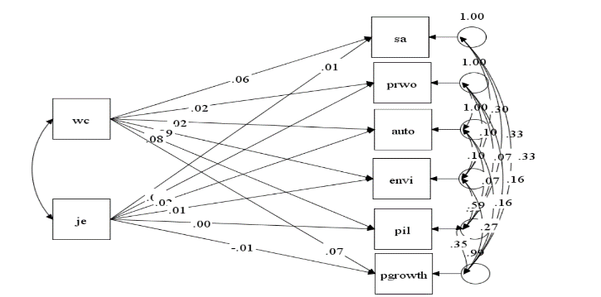

**Figure 1.** Diagram variants multivariate