A TURN-OFF FLUORESCENT CHEMOSENSOR FOR DETECTING FORMALDEHYDE BASED ON PYRIDINE DERIVATIVE

NURUL HIDAYAH1*, BAMBANG PURWONO2,

1Department of Food Technology, Universitas Ahmad Dahlan, Yogyakarta, Indonesia

2Department of Chemistry, Universitas Gadjah Mada, Yogyakarta, Indonesia

*Corresponding Author email: nurulhidayah@tp.uad.ac.id

FT-IR Spectrum of **ChP-0A**

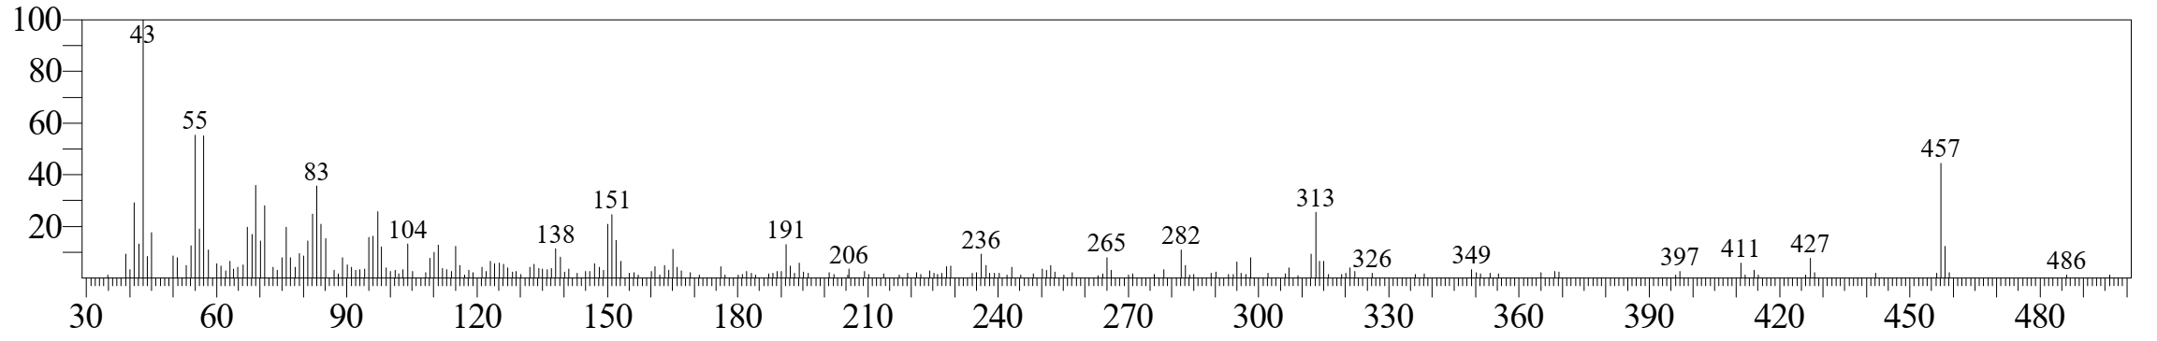

MS Spectrum of **ChP-0A**

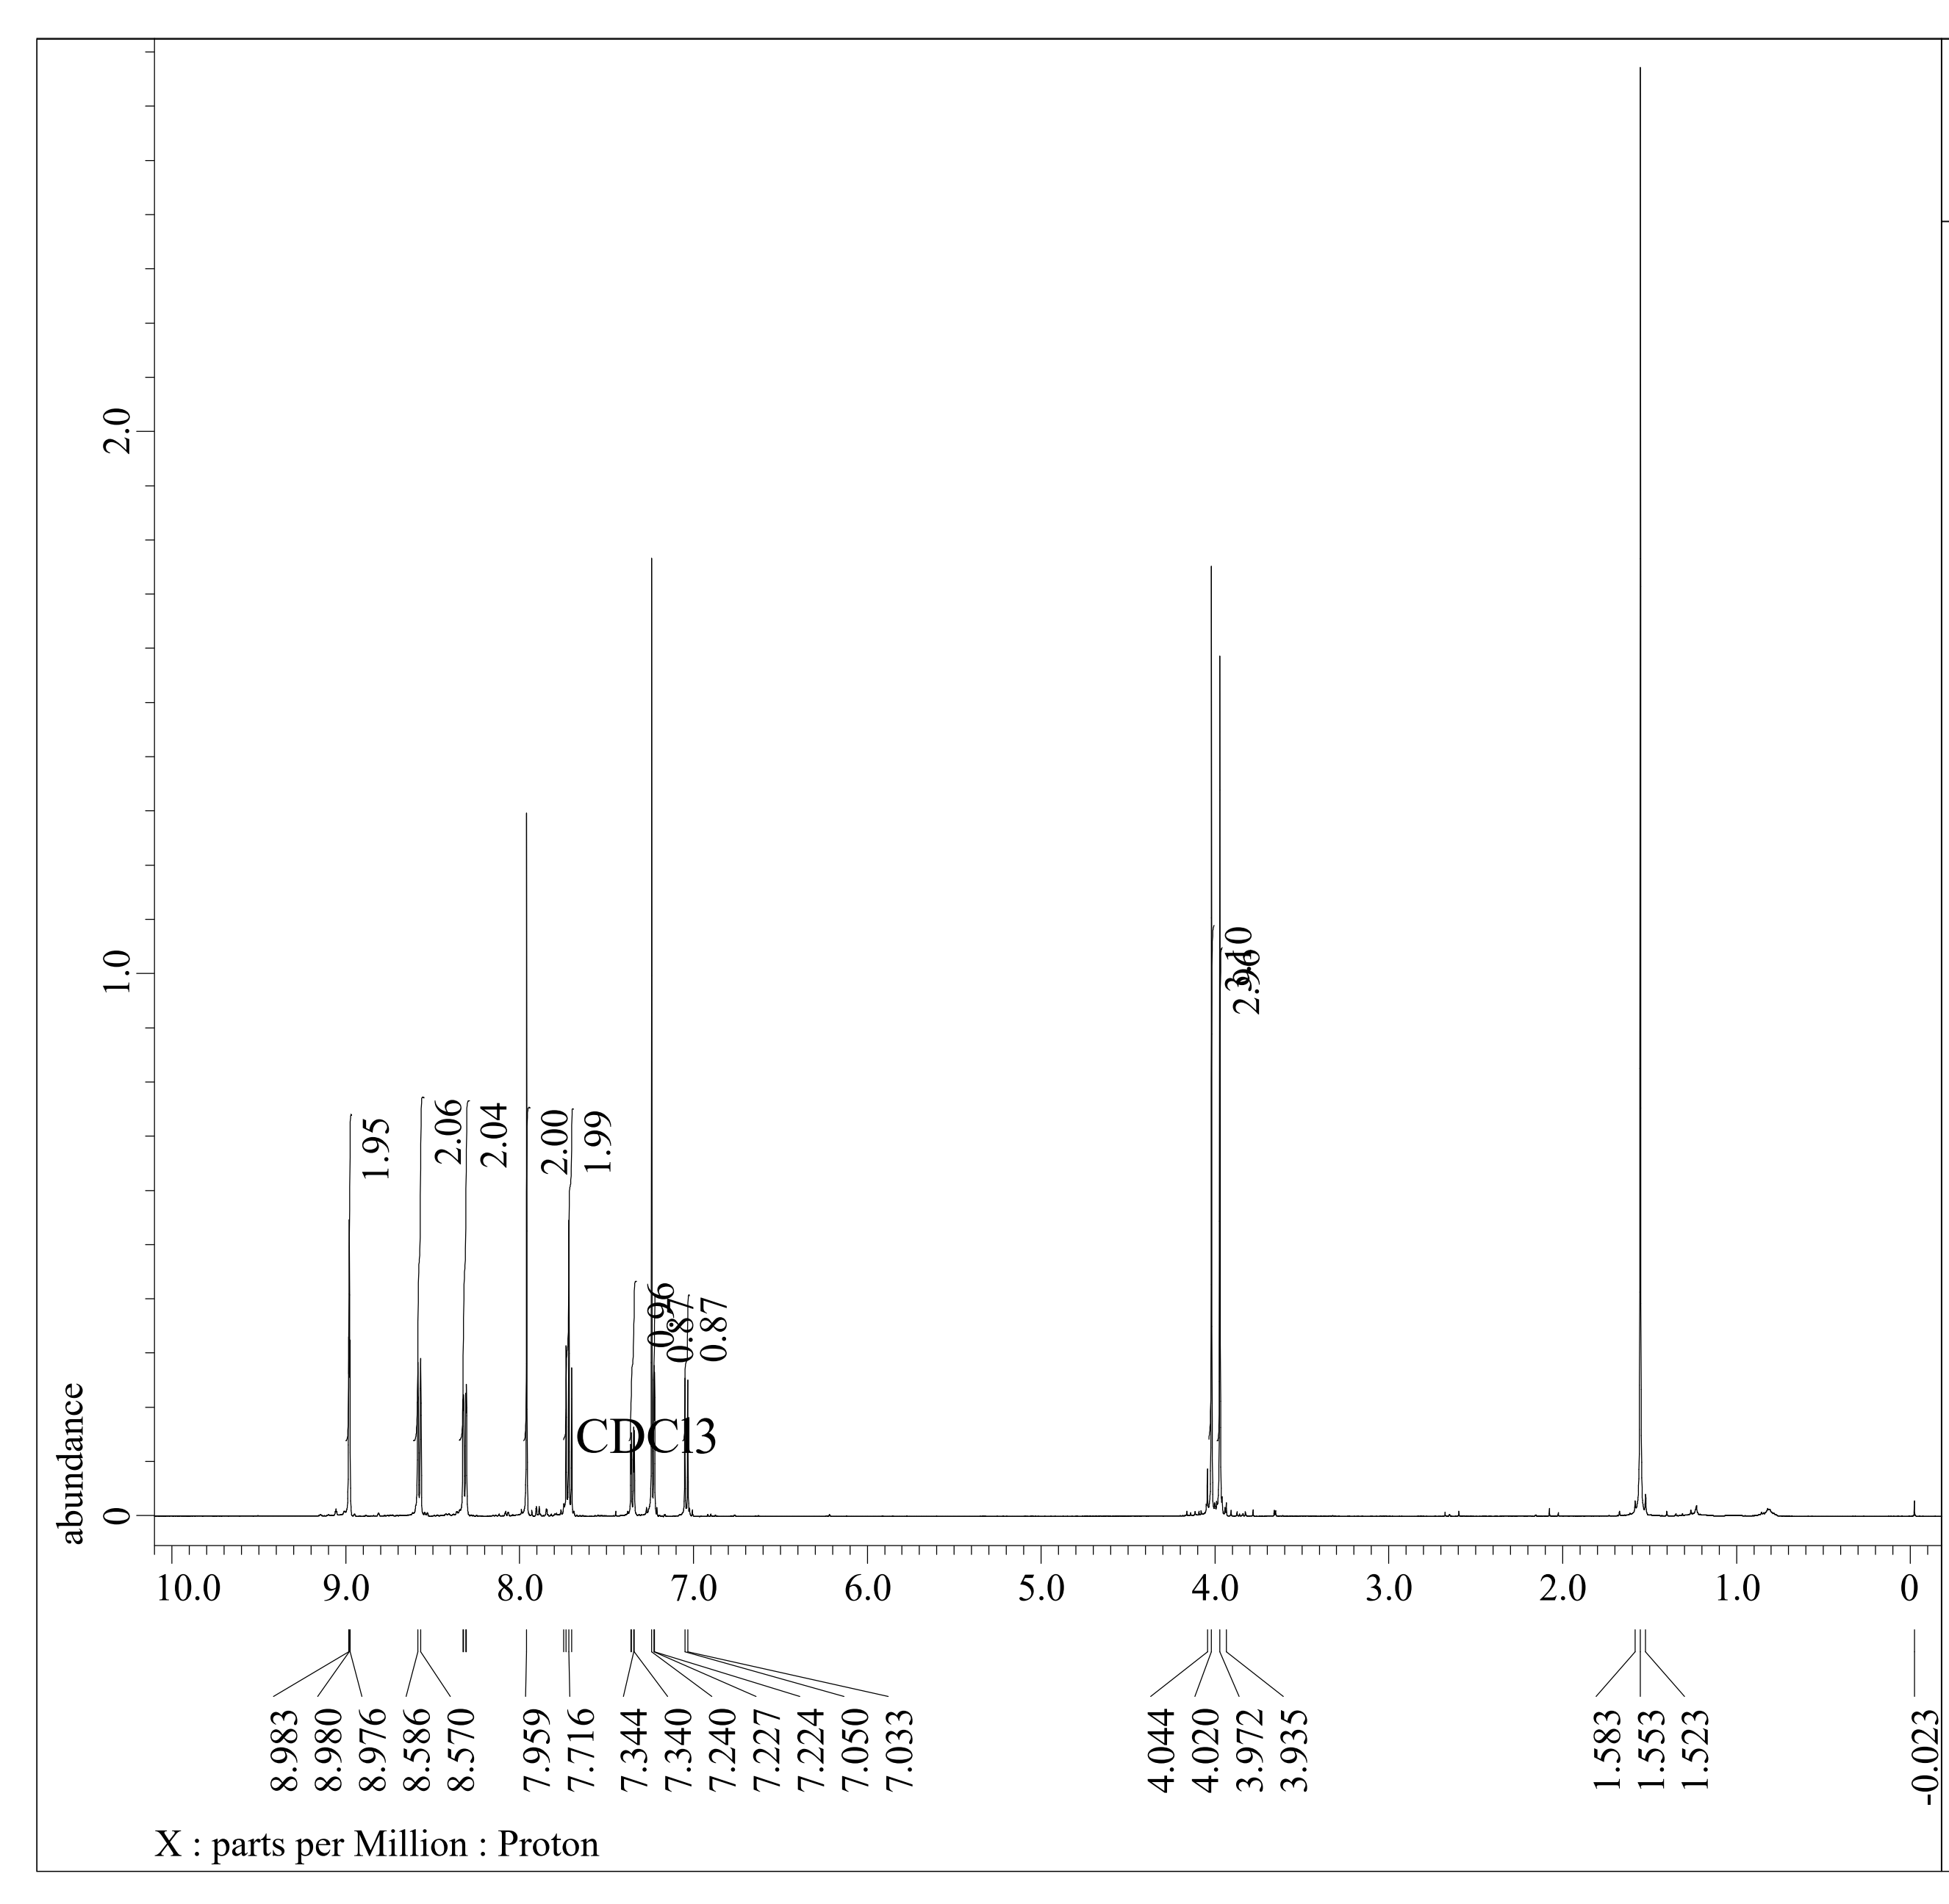

1H-NMR spectrum of **ChP-0A**

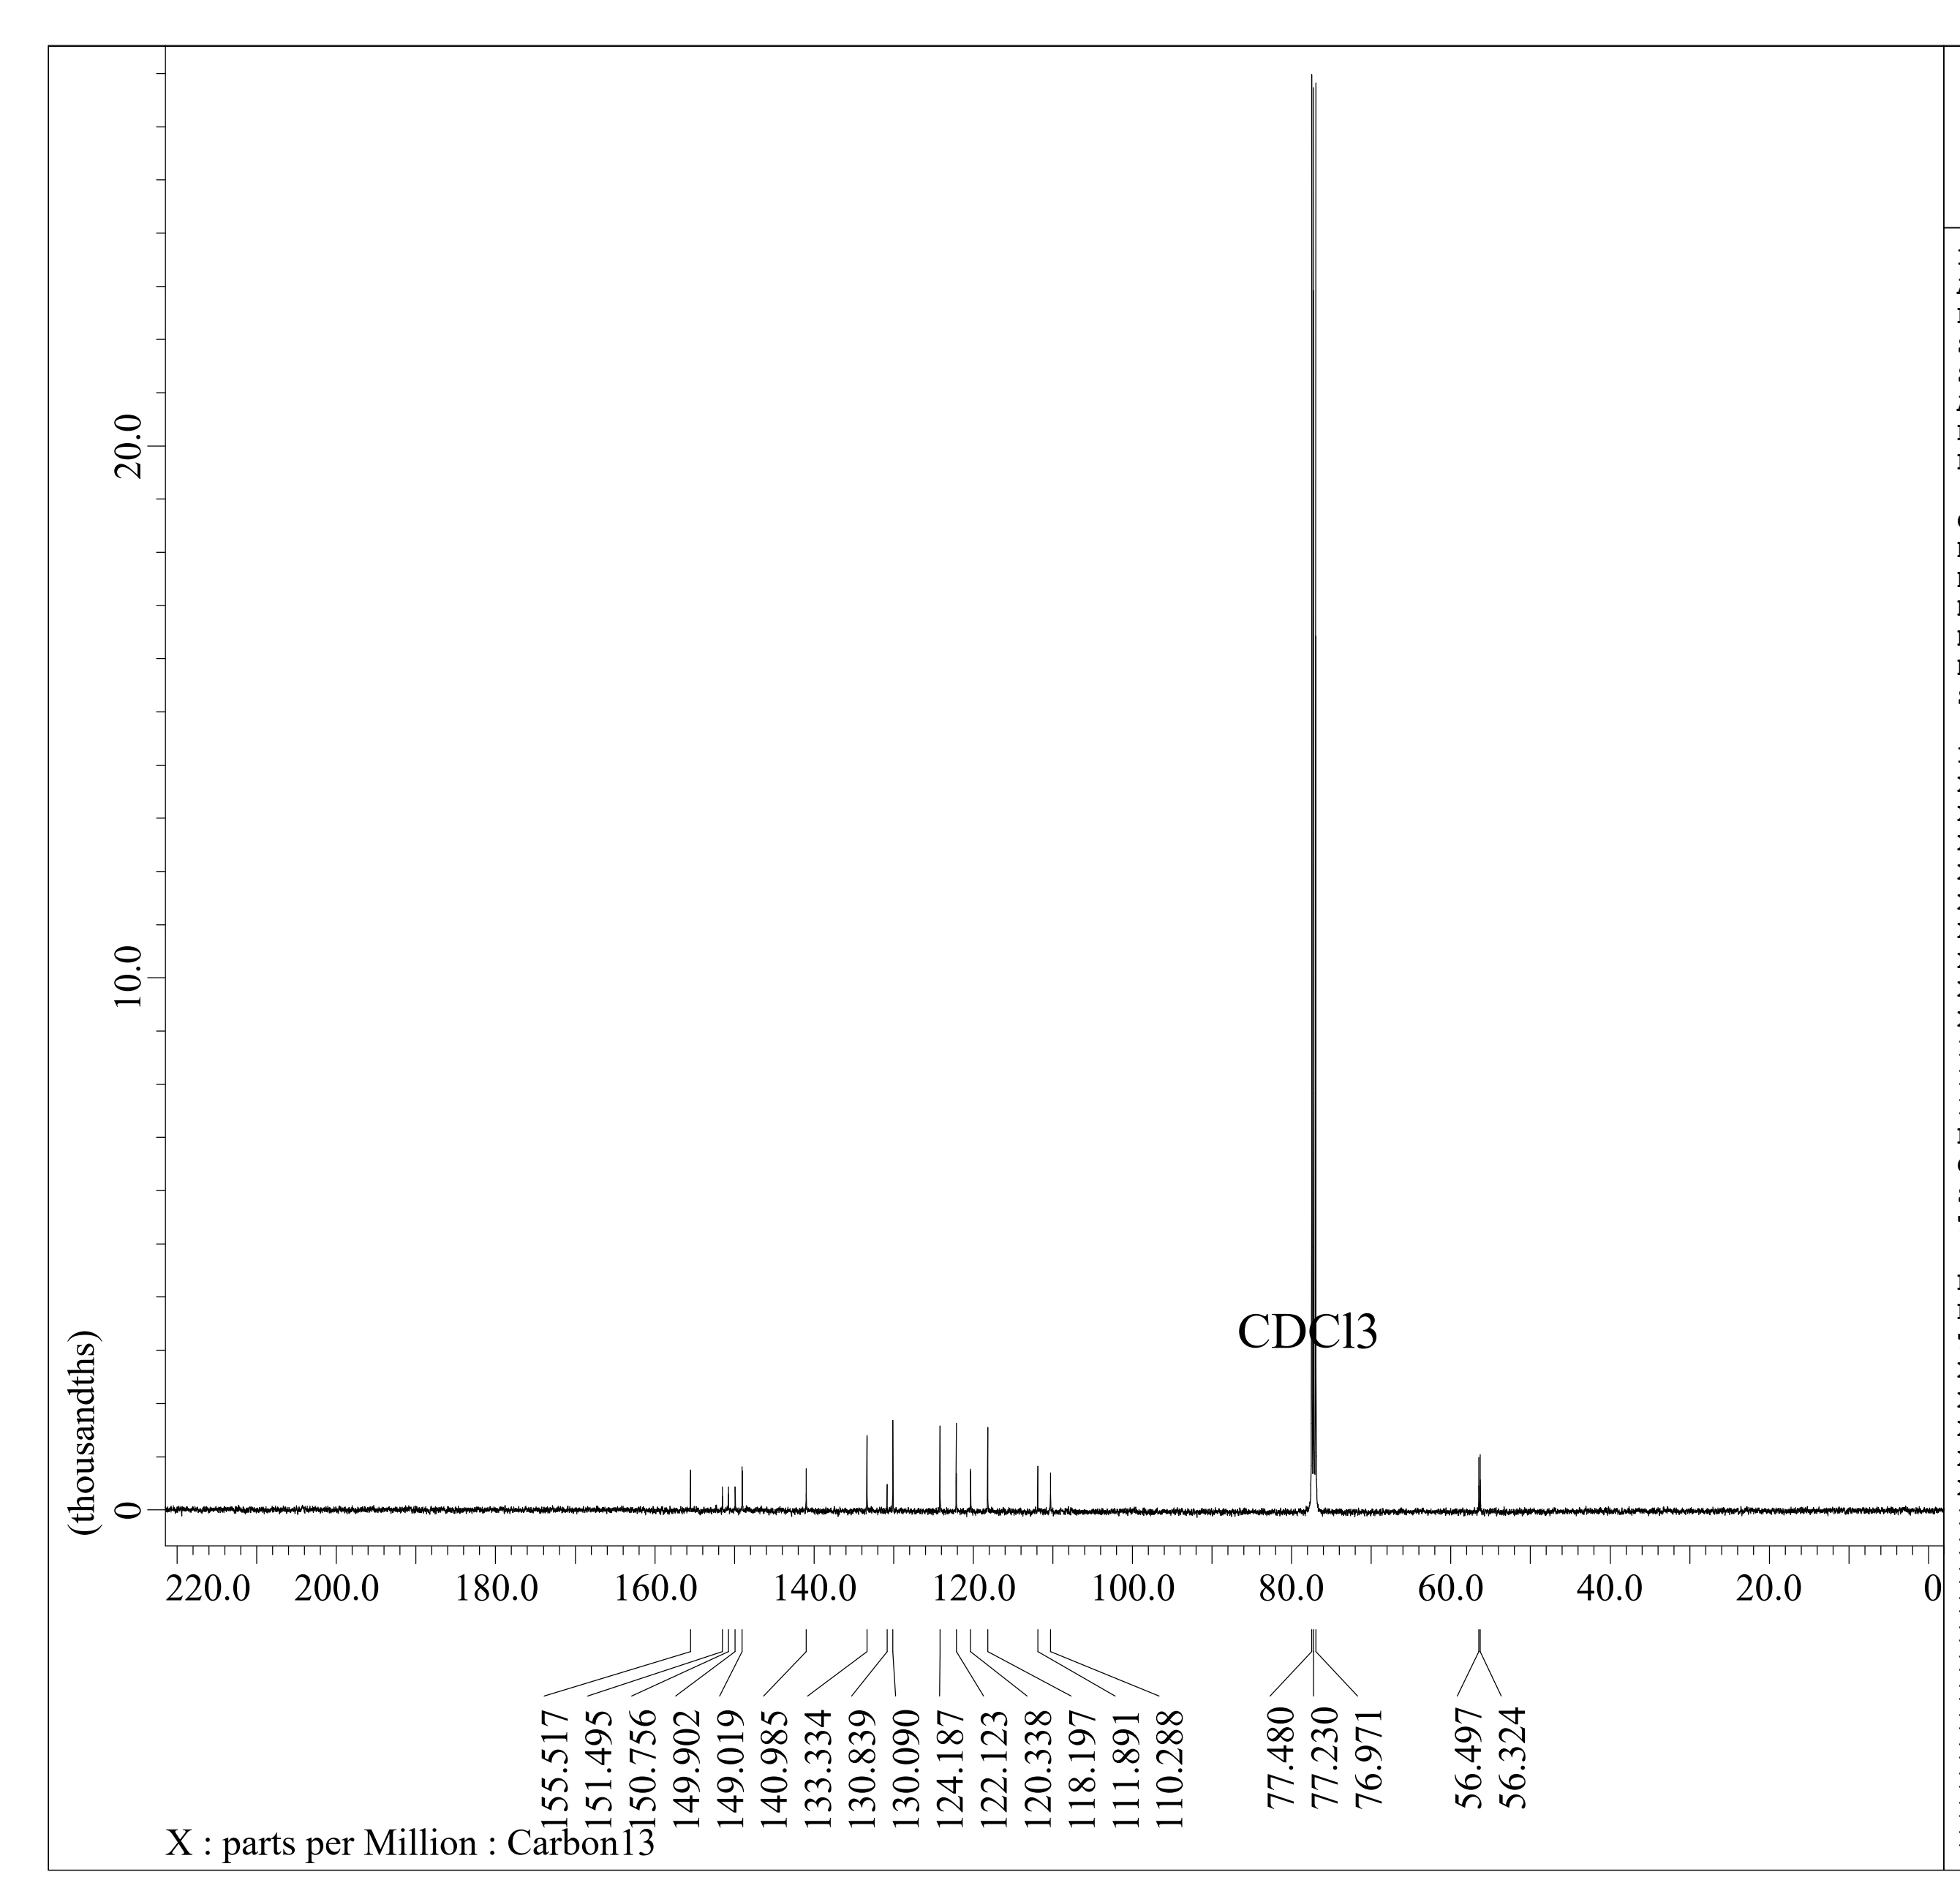

13C-NMR Spectrum of **ChP-0A**

FT-IR spectra of **ChP-0A** (black) and **ChP-2A** (blue)

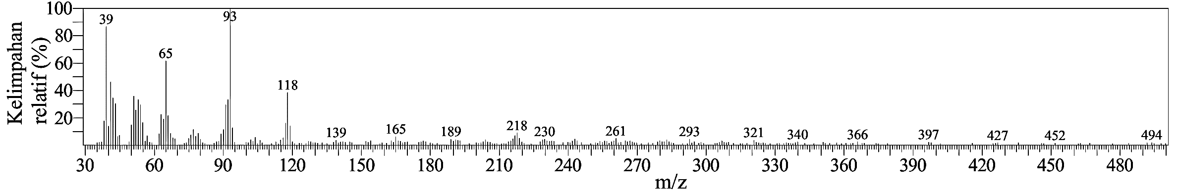

MS spectrum of **ChP-2A**

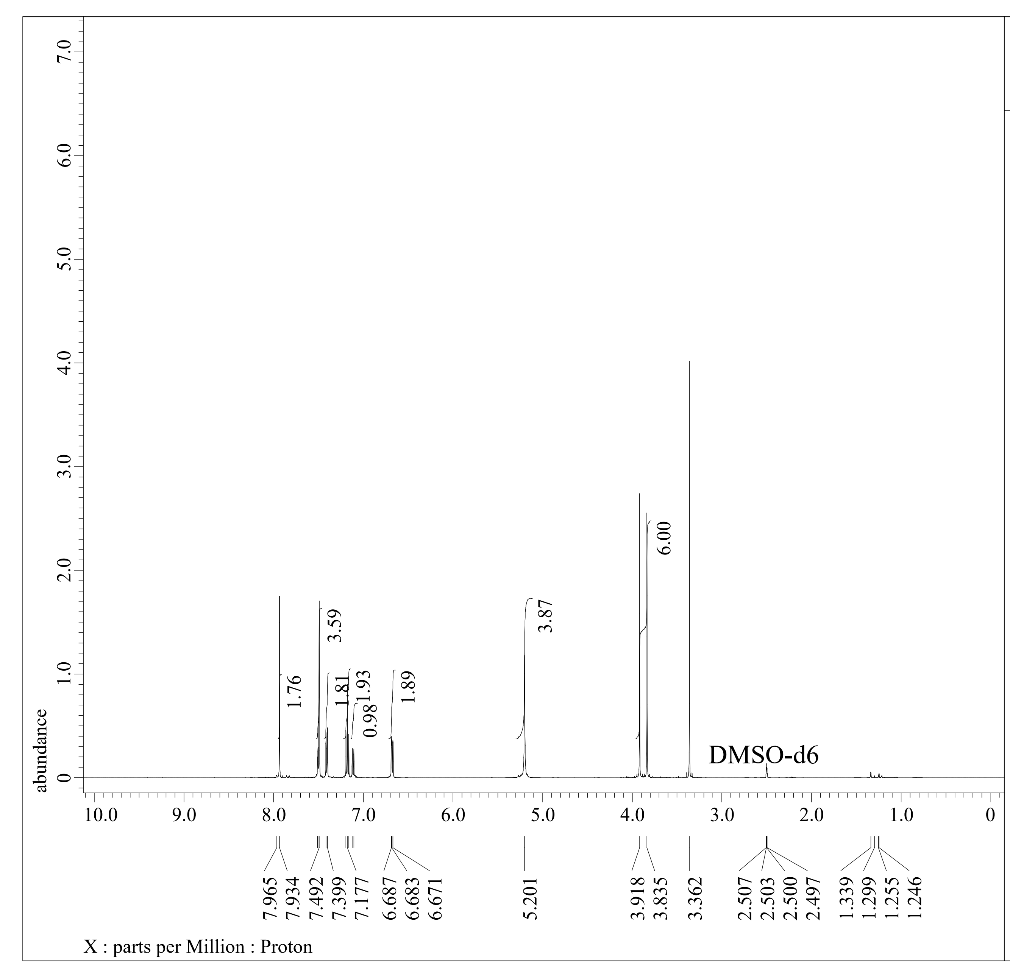

1H-NMR spectrum of **ChP-2A**

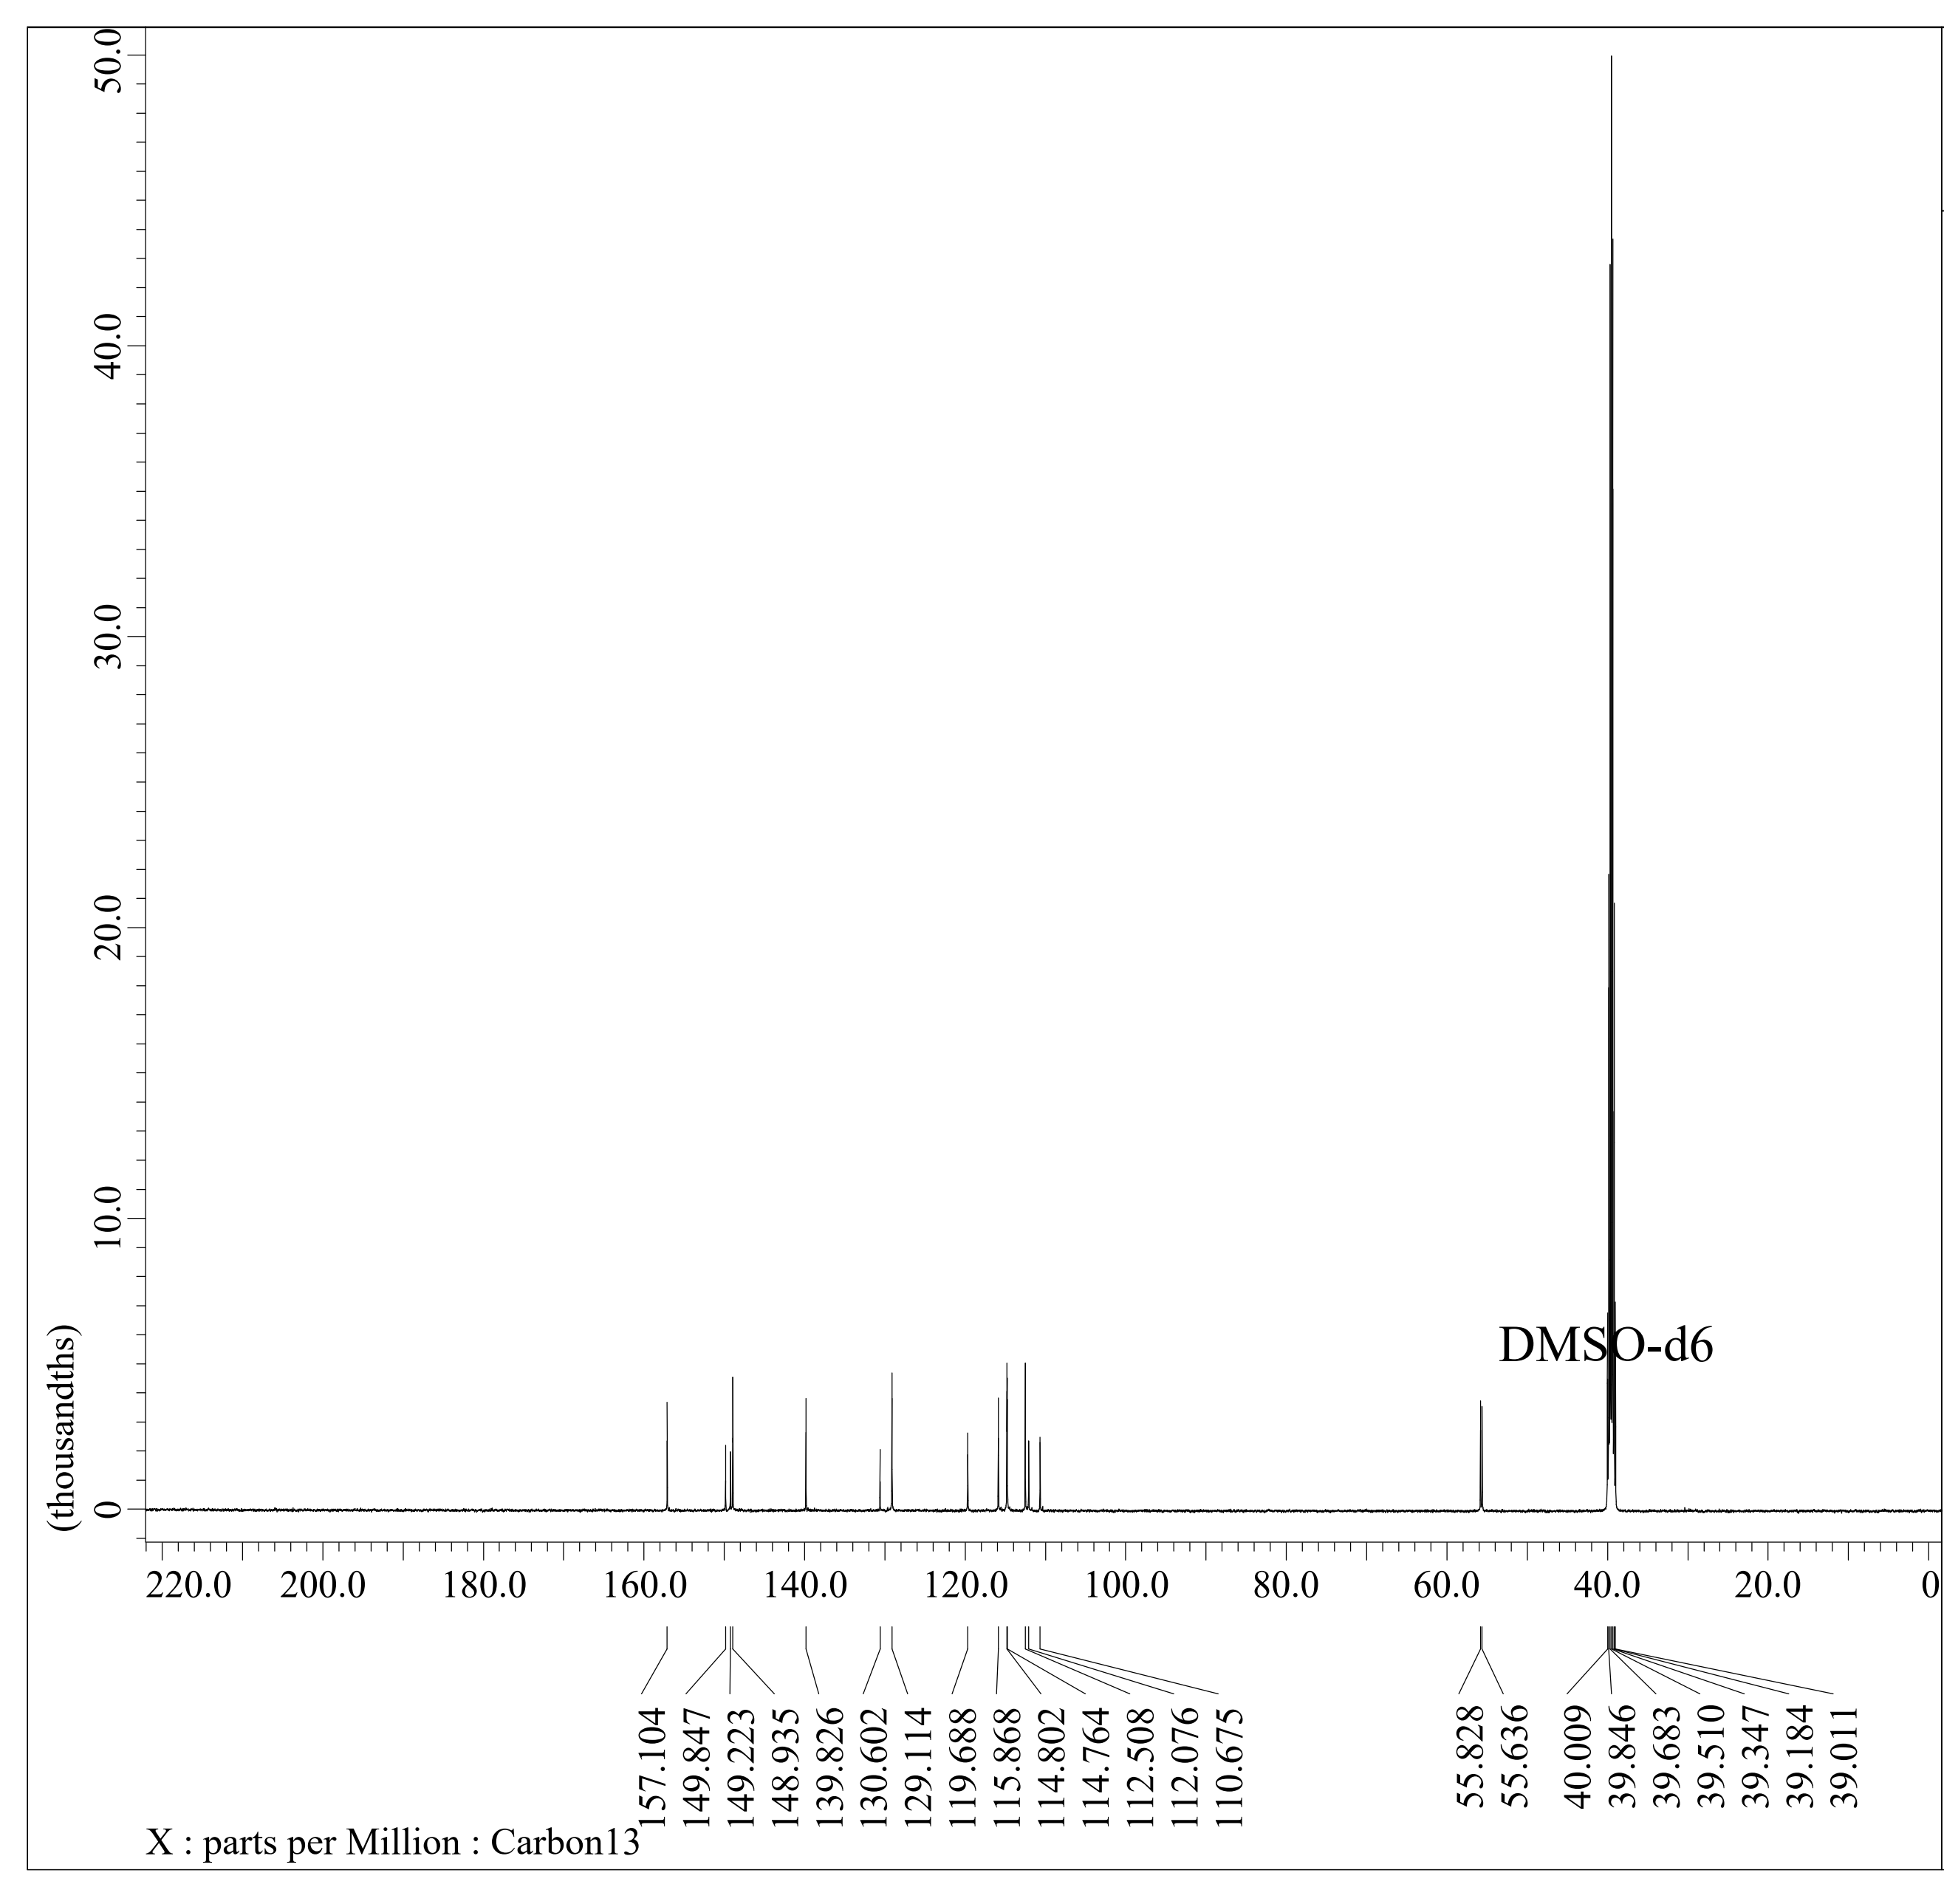

13C-NMR spectra of **ChP-2A**