**SUPLEMENTARY DATA**

**ISOLATION AND CHARACTERIZATION OF FLAVONOID DERIVATIVE OF ETHYL ACETATE EXTRACT FROM BAUHINIA LATISILIQUA STEM BARK AND ITS ACTIVITY AS ANTIOXIDANT**

SITTI HADIJAH SABARWATI1*, INDRIANI2, NURHAENI3, AHMAD RIDAY3, P. SATRIMAFITRAH4, JAYA HARDI5, RISMAWATY SIKANNA6

1Departement of Chemistry Halu Oleo University, Kendari, Indonesia

2,3,4,5Department of Chemistry Tadulako University, Palu, Indonesia

6Department of Chemistry, UIN Alauddin Makassar , Makassar, Indonesia

*Corresponding Author email: sabarwatisittihadijah@gmail.com

**A. NMR DATA**

**TABLE 1.** NMR spectroscopic data of isolated compound

|  |  |  |  |
| --- | --- | --- | --- |
|  |  | **Isolated compound of *B. latisiliqua*** | |
| **No** | 13**C** | **1H (mult., *J* in Hz)** | **HMBC (1H<=>13C)** |
| 2 | 82.9 | 4.56 (*d*, 7.4) | C-3, C-2’, C-6’ |
| 3 | 68.8 | 3.97(*m*) | - |
| 4 | 28.5 | 2.50 & 2.84 (*dd* & *dd*) | C-2, C-3, C-4a |
| 4a | 100.8 | - | - |
| 5 | 157.6 | - | - |
| 6 | 96.3 | 5.92 (*d*, 2.3) | C-5, C-7 |
| 7 | 157.8 | - | - |
| 8 | 95.5 | 5,85 (*d*, 2.3) | C-4a |
| 8a | 156.9 | - | - |
| 1’ | 132.3 | - | - |
| 2’ | 115.3 | 6,83 (*d*, 2.0) | C-3’, C-4’, C-6’ |
| 3’ | 146.2 | - | - |
| 4’ | 146.3 | - | - |
| 5’ | 116.1 | 6,76 (*d*, 8.0) | C-1’, C-3’, C-4’ |
| 6’ | 120.0 | 6,72 (*dd*, 8.3 & 2) | C-3’, C-4’,C-5’ |



**Figure 1** Structure of the isolated compound, 5,7,3’,4’-tetrahydroxyflavan-3-ol (Catechin)

**1H-NMR (methanol-d4, 500 MHz)** 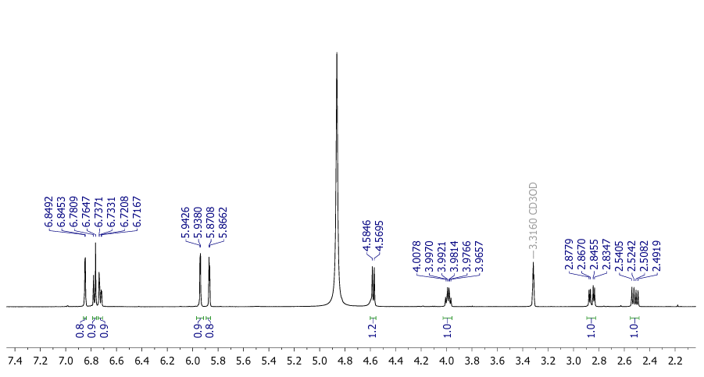

**Figure 2** 1H-NMR spectral data of the isolated compound (Cathecin)

**13C-NMR (methanol-d4, 125 MHz) Spectrum**

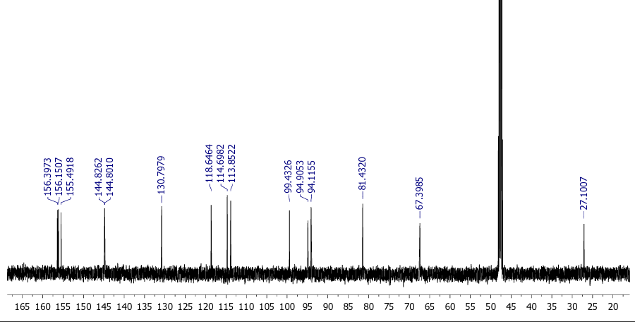

**Figure 3** 13C-NMR spectral data of the isolated compound (Catechin)

**NMR HMBC Cathecin**

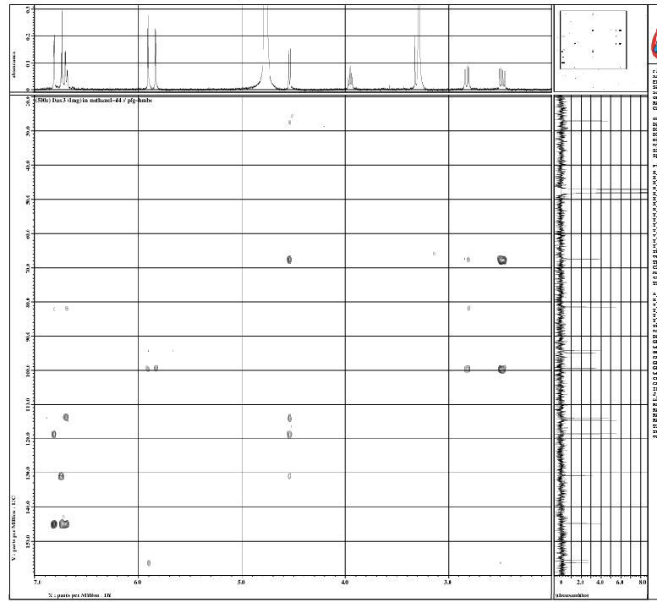

**Figure 4** HMBC spectral data of The isolated compound (Cathechin)