Naphthalene Derivatives from Bawang Tiwai Bulb Eleutherine bulbosa in Borneo

Supriatno Salam^{1,3}, Baso Didik Hikmawan¹, Erwin Samsul¹, Herman², Islamudin Ahmad², Laode Rijai², Mohd Azlan Nafiah^{3,*}.

¹Faculty of Pharmacy, Universitas Mulawarman, Samarinda 75119, Kalimantan Timur, Indonesia. supriatno.salam@unmul.ac.id; didikhikmawan@farmasi.unmul.ac.id, erwinsamsul@farmasi.unmul.ac.id
²Pharmaceuticals Research and Development Laboratory of Pharmaca Tropics, Faculty of Pharmacy, Universitas Mulawarman, Samarinda 75119, Kalimantan Timur, Indonesia. herman.mulawarman@gmail.com; islamudinahmad@farmasi.unmul.ac.id, laode@farmasi.unmul.ac.id
³Department of Chemistry, Faculty of Science and Mathematics, Sultan Idris Education Universiti, Tg Malim 35900, Perak, Malaysia. supriatno.salam@fsmt.upsi.edu.my, azlan@fsmt.upsi.edu.my

Corresponding authors. E-mail: azlan@fsmt.upsi.edu.my

Abstract
Naphthalene derivative compounds named Eleutherol (1) and Eleutherol C (2) have been isolated from Bawang Tiwai Bulb Eleutherine bulbosa. After isolating compounds 1 and 2 from the EtOH extract using conventional chromatography methods, their cytotoxic activity was tested against T47D breast cancer cells in vitro. Their chemical structures were elucidated based on spectroscopic analysis including IR, HR-TOFMS, 1D, and 2D NMR, and by comparison to those related spectra previously reported. Compounds 1 and 2 were tested for their cytotoxic effects against T47D breast cancer cells and showed moderate cytotoxicity against T47D breast cancer cells with IC₅₀ values 117.15 and 80.21 µM, respectively, compared with cisplatin 24.07 µM.

Keywords: Eleutherine bulbosa, Eleutherol, Eleutherol C, T47D breast cancer, East Kalimantan.

Introduction
E. bulbosa is an herbaceous plant belonging to the Iridaceae family which is distributed mainly in South Africa, South America, and Southeast Asia and grows mostly in sulfur areas, 600–2000 m above sea level [1]. In Indonesia, E. tubers are widely consumed by local tribal communities in Kalimantan, namely the Dayak tribe, and are traditionally used as a medicinal plant to increase breast milk production and treat diabetes, breast cancer, stroke, hypertension, and sexual disorders [2]. Research related to the search for compounds that play a role in the various properties of E. bulbosa tubers has been carried out. Naphthalene, anthraquinone, and naphthoquinone are the main constituents of E. bulbosa [3,4] which exhibit various pharmacological properties such as anti-diabetic [2], anti-inflammatory [5], anti-microbial [6,16], anti-melanogenesis [7], anti-MRSA [15], Antifungal [18] and anti-cancer [8]. As an anti-cancer, much research has been carried out on isolated compounds from E. bulbosa. For example, the compounds Eleutherinoside C and Isoeleutherin showed selective cytotoxic activity and inhibited TCF/β-catecin transcription in SW480 cancer cells in a dose-dependent manner [8], the compound isoeleutherol showed potent activity in both cancer cell lines against HeLa and MCF-7 cells with LC₅₀ values of 35.4 and 23.8 ppm respectively [9,11]. The activity of inhibit the cell cycle and induct apoptosis in HeLa cancer cell with a combination of Sabrang onion (E. palmifolia (L.) Merr) and Starfruit Mistletoe (Macrosolen cochinchinensis (Lour.) [17]. This study is a report on naphthalene derivative compounds that were isolated from the ethanolic extract of E. bulbosa. Eleutherol (1) and Eleutherol C (2) which are derivatives of naphthalene compounds have been isolated from E. bulbosa, along with their cytotoxic activity against T47D breast cancer cells in vitro. Activity tests were carried out on T47D because this naphthalene group has very good activity against cytotoxics, especially breast cancer cells.

Material and Methode
General experimental procedures
The UV spectrum was measured using a TECAN Infinite M200 pro (Mannedorf, Switzerland) with MeOH. The IR spectra were recorded on SHIMADZU IR Prestige-21 in KBr (Kyoto, Japan). The high-resolution of time-of-flight mass spectrometry (HR-TOFMS) data was recorded with Water Xevo QTOF MS (Milford, Massachusetts, USA). NMR spectrum was evaluated using JEOL ECZ-500 (Tokyo, Japan) at 500 MHz for ¹H and 125 MHz for ¹³C using tetramethylsilane (TMS) as the internal standard. In addition, the chemical shifts are expressed in ppm, concerning the CDCl₃ (δ_{H} 7.26/δ_{C} 77.2) signals. Column chromatography (CC) was performed using silica gel (70-230 mesh) (Merck, Darmstadt, Germany). Thin layer chromatography (TLC) was performed with silica gel 60. TLC plates were precoated with silica gel GF₂₅₄ (Merck, 0,25 mm, Darmstadt, Germany) using various solvent systems. Compounds were visualized under UV light (254 and 365 nm) or by spraying the heated silica gel plates with 10% H₂SO₄ in EtOH.
Plant material
The bulbs of E. bulbosa were collected from Batu Cermin, Samarinda, East Kalimantan, Indonesia. The plant was identified at the Laboratory of Ecology of Tropical Forest Biodiversity, Faculty of Forestry, Mulawarman University, Samarinda, East Kalimantan. Indonesia. The plant was shade-dried (<45°C), coarsely powdered, and stored in an airtight container.
Extraction and isolation
The dried E. bulbosa (200 g) was extracted with distilled ethanol at room temperature for 4 days (4×2.5 L) and concentrated using a vacuum rotary evaporator, yielding a concentrated extract (24 g). About 20 g of ethanol was chromatographed using silica gel column CC (70-230 mesh) with n-hexane: ethyl acetate as eluent (5% stepwise) and obtained 5 combined fractions (Fraction A-E).
Fraction A in the isocratic column chromatography and eluted using n-hexane: ethyl acetate (9:1) obtained fractions A1-A2. The A2 fraction was purified by recrystallization to obtain compound 1 (7.5 mg).
Fraction B was separated by silica gel column chromatography (70-230 mesh) with a gradient of 2.5% using n-hexane: ethyl acetate (9:1-7:3) eluent to produce 5 fractions (Fraction B1-B5). Then fraction B3 was selected to be purified using silica gel column chromatography with n-hexane: ethyl acetate (8.5:1.5) as eluent to obtain compound 1 (16.3 mg).
Fraction C was chromatographed on a silica gel column and eluted using n-hexane: ethyl acetate with a gradient of 2.5% (9:1-6:4) to produce 9 fractions (Fraction C1-C9). The C4 fraction was selected to be purified using column chromatography. Silica gel was eluted isocratically using n-hexane: ethyl acetate (7.5:2.5) and obtained compound 2 (14.2 mg).

Eleutherol (1) a needle-shaped white crystal (MeOH); IR (KBr) V_{max} 3471, 1664, 1382, 1320, 1243 cm⁻¹; ¹H-NMR and ¹³C-NMR data see Table 1; HR-TOFMS [M + H]⁺ m/z 245.1351 (calcd. C₁₄H₁₃O₄ m/z 245.1361).
Eleutherol C (2) a yellow amorphous powder (MeOH); IR (KBr) V_{max} 3471, 1664, 1382, 1320, 1243 cm⁻¹; ¹H-NMR and ¹³C-NMR data see Table 1; HR-TOFMS [M + H]⁺ m/z 245.1351 (calcd. C₁₄H₁₃O₄ m/z 245.1361).

Bioassays for cytotoxic activity
The T47D cells were seeded into 96-well plates at a density of 3 x 10⁴ cells/well and incubated in a humidified CO₂ incubator for 24 h. Varying concentrations of the test compound were dissolved in DMSO, followed by six desirable concentrations prepared using PBS (phosphoric buffer solution, pH 7.30-7.65). each concentration of the compound was added to the wells in triplicate and incubated in a humidified CO₂ incubator for 48 h, the negative control wells received only DMSO, and cisplatin was used as the positive control. After an incubation period, MTT reagent [3-(4,5-dimethylthiazol-2-yl)-2,5-diphenyl tetrazolium bromide] was added to all test and control well and the incubation was continued for another 4 h. The MTT-stop solution containing SDS (sodium dodecyl sulphate) was added to wells and incubated again for another 24 h. The absorbance values were read using a microplate reader at a wavelength of 550 nm. IC₅₀ values were determined by the linear regression method using Microsoft Excel software. The IC₅₀ is the concentration required for 50% growth inhibition [12].
Results and discussion
The ethanol extract of E. bulbosa was isolated using conventional column chromatography (CC) packed with silica gel 60 with gradient and isocratic elution and spectroscopic analysis to obtain the naphthalene derivatives, Eleutherol (1) and Eleutherol C (2) (Fig. 1).
Compound (1) was obtained as a needle-shaped white crystal soluble in methanol. The molecular formula was C₁₄H₁₂O₄ (Fig. 2), based on the high-resolution time-of-flight (HR-TOFMS) spectrum with a [M + H]⁺ ion peak at m/z 245.1351 (calcd. C₁₄H₁₃O₄ m/z 245.1361) and obtained Nine degrees of unsaturation. The Infrared (IR) spectrum (Fig. 3) showed the presence of hydroxyl groups (V_{max} 3471 cm-1), lactone functional groups (V_{max} 1664 cm⁻¹), and Aromatic carbon (V_{max} 1382, 1320, 1243 cm⁻¹). The Proton nuclear magnetic resonance (¹H-NMR) spectrum (Fig. 4, Table 1) showed one methyl proton signal at δ_{H} 1.725 (3H, d, J = 6 Hz, CH₃-1՛), one proton methine signal at δ_{H} 5.72 (1H, q, J = 6.5 Hz, H-1), one hydroxyl chelate signal at δ_{H} 9.63 (1H, s, OH-9), one oxygenated methyl proton signal at δ_{H} 4.09 (3H, s, OCH₃-2՛), one isolated aromatic proton signal at δ_{H} 7.83 (1H, s, H-4) and three aromatic proton signals at δ_{H} 6.91 (1H, d, J = 7.5 Hz, H-7), δ_{H} 7.39 (1H, t, J = 8.5 Hz, H-6) δ_{H} 7.54 (1H, d, J = 8.5 Hz, H-5) which implied the presence of a benzene ring in (1). Carbon nuclear magnetic resonance (¹³C-NMR) along with distortions enhancement by polarization transfer (DEPT) (Fig. 5) showed the presence of fourteen carbon signals consisting of five quaternary carbons sp² at δ_{C} 117.5 (C-8a), 125.9 (C-9a), 127.9 (C-3a) and 137.2 (C-4a). Two quaternary carbons are oxygenated at δ_{C} 149.2 (C-9) and 156.6 (C-8). Four carbons of methine at δ_{C} 106.3 (C-7), 116.5 (C-4), 123.7 (C-5) and 126.7 (C-6). One carbon of methine is oxygenated at δ_{C} 77.5 (C-1). One methyl at δ_{C} 19.2 (C-1՛), one oxygenated methyl at δ_{C} 56.5 (C-2՛), and carbon lactone at δ_{C} 170.7 (C-3). These functionalities accounted for six out of the total nine degrees of unsaturation. The remaining three degrees of unsaturation were consistent with a naphthalene skeleton. The IR spectra as well as the NMR data indicated (1) is a substituted naphthalene derivative [10] which was further confirmed by 2D NMR spectra HMQC (Fig. 6) and HMBC (Fig. 7). The connectivity of (1) was established mainly by proton multiple bond connectivity (HMBC). Fig. 9 for the HMBC spectrum showed the signal aromatic at δ_{H} 7.39 (1H, t, J = 8.5 Hz, H-6) was correlated to δ_{C} 106.3 (C-7) and 123.7 (C-5) which suggested that the aromatic proton was located at C-6. The methoxyl proton at δ_{H} 4.09 (3H, s, OCH₃-2՛) was correlated to δ_{C} 156.6 (C-8) which indicated that the methoxy group was located at C-8, respectively, the hydroxyl proton at δ_{H} 9.63 (1H, s, OH-9) was correlated to δ_{C} 149.2 (C-9), 125.9 (C-9a) and 117.5 (C-8a), and the aromatic proton at δ_{H} 7.83 (1H, s, H-4) was correlated to δ_{C} 127.9 (C-3a) and 137.2 (C-4a), which indicated that the hydroxyl group and aromatic proton were located at C-9 and C-4. The methyl proton at δ_{H} 1.725 (3H, d, J = 6 Hz, CH₃-1՛) was correlated to δ_{C} 77.5 (C-1) and 127.9 (C-3a), proving the presence of a methyl group located at C-1. The signal of proton methine at δ_{H} 5.72 (1H, q, J = 6.5 Hz, H-1) was correlated to the carbonyl lactone at δ_{C} 170.7 (C-3), which indicated that the lactone ring was formed between C-3a, C-3, and C-1. Based on the analysis of the spectra IR, 1D, and 2D NMR and compared with the previously reported literature, the structure of (1) was similar to the known compound Eleutherol, thus the structure of (1) was elucidated as shown and named Eleutherol.
Fig. 1. Structures of Compounds 1 and 2
Compound (2) was obtained as a yellow amorphous powder soluble in methanol. The molecular formula was C₁₄H₁₂O₄, based on the high-resolution time-of-flight (HR-TOFMS) spectrum with a [M + H]⁺ ion peak at m/z 245.1351 (calcd. C₁₄H₁₃O₄ m/z 245.1361) and obtained Nine degrees of unsaturation. The Infrared (IR) spectrum showed the presence of hydroxyl groups (V_{max} 3471 cm-1), lactone functional groups (V_{max} 1664 cm⁻¹), and Aromatic carbon (V_{max} 1382, 1320, 1243 cm⁻¹). The Proton nuclear magnetic resonance (¹H-NMR) spectrum showed one methyl proton signal at δ_{H} 1.725 (3H, d, J = 6 Hz, CH₃-1՛), one proton methine signal at δ_{H} 5.72 (1H, q, J = 6.5 Hz, H-1), one hydroxyl chelate signal at δ_{H} 9.63 (1H, s, OH-9), one oxygenated methyl proton signal at δ_{H} 4.09 (3H, s, OCH₃-2՛), one isolated aromatic proton signal at δ_{H} 7.83 (1H, s, H-4) and three aromatic proton signals at δ_{H} 6.91 (1H, d, J = 7.5 Hz, H-7), δ_{H} 7.39 (1H, t, J = 8.5 Hz, H-6) δ_{H} 7.54 (1H, d, J = 8.5 Hz, H-5). The ¹H-NMR and ¹³C-NMR spectra seemed identical to those of (1) (Table 1). However, the HMBC spectrum of (2) (Fig. 8) displayed the hydroxyl proton at δ_{H} 9.63 (1H, s, OH-9) was correlated to δ_{C} 156.6 (C-8), which indicated that the hydroxy group was located at C-8 (Fig. 8). The methoxyl proton at δ_{H} 4.09 (3H, s, OCH₃-2՛) was correlated to δ_{C} 149.2 (C-9), 125.9 (C-9a) proving the presence of methoxy group located at C-9., respectively. Based on these descriptions and comparing the respective spectroscopic evidence with existing publications, the structure of (3) was elucidated and determined as a known compound as Eleutherol C. [13].
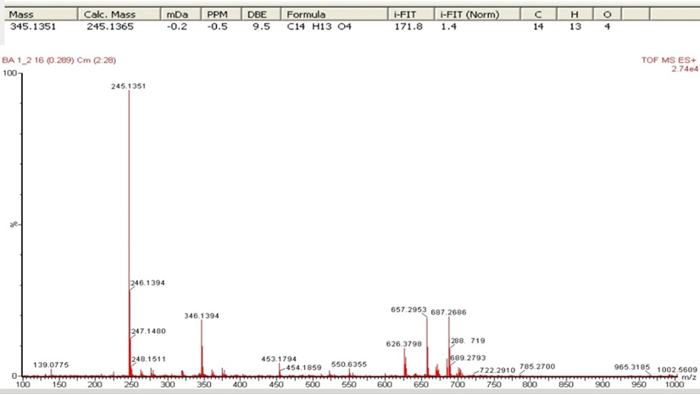
Fig. 2. HR-TOFMS spectra of Compound 1.

Compounds 1 and 2 were tested for cytotoxic activity against T47D breast cancer cells using the method previously described and cisplatin was used as a positive control. Compounds 1 and 2 showed moderate cytotoxicity with IC₅₀ values of 117.15 and 80.21 µM, respectively. This indicates that the location of the hydroxyl group can increase cytotoxic activity [14], whereas in compound 2 the hydroxyl group is located at C-8 and is not blocked by other groups which causes the IC₅₀ to be lower than compound 1.

Table 1 NMR spectral data for 1 and 2 (500 MHz for ¹H and 125 MHz for ¹³C in CDCl₃)
Position  Carbon | 1 |  |  | 2
 | ¹³C-NMR  δ_{C} (mult,) | ¹H-NMR  δ_{H} [(∑H, mult, J(Hz)] |  | ¹³C-NMR  δ_{C} (mult,) | ¹H-NMR  δ_{H} [(∑H, mult, J(Hz)]
1 | 77.5 (s) | 5.72 (1H, q, 6.5) |  | 77.5 (s) | 5.72 (1H, q, 6.5)
3 | 170.7 (q) | - |  | 170.7 (q) | -
3a | 127.9 (q) | - |  | 127.9 (q) | -
4 | 116.5 (s) | 7.83 (1H, s) |  | 116.5 (s) | 7.83 (1H, s)
4a | 137.2 (q) | - |  | 137.2 (q) | -
5 | 123.7 (s) | 7.54 (1H, d, 8.5) |  | 123.7 (s) | 7.54 (1H, d, 8.5)
6 | 126.7 (s) | 7.39 (1H, t, 8,5) |  | 126.7 (s) | 7.39 (1H, t, 8,5)
7 | 106.3 (s) | 6.91 (1H, d, 7.5) |  | 106.3 (s) | 6.91 (1H, d, 7.5)
8 | 156.6 (q) | - |  | 156.6 (q) | -
8a | 117.5 (q) | - |  | 117.5 (q) | -
9 | 149.2 (q) | - |  | 149.2 (q) | -
9a | 125.9 (q) | - |  | 125.9 (q) | -
1՛-OCH₃ | 19.2 (t) | 1.72 (3H, d, 6) |  | 19.2 (t) | 1.72 (3H, d, 6)
2՛-CH₃ | 56.5 (t) | 4.09 (3H, s) |  | 56.5 (t) | 4.09 (3H, s)
9-OH | - | 9.63 (1H, s) |  | - | -
8-OH | - | - |  | - | 9.63 (1H, s)

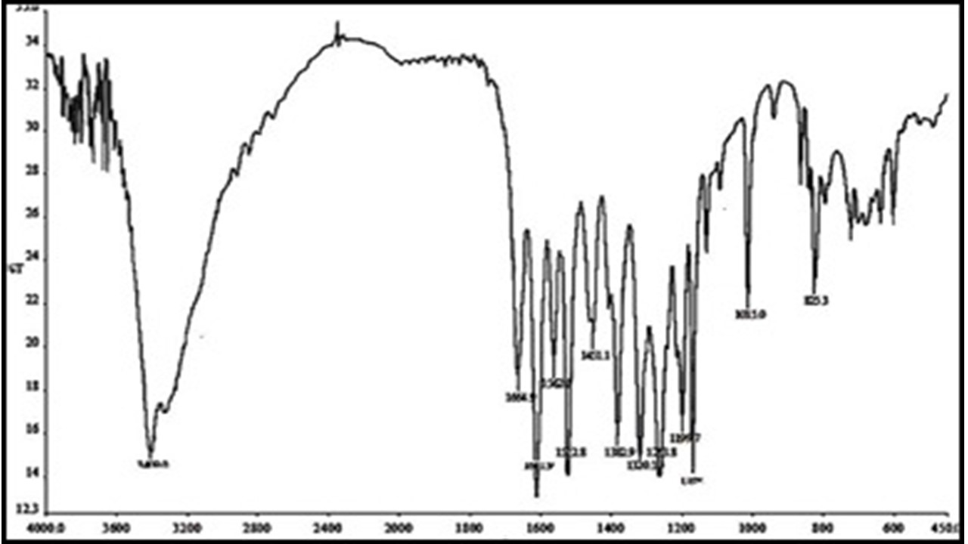
Fig. 3. IR spectra of Compound 1 (KBr).

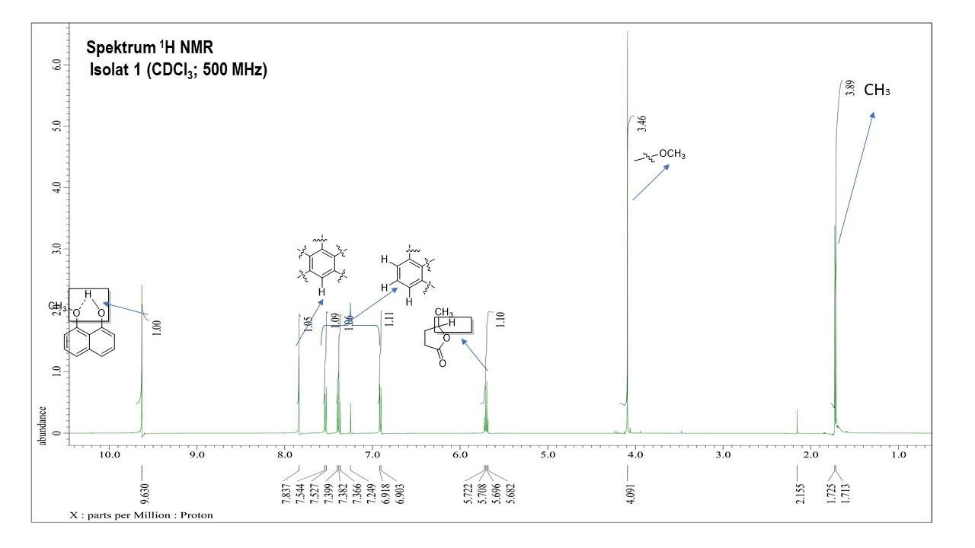
Fig. 4. ¹H-NMR spectra of Compound 1 (500 MHz, CDCl₃).
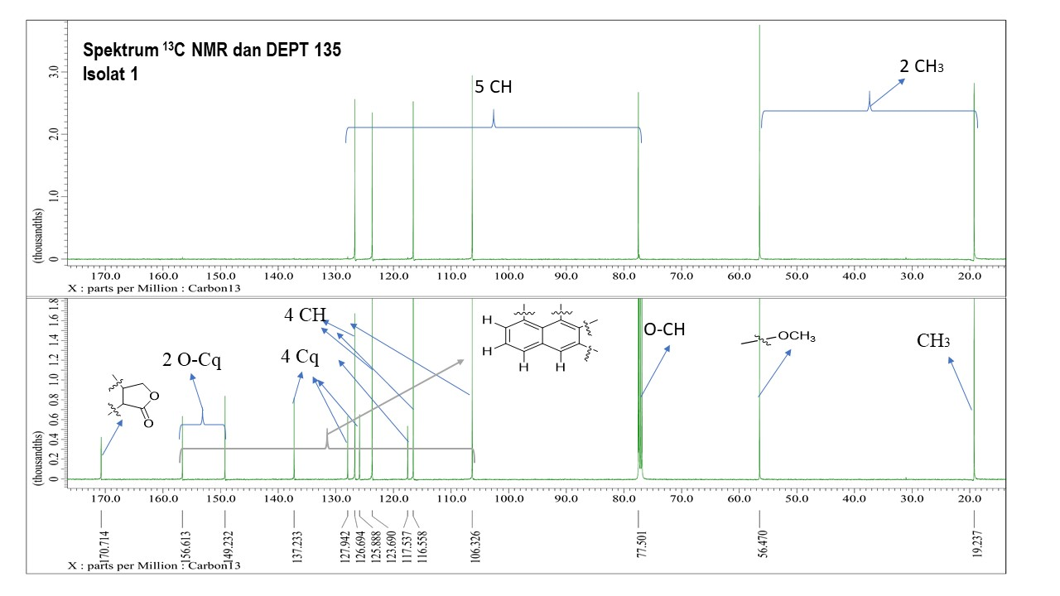
Fig. 5. ¹³C-NMR and DEPT 135º spectra of Compound 1 (125 MHz, CDCl₃).
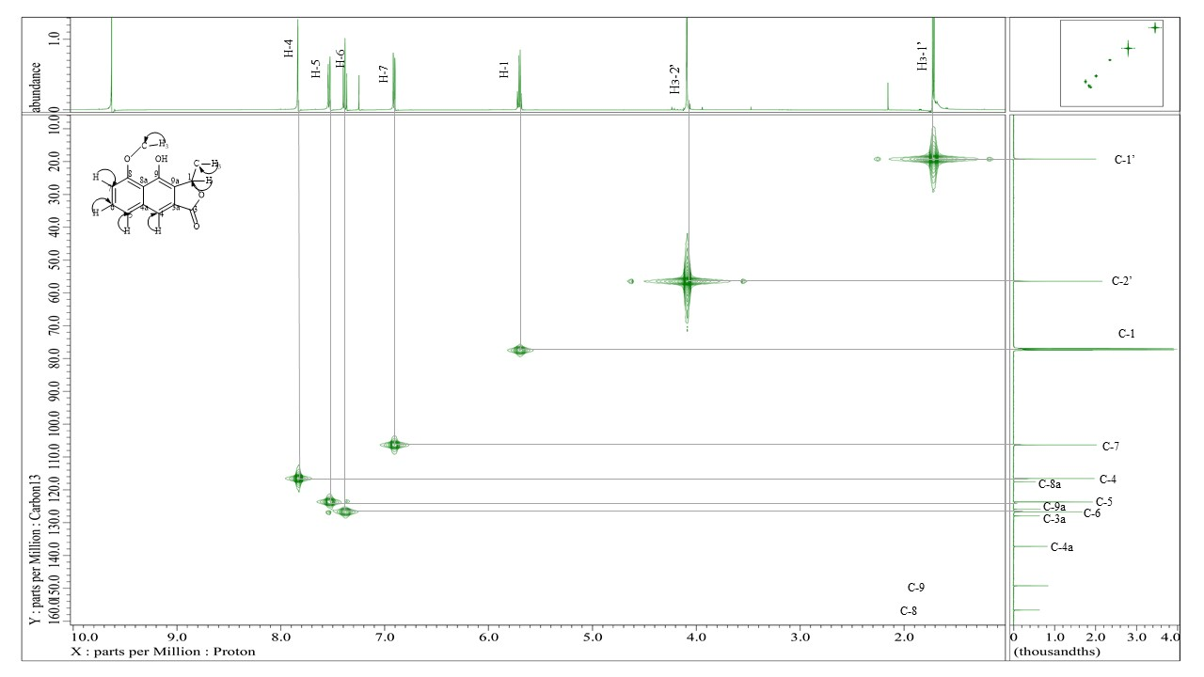
Fig. 6. HMQC spectra of Compound 1.
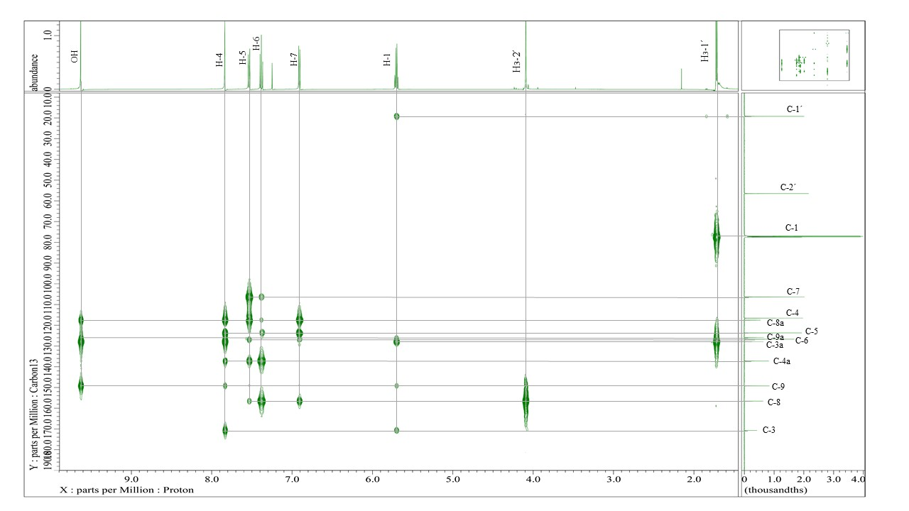
Fig. 7. HMBC spectra of Compound 1.
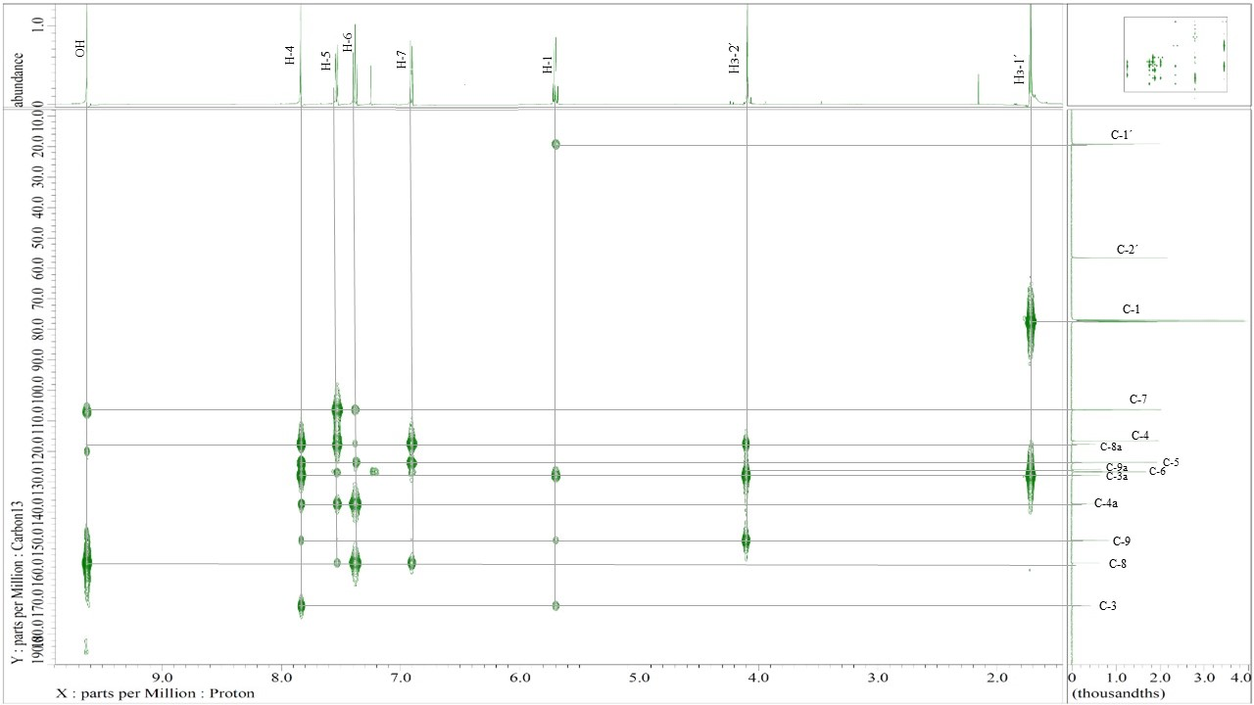
Fig. 8. HMBC spectra of Compound 2.

Fig. 9. (a) selected HMBC correlation of 1 (b) selected HMBC correlation of 2
Conclusions
Naphthalene derivatives, namely Eleutherol (1) and Eleutherol C (2) were isolated from the bulbs of E. bulbosa. The cytotoxic activity was evaluated against the T47D breast cancer cell line in vitro, Compounds 1 and 2 showed weak and no cytotoxic activity with IC₅₀ values of 117.15 and 80.21 µM, respectively compared with cisplatin 24.07 µM. Suggesting that the location of the hydroxyl group can increase cytotoxic activity.

Acknowledgments
We thank to the Tropical Pharmacy Research and Development Laboratory at Mulawarman University and the Department of Chemistry, Faculty of Science and Mathematics, Sultan Idris Education Universiti, Tg Malim 35900, Perak, Malaysia.
Conflicts of Interest
The authors have declared no conflict of interest.
References
- Insanu, M.; Kusmardiyani, S.; Hartati, R. Recent studies on phytochemicals and pharmacological effects of Eleutherine americana Merr. Procedia Chem. 2014, 13, 221–228
- Ieyama, T.; Gunawan-Puteri, M.D.; Kawabata, J. α-Glucosidase inhibitors from the bulb of Eleutherine americana. Food Chem. 2011, 128, 308–311.
- Chen Z, Huang H, Wang C, Li Y, Ding J, Ushio S, Hiroshi N, Yoichi I. Hong-conin, a new naphthalene derivative from Hong-Cong the rhizome of Eleutherine americana Merr and Heyne (Iridaceae). Chem Pharm Bull 1986; 34: 2743–2746
- Hara H, Maruyama N, Yamashita S, Hayashi Y, Lee KH, Bastow FK, Chirul, Marumoto N, Imakura Y. Elecanacin, a novel new naphthoquinone from the bulb of Eleutherine americana. Chem Pharm Bull 1997; 45: 1714– 1716
- Paramita, S.; Nuryanto, M.K. Anti-inflammatory activity of Bawang Dayak (Eleutherine bulbosa (Mill. Urb.)) ethanol bulb extracts. J. Vocation. Health Stud. 2018, 2, 51–55.
- Jiang, H.; Man, W.J.; Hou, A.J.; Yang, L.; Xing, X.D.; Yan, M.L.; Guo, X.Y.; Yang, L. The chemical constituents from the active fractions of Eleutherine bulbosa with their anti-microbial activity. Nat. Prod. Res. 2020, 34, 1743–1749.
- Arung, E.T.; Kusuma, I.W.; Christy, E.O.; Shimizu, K.; Kondo, R. Evaluation of medicinal plants from Central Kalimantan for antimelanogenesis. J. Nat. Med. 2009, 63, 473–480.
- Li, X., Ohtsuki, T., Koyano, T., Kowithayakorn, T., & Ishibashi, M. 2009. New Wnt/ beta-catenin signaling inhibitors isolated from Eleutherine palmifolia. Chemistry– An Asian Journal, 4, 540–547
- Manjula, K. K.; Bindu, R.; Nair. Isolation of isoeleutherol from microwave assisted methanol extract of eleutherine bulbosa bulbs, its crystal structure elucidation and cytotoxicity evaluation. Journal of molecular structure. 2022, 1247, 131376.
- Chen, D.L.; Hu, M.G.; Liu, Y.Y.; Li, R.T.; Yu, M.; Xu, X.D.; Ma, G.X. New naphthalene derivatives from the bulbs of Eleutherine americana with their protective effect on the injury of HUVECs. Molecules 2018, 23, 2111.
- Almeida, M.; Salam, S.; Rahmadani, A.; Helmi.; Narsa, A. C.; Kusuma, S. A. F.; Sriwidodo. The Potency of the Genus Uncaria from East Borneo for Herbal Medicine Purposes: A Mini review. Journal of Tropical Pharmacy and Chemistry 2022, 6, 167-176.
- Supriatno; Nurlelasari; Herlina, T.; Harneti, D.; Maharani, R.; Hidayat, A.T.; Mayanti, T.; Supratman, U.; Azmi, M.N.; Shiono, Y. A. New Limonoid from Stem Bark of Chisocheton pentandrus (Meliaceae). Nat. Prod. Res. 2018, 32, 2610–2616.
- Alves TMA, H. K. 2003. Eelutherinone A Fungitoxic Naphtoquinone from Eleutherine Bulbosa (Iridiceae). Memorias do Instituto Oswaldo Cruz.
- Salam, S.; Harneti, D.; Maharani, R.; Safari, A.; Hidayat, A. T.; Lesmana, R,; Nafiah, M. A.; Supratman, U.; Prescott, T. A. K.; Shiono, Y. Cytotoxic triterpenoids from Chisocheton pentandrus. Phytochemistry 2021. 187, 112759.
- Chen, D.; Sun, Z.; Liu, Y.; Li, Z.; Liang, H.; Chen, L.; Xu, X.; Yang, J.; Ma, G.; Huo, X. 2020. Eleucanainones A and B: Two dimeric structures from the bulbs of Eleutherine americana with anti-MRSA activity. Org. Lett. 22, 3449–3453.
- Ifesan BOT, Ibrahim D, Voravuthikunchai SP, 2010. Antimicrobial activity of crude ethanolic extract from Eleutherine americana, Journal of Food, Agriculture & Environment, 8(3&4), 1233-1236
- Mutiah, R.; Listiyana, A.; Suryadinata, A.; Annisa, R.; Hakim, A.; Anggraini, W.; Susilowati, R. 2019. Activity of inhibit the cell cycle and induct apoptosis in HeLa cancer cell with combination of Sabrang onion (Eleutherine palmifolia (L.) Merr) and Starfruit Mistletoe (Macrosolen cochinchinensis (Lour.) Tiegh). J. Appl. Pharm. Sci. 8, 122–128.
- Xu, J. Z.; Qiu, F.; Qu, G. X; Wang, N. L; Yao, X.s. 2006 Studies on the Antifungal Constituens Isolated from Eleutherine americana. Chin. J. Med. Chem. 15, 157-161.

