**Arang Aktif Pelepah Kelapa Sawit Sebagai Adsorben**

**Asam Lemak Bebas Dari CPO (*Crude Palm Oil*)**

**Instrumentasi**

Peralatan analisis yang digunakan

1. Fourier Transform Infra Red (FTIR) Spectrophotometer Shimadzu IR Prestige 21
2. Scanning Electron Microscope (SEM) 6510 LA.

**Data-data**

**Tabel 1**. Kadar air, abu, dan zat menguap pada setiap APS.

|  |  |  |  |
| --- | --- | --- | --- |
| Jenis arang | Kadar, % | | |
| Air | Abu | Zat menguap |
| APS30 | 0,33 | 2,07 | 5,66 |
| APS60 | 0,25 | 1,96 | 6,66 |
| APS120 | 0,23 | 2,10 | 6,11 |
| SNI 06-3730-1995 | maks. 15 | maks. 10 | maks. 25 |

**Tabel 2**. Identifikasi gugus fungsi permukaan APS melalui FTIR

|  |  |  |  |  |  |
| --- | --- | --- | --- | --- | --- |
| Gugus  fungsi | Bilangan gelombang, cm-1 | | | | |
| APS  30 | APS  60 | APS  120 | Rujukan | |
| [4] | [5] |
| O-H (alkohol, fenol) | 3047 | 3047 | 3051 | 3417 | 3341; 2898 |
| Vibrasi tekuk  C-H | 2360 | 2360 | - | - | - |
| Vibrasi skeleton C-C (aroma-tik) | 1680 | 1699 | 1584 | - | 1598 |
| Vibrasi C=O | 1586 | 1586 | 1584 | - | - |
| Vibrasi C-O (asam karbok-silat) | 1289 | 1288 | 1395 | - | 1240 |
| C-O-C | 1192 | 1181 | - | 1040 | 1036; 1242 |

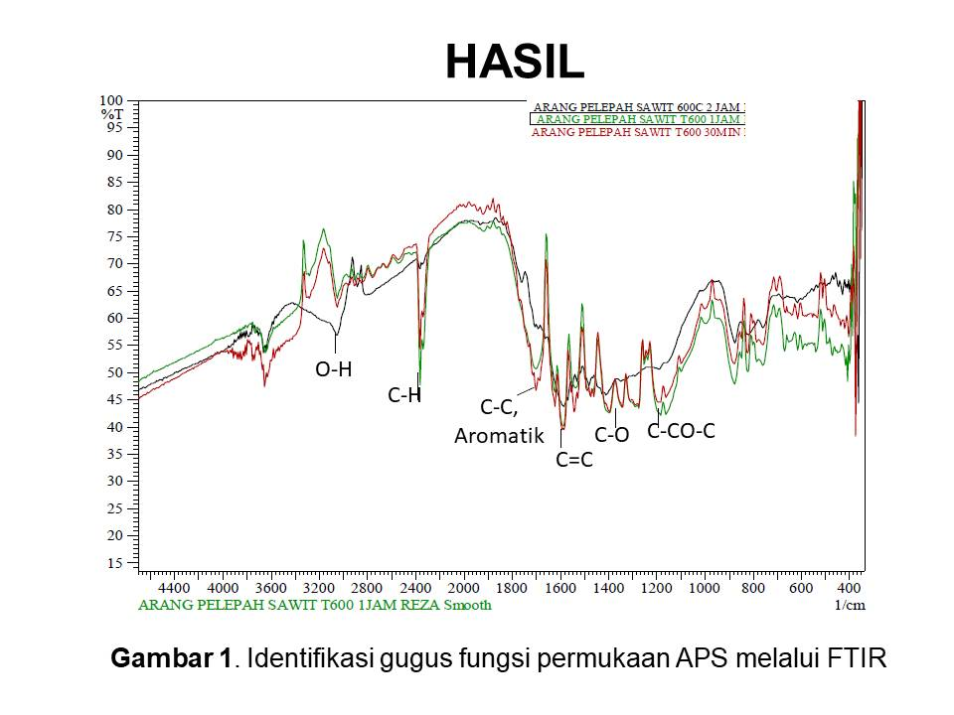

**Tabel 3**. Jenis dan jumlah situs asam pada APS

|  |  |  |  |  |
| --- | --- | --- | --- | --- |
| Jenis arang | mmol g-1 | | | |
| Karbok-  silat | Fenolat | Laktonat | Total asam |
| APS30 | 0,867 | 12,3360 | 0,7980 | 14,0010 |
| APS60 | 1,020 | 12,0010 | 0,9796 | 14,0010 |
| APS120 | 5,306 | 7,4955 | 1,0440 | 13,8455 |