EFFECT OF SALES GROWTH (SG), CASH TURN OVER (CTO) AND DIVIDEND PAYOUT RATIO (DPR) ON STOCK PRICE

Fadila Nurjanah
(Manajemen Keuangan Syariah, Universitas Islam Negeri Sunan Gunung Djati Bandung)
Email penulis: fadilanurjanah5@gmail.com
Usep Deden Suherman*
(Manajemen Keuangan Syariah, Universitas Islam Negeri Sunan Gunung Djati Bandung)
Email penulis: usepds@uinsgd.ac.id

Abstract

The capital market plays a crucial role in supporting company funding and individual investment, with stock investment being the main choice. However, complex share price fluctuations are often influenced by factors such as Sales Growth, Cash TurnOver, and the company's dividend policy. Therefore, further research needs to be carried out, especially in the context of PT Hexindo Adiperkasa Tbk. which is connected to complex industries such as mining, construction and forestry. This research aims to analyze the influence of Sales Growth (SG), Cash Turn Over (CTO), and Dividend Payout Ratio (DPR) on Stock Price at PT. Hexindo Adiperkasa Tbk during the 2013-2022 period. The research method used is descriptive with a quantitative approach, using secondary data from the company's financial reports. The research results show that there are complex fluctuations between the observed variables. Partially, Sales Growth (SG), Cash Turn Over (CTO), and Dividend Payout Ratio (DPR) do not have a significant effect on Stock Price. Likewise, simultaneously, the three of them have no significant effect on Stock Price. The implications of this research highlight the incompatibility of data with existing theory and provide insight into the factors that influence company stock prices.
Keywords: Sales Growth, Cash Turn Over, Dividend Payout Ratio, Stock Price

- Introduction
The capital market acts as an important tool in funding companies and institutions and provides opportunities for investment. Among the various investment options available, stock investment is a popular choice among the public. Shares, as a form of ownership in a company, reflect the value of the company that has made a public offering. According to Tandelilin (2018), the share price is the amount of money spent to obtain ownership rights in the company. Companies can increase their value by providing information to the public, especially in financial reports, to reduce uncertainty and increase the company's future value. Investing in stocks has the capacity to yield income for investors through dividends and capital gains. However, this investment also has risks such as capital loss and liquidation risk. Therefore, careful analysis is required before making an investment decision. This analysis involves assessing the company's fundamental performance and economic factors that influence the company's future prospects, as explained by Suyandi & Hadi (2019).
Share prices always fluctuate from time to time. Changes in share prices can be caused by various factors. According to (Darmawan, 2020), share prices can be influenced by Sales Growth. The calculation of the sales growth rate involves dividing the difference between the current year's sales and those of the prior year by the sales of the prior year. An increase in company revenue will strengthen the business foundation and increase the potential for profit growth. Investors often interpret sales growth as an indicator of business health, which is reflected in the share price. The idea proposed by Barton (1988) in Ansori, Ach, & Budi Riharjo (2020) asserts that there is a notable correlation between Sales Growth and stock prices. Specifically, an upward trend in Sales Growth leads to a corresponding rise in stock prices, whereas a decline in Sales Growth is associated with a decrease in stock prices.
Share prices can also be influenced by Cash Turn Over. Cash TurnOver reflects the company's operational efficiency and financial management policies. Cash turnover plays an important role in the financial cycle, as it helps companies identify opportunities and reduce the risk of financial crises. Harjito's theory (1994) in Kharisma & Syelma (2020) states that Cash Turnover affects stock prices, namely that an increase in Cash Turnover results in an increase in stock prices, and vice versa. Also capable of affecting share prices is a firm's dividend policy, which is determined by net profit. A high Dividend Payout Ratio (DPR) is considered positive because it indicates large cash dividends, attracts investor interest, and can increase share prices. Sartono's (1996) theory in Estiasih, Endang & Fatmawati (2020) states that DPR influences share prices: an increase in DPR causes an increase in share prices, and vice versa.
Previous research shows differences in the relationship between the Sales Growth, Cash TurnOver and Dividend Payout Ratio (DPR) variables on Stock Prices, creating a Research Gap. For example, Priandi & Rampun M (2019) and Ikayanti, Rahmatiah & Nafisah (2022) concluded that Sales Growth does not affect Stock Prices, while Octavianus & Lie Sha (2018) found a positive relationship between the two. Suryani (2022) found that Cash Turnover had no effect on Stock Prices, but research by Muhammad Syaiful (2022) showed the opposite. Likewise, Ansori, Ach, & Aziz (2022) discovered the exact opposite conclusion regarding the relationship between the Dividend Payout Ratio (DPR) and stock price, as opposed to the findings of Budi Riharjo (2020).
This research was conducted at PT Hexindo Adiperkasa Tbk. registered in the Jakarta Islamic Index for the 2013-2022 period. The company focuses on sales and distribution of heavy equipment, such as excavators, bulldozers and other construction equipment. PT Hexindo Adiperkasa has a significant role in providing heavy equipment for the mining, construction, forestry and other sectors.

Tabel 1. SG, CTO, DPR, dan Stock Price pada PT Hexindo Adiperkasa Tbk.
Periode | Sales Growth |  | Cash TurrnOver |  | Dividend Payout Ratio |  | Stock Price
Periode | % |  | % |  | % |  | Rp | %
2013 | - | 0,29 | - | 20,25 | - | 2,70 | 5.600 | 15,42 | -
2014 | ↓ | -17,14 | ↑ | 20,76 | ↑ | 7,88 | 3.930 | 10,82 | ↓
2015 | ↑ | -8,57 | ↓ | 14,17 | ↓ | 3,09 | 3.450 | 9,50 | ↓
2016 | ↓ | -41,43 | ↓ | 1,83 | ↑ | 7,10 | 1.600 | 4,41 | ↓
2017 | ↑ | 12,86 | ↑ | 5,92 | ↑ | 45,33 | 3.800 | 10,46 | ↑
2018 | ↑ | 25,71 | ↓ | 2,11 | ↓ | 4,94 | 3.000 | 8,26 | ↓
2019 | ↑ | 55,71 | ↑ | 3,61 | ↓ | 3,71 | 3.050 | 8,40 | ↑
2020 | ↓ | 7,14 | ↑ | 10,24 | ↑ | 6,02 | 2.260 | 6,22 | ↓
2021 | ↓ | -64,29 | ↓ | 2,62 | ↑ | 9,34 | 3.480 | 9,58 | ↑
2022 | ↑ | 130,00 | ↑ | 10,08 | ↑ | 9,88 | 6.150 | 16,93 | ↑
Source: Empirical data processed from the PT Annual Report. Waskita Karya, Tbk.
Information:
↑ : Experienced an increase from the previous year
↓ : Experienced a decrease from the previous year
Referring to the table above, it can be seen that Sales Growth (SG), Cash TurnOver (CTO), Dividend Payout Ratio (DPR), and Stock Price fluctuate every year. This is possible because PT Hexindo Adiperkasa depends on industries such as mining, construction and forestry, where the need for heavy equipment will depend on many influencing factors and is also very complex. Based on the description above, this research will examine the influence of Sales Growth, Cash Turnover, Dividend Payout Ratio, and Cash Turnover at PT. Hexindo Adiperkasa Tbk. registered in the Jakarta Islamic Index (JII) in the 2013-2022 period.

2. Literature Review
2.1 Sales Growth
According to Meygriza and Anneke (2019), Sales growth is increase in the number of sales from year to year or from period to period. Then Kasmir (2019) stated that sales growth shows the extent to which a company can increase its sales compared to total sales as a whole. Meanwhile, Kurniawan (2020) stated that sales growth is the company's ability to increase sales of its products in terms of increasing sales frequency or volume. From the definitions above, it can be concluded that sales growth is an increase in sales from period to period and provides guidance about performance, investment, operations, and the impact on company profitability.
The components of sales growth include important factors used in measuring a company's sales growth, including: 1) Current income, is the company's income or sales in the period being measured. These are the most recent revenue figures who want to compare with the previous period. 2) Previous year's income, which is income or sales companies in the previous period you want to compare with current income.
  - Cash Turnover
Cash TurnOver is a ratio that describes how many times cash is earned rotates over a period. According to Triwartono (2018), cash turnover is the number of times cash rotates in a certain period through sales. Kasmir (2019) states that the cash turnover ratio is a ratio to measure a company's ability to pay short-term obligations with available cash. then Rudianto (2018), cash turnover is the comparison between the number of sales and the average amount of cash. Thus, it can be concluded that cash turnover is a measure of the efficiency of using a company's cash to support sales, both in terms of cash turnover and the ability to finance sales and short-term obligations. This metric provides an overview of how well a company uses its cash for its business operations. The higher the cash turnover, the more efficient the use of cash in the company. However, if cash turnover is too high and the available working capital is too small, it can result in a shortage to meet the company's needs. On the other hand, if cash turnover is low, there will be a lot of unproductive cash and this can reduce the company's probability. Therefore, companies need to maintain a balance in cash turnover so that it is efficient and in accordance with operational needs. To calculate the Cash Turnover ratio, a comparison is made between sales and the amount of cash and cash equivalents. This ratio provides an overview of how efficient the company is in managing cash and cash equivalents to support their sales activities. By understanding these ratios, companies can evaluate the extent to which they optimize the use of their financial resources and identify opportunities to improve their operational efficiency.
2.3 Dividen Payout Ratio
The dividend payout ratio is a ratio that measures the proportion of dividends distributed to the net income of a company. According to Indriyo and Basri (2022), the Dividend Payout Ratio (DPR) is known as dividend payout ratio, is an indicator of the percentage of net profit paid as dividends and is generally expressed in percentage form. then Herry (2018), Dividend Payout Ratio (DPR) is a ratio that shows the comparison between cash dividends per share and profit per share. Meanwhile, Welas and Nugroho (2019), stated that the Dividend Payout Ratio (DPR) is a tool for measuring and comparing dividends paid with the net profit obtained and is usually presented in percentage form. According to Kasmir (2019), the Dividend Payout Ratio (DPR) is a ratio finance used to evaluate the extent to which a company distributes net profits to shareholders in the form of dividends. From these several definitions, it can be concluded that the Dividend Payout Ratio (DPR) is a ratio that measures the percentage of a company's net profit that is paid as dividends to shareholders. DPR provides an overview of how much of a company's net profit is allocated for dividend payments to shareholders, generally presented in percentage form. This allows investors and financial analysts to understand company policies regarding profit sharing and evaluate the extent to which the company distributes net profits to shareholders.
Having calculations and analysis regarding the Dividend Payout Ratio (DPR) is very useful for internal and external parties, especially investors. This can be an indicator for companies in making investment decisions, as follows:

1) To find out how much net profit is distributed as dividends;
2) A company indicator to measure dividends distributed;
3) Benchmark share prices in a company;
4) Measure dividends every year.
By knowing the dividend payout ratio, companies can provide important information for investors in making investment decisions.
  - Stock Price
Share price or share value (stock price) refers to the value of a stock shares when traded on the stock market. According to Rico Linanda (2019), the share price is the price of a share that occurs on the stock market at a certain time which is determined by market players and is determined by the demand and supply of the shares in question on the market capital. Then Wardhani (2022), share prices are prices that are formed through interactions between share sellers and buyers in every transaction that occurs on the stock market, which is based on their expectations of the company's profits. According to Tandelilin (2018), share prices are a reflection of investors' expectations regarding earnings factors, cash flow and the level of return required by investors, where these three factors are also greatly influenced by macroeconomic performance. From the definitions above, it can be concluded that share prices are values determined by the interaction of supply and demand in the stock market, reflecting investors' expectations of company performance as well as economic factors.
Share prices are the main indicator in evaluating company performance and are the basis for investors' investment decisions. Thus, a deep understanding of stock market dynamics and the factors that influence stock prices is very important for market players and investors to make smart investment decisions that have the potential to provide optimal results. Benefits of Stock Price (share price):
- As an indicator of market movements that provides information about current market conditions.
- As a reference for evaluating the performance and value of the investment portfolio to be made.
- As an indicator that shows Indonesia's economic development and has an important role in this matter.
By knowing the stock price, companies can provide important information for investors in making investment decisions.
3 Research Method
The study methodology employed is a descriptive approach utilising quantitative methods. The objective of this study is to elucidate the correlation between the independent variable and the dependent variable. The research focuses on PT. Hexindo Adiperkasa Tbk. The data source utilised is secondary data acquired from the company's official website's annual financial report. The data analysis involved the use of descriptive tests, classical assumption tests, and quantitative testing such as linear regression analysis, correlation, coefficient of determination, and significance tests. The analysis process use the SPSS programme.

4. Research Result and Discussion
4.1 Research Results
The research findings encompass a comprehensive overview and specific particulars of the data derived from the analysis conducted in the study. The findings of this research include the company profile of PT. Hexindo Adiperkasa Tbk, classic assumption analysis, descriptive analysis, quantitative analysis, and significance testing using statistical tools, namely SPSS Software for Windows V.27.
4.1.1 Classic Assumption Test
Normality test
Normal data has a significance > 0.05. The techniques used by researchers include the Normal Probability Plot and the Kolmogrov-Smirnov test table to clarify the numbers.

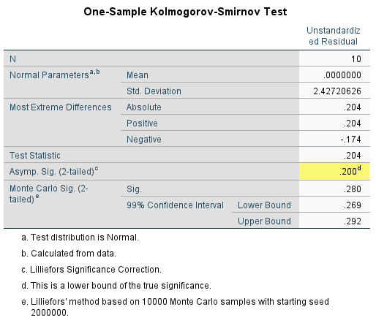
Tabel 3. Normality Test
Source: SPSS For Windows V.27.0 output data
According to the table provided, a significance value of 0.200 is greater than 0.05. The research data is considered to be regularly distributed due to the fact that the significance value is higher than 0.05. Once the normalcy test is satisfied, it is possible to proceed with regression analysis.
Test for Multicollinearity
A multicollinearity test is conducted to ascertain the presence of interrelated independent variables inside a single model. An ideal regression model should exhibit no correlation among the independent variables.
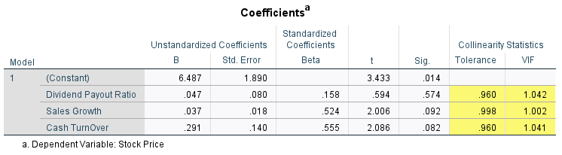
Table 4. Multicollinearity Test
Source: SPSS For Windows V.27.0 output data

It is evident from the aforementioned multicollinearity test results that the Variance Inflation Factor (VIF) Sales Growth (SG) value is 1.002, Cash TurnOver (CTO) 1.041, Dividend Payout Ratio (DPR) 1.042. Every individual variable's VIF value is below 10. Value tolerance Sales Growth (SG) 0.998, Cash TurnOver (CTO) 0.960, and Dividend Payout Ratio (DPR) 0.960. The tolerance value results for each variable are more than 0.1. This suggests that there is no correlation between the independent variables. Therefore, it may be inferred that there is no multicollinearity present and the regression model is appropriate for usage.
Auto Correlation Test
The autocorrelation test is conducted to assess the presence of a correlation between the error in one period and the error in the preceding period in the multiple linear regression model. The investigation utilised the Durbin Watson procedure as its methodology.

Tabel 5. Auto Correlation Test
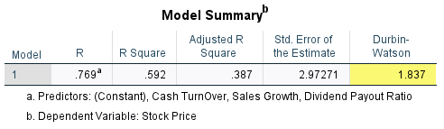
Source: SPSS For Windows V.27.0 output data
The D-W (Durbin Watson) technique can be employed to determine the presence of autocorrelation in the regression model. As stated by Singgih Santoso (2020), there are three autocorrelation criteria. The first criterion is that 1) a Durbin-Watson (D-W) value below -2 indicates the presence of positive autocorrelation, 2) A D-W score within the range of -2 to 2 indicates the absence of autocorrelation, 3) A D-W value greater than 2 indicates the presence of negative autocorrelation.
According to the table, a value of 1,837 is achieved, suggesting that the data is not affected by autocorrelation.
Heteroscedasticity Test
Researchers employed the Scatter Plot and the Glejser test to conduct the heteroscedasticity test. If all explanatory variables have a significance value (Sig.) greater than 0.05, then the regression model is deemed to be free from heteroscedasticity. The analysis findings obtained using SPSS for Windows version 27.0 validate this.
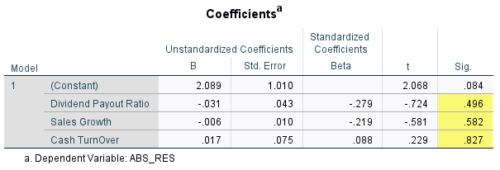
Tabel 6. Heteroscedasticity Test

Source: SPSS For Windows V.27.0 output data
From this table, the results of the heteroscedasticity test with a Sig value are obtained. for the variables Sales Growth (SG), Cash TurnOver (CTO), and Dividend Payout Ratio (DPR) are 0.582, 0.827, and 0.496 respectively, which are all greater than 0.05. This shows that the model does not experience heteroscedasticity because all variables are not significant, namely with a Sig value. greater than 0.05.
4.1.2 Descriptive Statistics
Descriptive analysis is employed to streamline the information gathered by providing a comprehensive account of the research data. It encompasses metrics such as average, total, standard deviation, variance, range, lowest, and maximum values.. The results of this descriptive analysis are also strengthened by the output from the SPSS for Windows application version 27.0.
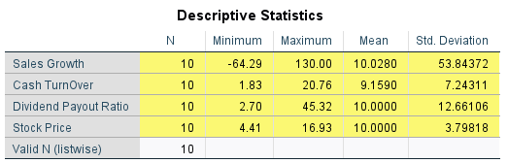
Tabel 7. Descriptive analysis
Source: SPSS For Windows V.27.0 output data

Based on this analysis, Sales Growth (SG) PT. Hexindo Adiperkasa, Tbk during 2013-2022 showed fluctuations, with a significant increase occurring in 2016 to reach 130%, while the largest decline was recorded in 2014 at -61%. Cash TurnOver (CTO) also experienced fluctuations, with a significant increase occurring in 2022 of 2.85%, while the largest decrease occurred in 2016 of -0.87%. The Dividend Payout Ratio (DPR) also shows significant variations, with the largest increase recorded in 2017 at 5.38%, while the lowest point occurred in 2013 with a value of 2.70. Stock price developments also experienced fluctuations, with the largest increase occurring in 2017 at 1.38%, and the lowest point was recorded in 2016 with a value of 4.41.
4.1.3 Quantitative Test
4.1.3.1 The Effect of Sales Growth on Stock Price at PT Hexindo Adiperkasa Tbk.
Sales growth refers to the upward trend in sales volume across consecutive time periods. and provides clues about performance, investment, operations, and the impact on company profitability. The investigation determined that there was no statistically significant relationship between sales growth and share prices of PT. Hexindo Adiperkasa, Tbk. This conclusion is substantiated by the outcomes of the Pearson Product Moment correlation test and the coefficient of determination. The conclusions are further validated by the results of a simple linear regression analysis.
Table 8. Simple Regression Test for Sales Growth on Stock Price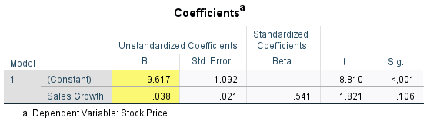
Source: SPSS For Windows V.27.0 output data
The results of manual calculations and output from data processing using the SPSS for Windows version 27.0 program, the following regression equation is obtained.
Y = a + b X₁
Stock Price = 9,617 + 0,038 Sales Growth

This equation indicates that when Sales Growth is ignored (no influence) or has a value of zero (0), the Stock Price value will remain at 9.617. A 1% rise in Sales Growth will result in an approximate 0.038 increase in Stock Price. Therefore, it may be inferred that variable X2 (Sales Growth) has a positive impact on Y (Stock Price). Next, to show the close relationship between Sales Growth and Stock Price, it will be analyzed using a statistical calculation method, namely the Pearson Product Moment correlation. These are the correlation calculation's outcomes.

Table 9. Simple Correlation Test of Stock Price on Stock Price
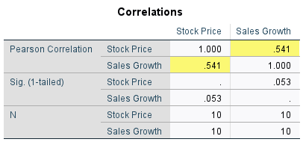

Source: SPSS For Windows V.27.0 output data

After carrying out manual calculations and analyzing the data using SPSS 27.0 software, the results showed that the correlation value (r) between Sales Growth and Stock Price was 0.541. This figure shows that there is a relationship between these two variables. With values in the interval range of 0.40 to 0.599, it can be concluded that the correlation between Sales Growth and Stock Price is at a moderate level. This indicates that changes in Sales Growth have a relevant influence on stock price movements, even though they do not reach a high level of correlation.To find out how much influence Sales Growth contributes to Stock Prices, it can be estimated using the SPSS version 27 calculation results, namely the coefficient of determination.
Table 10. Sales Growth Determination Test on Stock Price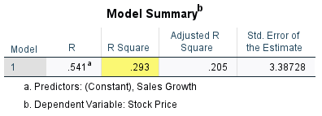
Source: SPSS For Windows V.27.0 output data

According to the calculations in the above table, the R Square value is 0.293, or 29.3% as a percentage. According to this deciding coefficient, sales growth influences stock price by 29.3%, with other factors beyond the purview of the research accounting for the remaining 70.7%.
4.1.3.2 The impact of cash turnover on PT Hexindo Adiperkasa Tbk's stock price.
A financial ratio called cash turnover assesses how rapidly a business turns cash into revenue. The analysis's findings indicate that there is no partially significant impact of Cash Turnover on Stock Price at PT. Hexindo Adiperkasa, Tbk. The following outcomes are demonstrated by the simple linear regression test:
Table 11. Simple Regression Test for Cash Turnover on Stock Price
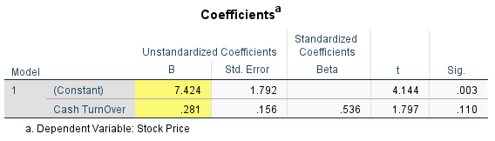

Source: SPSS For Windows V.27.0 output data
The results of manual calculations and output from data processing using the SPSS for Windows version 27.0 program, the following regression equation is obtained.
Y = a + b X₃
Stock Price= 7,424 + 0,281 Cash TurnOver
This shows that when Cash TurnOver has a value of zero, the Stock Price value remains around 7.424. If there is an increase of 1% in Cash TurnOver, then the Stock Price will also increase by around 0.281, indicating a positive influence from the variable X3 (Cash TurnOver) on Y (Stock Price). Next, to show the close relationship between Cash Turnover and Stock Price, it will be analyzed using a statistical calculation method, namely the Pearson Product Moment correlation. The findings of the correlation calculation are as follows.
Table 12. Simple Correlation Test of Cash Turnover on Stock Price
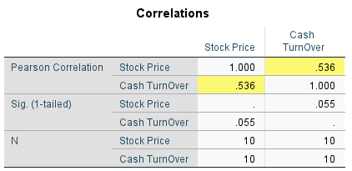

Source: SPSS For Windows V.27.0 output data

From manual calculations and data output using SPSS 27.0, the correlation value (r) for the effect of Cash Turnover on Stock Price is 0.536. This value indicates a moderate relationship, within the interval range of 0.40-0.599. To find out how much influence Cash Turnover contributes to Stock Prices, it can be estimated using the results of SPSS version 27 calculations, namely the coefficient of determination.
Table 13. Simple Determination Test of Cash Turnover on Stock Price
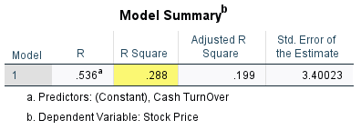

Source: SPSS For Windows V.27.0 output data
The calculations in the table show that the R Square value is 0.288, which is comparable to 28.8% when represented as a percentage. The coefficient of 28.8% quantifies the influence of Cash TurnOver on Stock Price. The remaining 71.2% of the impact on Stock Price is attributed to factors that are beyond the scope of this research.
4.1.3.3 A study examining the influence of the dividend payment ratio on the stock price of PT Hexindo Adiperkasa Tbk.
The Dividend Payout Ratio is a quantitative measure that represents the percentage of a company's profits that are distributed to shareholders as dividend payments. The analysis findings suggest that the Dividend Payout Ratio to Stock Price at PT. Hexindo Adiperkasa, Tbk. does not exhibit a statistically significant impact. The results of the simple linear regression analysis are as follows:
Table 14 Simple Regression Test for Dividend Payout Ratio on Stock Price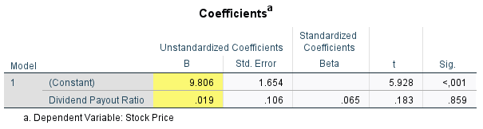
Source: SPSS For Windows V.27.0 output data

The results of manual calculations and output from data processing using the SPSS for Windows version 27.0 program, the following regression equation is obtained.
Y = a + bx1
Stock Price= 9,806 + 0,019 Dividend Payout Ratio

This equation indicates that when the Dividend Payout Ratio is ignored (no influence) or has a value of zero (0), the Stock Price value will remain at 9.806. An increase of 1% in the Dividend Payout Ratio will result in a corresponding increase of around 0.019 in the Stock Price. Therefore, it may be inferred that variable X1 (Dividend Payout Ratio) has a positive impact on Y (Stock Price). Following that, illustrate the strong correlation between the stock price and the dividend payout ratio, it will be analyzed using a statistical calculation method, namely the Pearson Product Moment correlation. The subsequent items are the outcomes of the correlation computation.

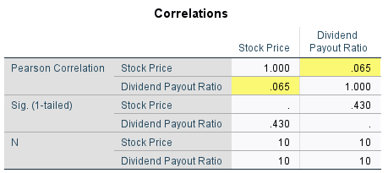
Table 15 Simple Correlation Test of Dividend Payout Ratio on Stock Price
Source: SPSS For Windows V.27.0 output data
From manual calculations and data output using SPSS 27.0, the correlation value (r) for the influence of the Dividend Payout Ratio on Stock Price is 0.065. This value indicates a very weak relationship, within the interval range of 0.00-0.199. To find out how much influence the Dividend Payout Ratio contributes to Stock Price, it can be estimated using the SPSS version 27 calculation results, namely the coefficient of determination.
Table 16 Simple Determination Test of Dividend Payout Ratio to Stock Price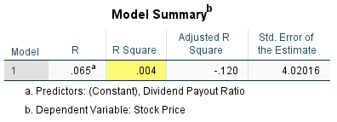
Source: SPSS For Windows V.27.0 output data

As shown in the table above, the R Square value is 0.004, which corresponds to 0.4% as a percentage. The determining coefficient denotes that the impact of the Dividend Payout Ratio on the Stock Price is 0.4%. The remaining 99.6% is attributable to extraneous factors that are beyond the purview of this study.
4.1.3.4 The influence of Sales Growth and Cash Turnover and Dividend Payout Ratio on Stock Prices
Strong sales growth can indicate the potential for higher earnings in the future, while efficient Cash TurnOver reflects a company's ability to manage its cash flow well. Investors who are looking for dividend income may find a high or consistent Dividend Payout Ratio appealing, which can therefore impact the demand for company shares. Partially, the variables of Sales Growth, Cash Turnover, and Dividend Payout Ratio do not exert a substantial influence on Stock Price. The outcomes are observable by the regression analysis, the Pearson product moment correlation test, the coefficient of determination test, and the F test. The multiple regression test yielded the following results:

Table 17 Multiple Regression of Sales Growth and Cash Turnover
and Dividend Payout Ratio on Stock Price
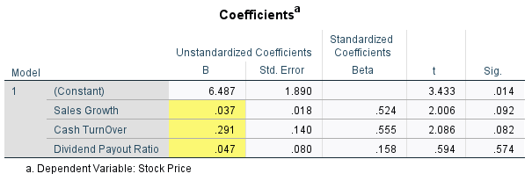
Source: SPSS For Windows V.27.0 output data
By utilising the SPSS for Windows Version 27.0 output and the outcomes of manual calculations, the following multiple regression analysis equation was derived to determine the relationship between Stock Price and Sales Growth (SG), Cash TurnOver (CTO), and Dividend Payout Ratio (DPR):
Y = a + bX₁ +Bx₂+ BX₃
Stock Price = 6,487 + 0,037X₁ + 0,29X₂ + 0,047X₃
From the equation above, we get a constant value of 6.487, which means that if Sales Growth (X1), Cash Turnover (X2), and Dividend Payout Ratio (X3) are 0 then the Stock Price (Y) is 6.487. If there is no Sales Growth (SG), Cash TurnOver (CTO), and Dividend Payout Ratio (DPR), the Y value will increase by 6.487.
The regression coefficient for the Sales Growth variable is 0.037, indicating that an increase in Sales Growth is associated with an increase in Stock Price. Similarly, the regression coefficient for the Cash TurnOver variable is 0.291, and the regression coefficient for the Dividend Payout Ratio variable is 0.047, both of which have positive values, assuming that if Sales Growth, Cash Turnover and Dividend Payout Ratio have increased, so Stock Prices tend to increase. Then, to show the close relationship between Sales Growth (SG), Cash TurnOver (CTO), and Dividend Payout Ratio (DPR) on Stock Price, it will then be analyzed using a statistical calculation method, namely correlation.
Table 18 Multiple Correlation of Sales Growth and Cash Turnover and Dividend Payout Ratio on Stock Price
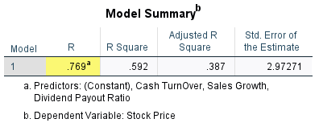

Source: SPSS For Windows V.27.0 output data
The table reveals a correlation coefficient of 0.769 between Sales Growth, Cash TurnOver, and Dividend Payout Ratio. This figure is in the range of 0.60-0.799, illustrating that the relationship between Sales Growth, Cash TurnOver and Dividend Payout Ratio on Stock Price can be considered "strong," indicating a positive or unidirectional influence. This means that increasing the values of Sales Growth, Cash TurnOver and Dividend Payout Ratio will likely have an impact on increasing Stock Prices. Based on the previous correlation test, it is established that the r value is 0.808. The impact of Sales Growth, Cash Turnover, and Dividend Payout Ratio on Stock Price can be determined by analyzing the calculation results obtained using SPSS version 27.
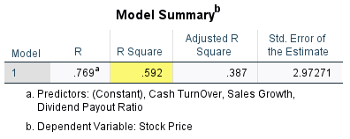
Table 19. Multiple Determination of Sales Growth and Cash Turnover and Dividend Payout Ratio to Stock Price
Source: SPSS For Windows V.27.0 output data

Based on manual calculations and using the SPSS version 27.0 program, an R Square value of 0.592 or 59.2% was obtained, which shows the large influence of Sales Growth, Cash Turnover and Dividend Payout Ratio on Stock Price. These results show that changes in Stock Price can be influenced by Sales Growth, Cash Turnover and Dividend Payout Ratio by 59.2%, Meanwhile, the remaining 40.8% is impacted by several factors.

4.1.4 Significance Test
4.1.4.1 The impact of sales growth on stock price is just partial.
The t test was used to examine the specific impact of Sales Growth on Stock Price, and the following results were obtained:

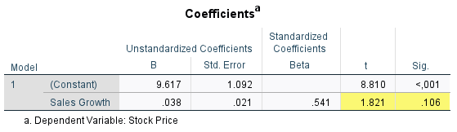
Tabel 20. T Test
Source: SPSS For Windows V.27.0 output data

The table above displays the results of the t-test computation, namely the tcount value of 1.821 and the ttable value of 2.364, as described in the t column of the table. . Because the value of tcount < ttable (1.821 < 2.364), and Based on the significance value, the coefficient table shows a significance value of 0.106, which is greater than 0.05. Therefore, we accept the null hypothesis (H0) and reject the alternative hypothesis (H1). This implies that there is no significant relationship between Sales Growth and Stock Price at PT. Hexindo Adiperkasa Tbk. Moreover, the statistical analysis indicates that there is no substantial impact of Sales Growth (SG) on the share price of PT. Hexindo Adiperkasa, Tbk. 2013-2022. Investors are paying more attention to profitability and sustainability of company profits. Without adequate profit margins, SG has limited impact on share value and price. Cost analysis, efficiency, pricing strategy, and market expectations need to be considered.
4.1.4.2 The impact of partial cash turnover on stock prices
The t test was used to acquire the results for determining the partial effect of Cash Turnover on Stock Price.

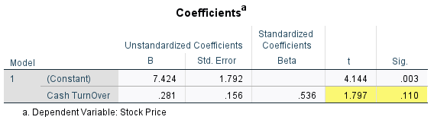
Table 21. Cash Turnover T Test on Stock Price
Source: SPSS For Windows V.27.0 output data

The table above displays the results of the t-test computation, namely the tcount value of 1.797 and the ttable value of 2.364, as indicated in the t column of the table. Since the value of tcount (1.797) is less than ttable (2.364), and considering the significance value from the coefficients table, we obtain a significance value of 0.110 which is greater than 0.05. If H0 is accepted and H1 is refused, it indicates that there is no statistically significant relationship between Cash Turnover and Stock Price at PT. Hexindo Adiperkasa Tbk. High CTO does not always reflect optimal efficiency in the company's financial structure; reliance on debt can influence investors' financial risk perceptions. External factors such as regulations or global market conditions must also be considered. In dynamic or high-risk business environments, investors may give priority to factors other than CTO.
4.1.4.3 The impact of a partial dividend payout ratio on the stock price.
The t test was used to determine the specific impact of the Dividend Payout Ratio on Stock Price, and the following results were obtained:

Table 22. Dividend Payout Ratio T Test on Stock Price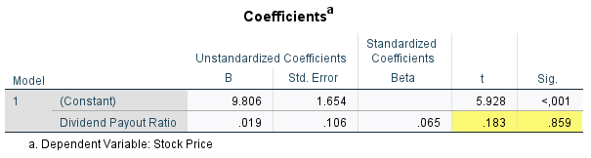
The data output is sourced from SPSS For Windows V.27.0. The table above displays the results of the t-test computation, namely the tcount value of 0.183 and the ttable value of 2.364, as described in the t column of the table. Since the value of tcount (0.183) is less than the value of ttable (2.364), and the significance value (0.859) obtained from the coefficients table is more than 0.05, we may conclude that there is no significant relationship. If H0 is accepted and H1 is rejected, it indicates that there is no statistically significant relationship between the Dividend Payout Ratio and Stock Price at PT. Hexindo Adiperkasa Tbk. The influence of DPR on share prices is not always significant due to various considerations. Market expectations of dividends can influence their impact. In addition, company growth, potential capital gains, and reinvestment policies also influence shareholders' assessment of investments.
The Simultaneous Influence of Sales Growth and Cash Turnover and Calculating the Dividend Payout Ratio for Stock Prices. An F test was conducted to examine the combined impact of Sales Growth, Cash Turnover, and Dividend Payout Ratio. The F test results indicate:
Table 23. F Test Sales Growth and Cash Turnover and Dividend Payout Ratio against Stock Price
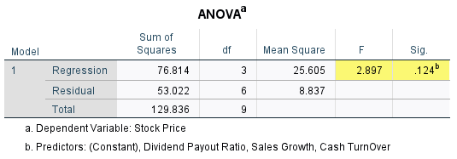

Source: SPSS For Windows V.27.0 output data
According to the computation provided, the Fcount value is 2.897, and the resultant Ftable value is 4.74. Based on the comparison of 2.897 < 4.74 and a significance value of 0.124 > 0.05, we can infer that the null hypothesis (H0) is accepted and the alternative hypothesis (H1) is rejected. Collectively, Sales Growth, Cash Turnover, and Dividend Payout Ratio lack a substantial impact on Stock Price. The statistical research indicates that Sales Growth, Cash Turnover, and Dividend Payout Ratio do not together exert a substantial influence on Investor Share Prices at PT. Hexindo Adiperkasa, Tbk. during the 2013-2022 period. This lack of influence is influenced by a number of complex factors, both internal and external to the company. The importance of synergy between these three factors is clear; an imbalance between them can reduce their overall impact. For example, when there is high sales growth but Cash Turnover efficiency is low, the positive impact is reduced. Dividend policies that are inconsistent with the company's growth strategy can also affect the influence of all three. External factors such as global market conditions and industry developments also play a role; in times of uncertainty or structural challenges, the combination of these three factors may not provide significant increases in share prices.
Discussion
Influence of Sales Growth (SG) on Stock Price
Based on statistical calculations, partial Sales Growth (SG) does not have a significant influence on Stock Price for Investors at PT. Hexindo Adiperkasa, Tbk. Period 2013-2022. One critical aspect that needs to be taken into account is the company's profitability. Although Sales Growth is important, investors are often more interested in a company's ability to generate sustainable profits. If Sales Growth is not matched by good profit margins, its positive impact on company value and, ultimately, share price, may be limited. Therefore, it is necessary to carry out a thorough analysis of the company's cost structure, operational efficiency and pricing strategy to understand whether Sales Growth can make a meaningful contribution to profitability.
Market expectations and investor behavior are also important elements that need to be taken into account. If the market has anticipated Sales Growth and has reflected it in share prices, its impact may have been reflected beforehand and therefore would not have provided a significant spike in share prices when Sales Growth actually occurred. Overall, in-depth research into why Sales Growth does not always have a significant effect on stock prices requires a holistic approach involving analysis of the company's internal, external factors, and market expectations. The results of this research are supported by previous research conducted by Priandi & Rumpun M (2019), and Ikayanti, Rahmatiah & Nafisah (2022) which said that there was no significant influence between Sales Growth (SG) on Stock Price. However, the results of this research contradict research conducted by Octavianus & Lie Sha (2018), and Ansori, Ach, & Budi Riharjo (2020) which shows that Sales Growth (SG) has a significant positive effect on Stock Price.
Effect of Cash Turnover (CTO) on Stock Price
Based on statistical calculations, partial Cash Turnover (CTO) does not have a significant influence on Stock Prices for Investors at PT. Hexindo Adiperkasa, Tbk. For the 2013-2022 period, the minimal impact of Cash Turnover on a company's share price involves an in-depth understanding of the variables that moderate the relationship between the two.
Although Cash Turnover is considered an indicator of efficiency in managing liquidity, sometimes its impact on share prices is not as great as anticipated. First of all, it should be noted that high Cash Turnover does not always reflect optimal efficiency in the company's financial structure. If a company finances its operations through debt or other external financing, this can distort investors' perception of risk financial, even though Cash Turnover looks high. Furthermore, external factors such as changes in regulations or global market conditions need to be identified in relation to the impact of Cash Turnover. If a company operates in a dynamic, high-risk environment, investors may be less inclined to assess Cash Turnover as a major factor which affects share prices. Market perception and investor behavior are also critical aspects explains the minimal influence of Cash Turnover on share prices. If the market already anticipates the company's cash efficiency level, or if investors tend to focus more on other factors such as innovation or revenue growth, then this can obscure or reduce the sensitivity of the significance of the direct influence between Cash Turnover on Stock Price.
The results of this research are supported by previous research conducted by Priandi & Rumpun M (2019), and Ikayanti, Rahmatiah & Nafisah (2022) which said that there is no significant influence between Cash Turnover (CTO) on Stock Price. However, the results of this research contradict research conducted by Octavianus & Lie Sha (2018), and Ansori, Ach, & Budi Riharjo (2020) shows that Cash Turnover (CTO) has a significant positive effect on Stock Price
The Effect of Dividend Payout Ratio (DPR) on Stock Prices
Based on statistical calculations, partially the Dividend Payout Ratio (DPR) does not have a significant influence on the Stock Price for Investors at PT. Hexindo Adiperkasa, Tbk. For the 2013-2022 period, the lack of significant influence of the Dividend Payout Ratio on share prices requires careful analysis of a number of variables and factors that can moderate the relationship between the two. Dividend Payout Ratio, as an indicator of how much of a company's net profit is distributed to shareholders in the form of dividends, does not always have a striking impact on share prices for various reasons. One aspect that is worth paying attention to is market expectations for dividends. If the market has reflected certain expectations regarding dividends in share prices, a company's decision to pay dividends in line with or even exceeding the anticipated payout ratio may not result in a significant price spike. Not only that, shareholders may also assess the value of their investment by considering other factors besides dividends. If the company is able to show impressive growth, potential high capital gains, or a promising reinvestment strategy, then shareholders may be more motivated by long-term prospects than by the size of dividends received.
Internal aspects of the company can also influence the relationship between the Dividend Payout Ratio and share prices. If a company is facing promising investment projects and requires substantial funding sources, high dividend payments may be considered a barrier to growth and less desirable by investors who prefer a profit reinvestment policy.It is also important to highlight that economic and market conditions can also play a significant role in moderating this relationship. In times of economic uncertainty, investors may be more likely to prioritize safety and capital growth over dividends when they evaluate potential investments.The results of this research are supported by previous research conducted by Octavianus & Lie Sha (2018), Priandi & Rumpun M (2019), Ansori, Ach, & Budi Riharjo (2020) which said that there was no significant influence between the Dividend Payout Ratio (DPR) to Stock Price. However, the results of this research contradict research conducted by Estiasih & Fatmawati (2020) which shows that the Dividend Payout Ratio (DPR) has a significant positive effect on Stock Price.

Influence of Sales Growth (SG), Cash Turnover (CTO), and Dividends Payout Ratio (DPR) simultaneously to Stock Price
Based on statistical calculations, simultaneously Sales Growth, Cash Turnover, and Dividend Payout Ratio do not have a significant influence on Stock Price for Investors at PT. Hexindo Adiperkasa, Tbk. For the 2013-2022 period, the lack of significant influence of Sales Growth, Cash Turnover, and Dividend Payout Ratio on share prices simultaneously could be caused by various complex factors involving the company's internal and external dynamics. One aspect that needs to be considered is the synergy between these three factors. If the three do not support each other or even conflict,the effect on share prices may not be as great as expected.
First, when Sales Growth increases, but efficiency in Cash Turnover decreases, the positive impact of sales growth can be reduced. For example, if a company faces an increase in receivables or inventory that is disproportionate to the increase in sales, this can reduce cash flow and hinder overall financial performance. Thus, an unbalanced relationship between Sales Growth and Cash Turnover can contribute to the minimal influence on share prices. Apart from that, a dividend policy that is less coherent with the company's growth strategy can also influence the influence of all three on share prices. If a company chooses to pay high dividends, while at the same time trying to experience high growth aggressive, this can cause uncertainty and worry among investors. They may prefer companies that decide to retain most of their profits to support further investment.
External factors such as global market conditions and industrial developments also play a role in explaining the minimal simultaneous influence of these three variables. If the market is experiencing uncertainty or the industry is facing structural challenges, then even a combination of high Sales Growth, efficient Cash Turnover, and optimal Dividend Payout Ratio may not provide a significant increase in share prices. The results of this research are supported by previous research conducted Priandi & Rumpun M (2019) who said that simultaneously there is no significant influence between Sales Growth, Cash Turnover and Dividend Payout Ratio on Stock Price.

5. Conclusion
Sales Growth (SG) has an insignificant impact on share prices. The correlation coefficient between SG and Stock Price is 0.541, indicating a moderate relationship. However, the results of the significance test show tcount < ttable, namely 1.821 < 2.364, which indicates that the influence of SG on stock prices is not significant. A similar thing also happened to Cash Turnover (CTO), where the correlation coefficient was 0.536, but the results of the significance test showed tcount < ttable, namely 1.797 < 2.364. Meanwhile, the Dividend Payout Ratio (DPR) shows a very weak relationship with a correlation coefficient of 0.065, and the results of the significance test also show tcount < ttable, namely 0.183 < 2.364. When the three were tested simultaneously, a correlation coefficient of 0.769 was found, indicating a strong relationship with Stock Price. However, the results of the significance test show tcount < ttable, namely 2.897 < 4.74, with a significance value of 0.124 > 0.05, which shows that the influence of the three together on stock prices is not significant. This shows that the company's performance in terms of sales growth, cash management efficiency and dividend policy does not always have the expected impact in increasing share prices significantly.

Referensi
Aminah. (2018). Analisis Tingkat Pertumbuhan Penjualan. Jurnal Ekonomi dan Bisnis.
Aziz, I. A. (2022). Pengaruh Cash TurnOver dan Dividend Payout Ratio terhadap Harga Saham pada Sektor Farmasi yang terdaftar di BEI Tahun 2018-2022. Jurnal Ekonomi dan Kebijakan.
Ansori, F., Ach., & Budi Riharjo, I. (2020). Pengaruh Rasio Keuangan, Sales Growth dan Dividend Payout Ratio terhadap Perubahan Harga Saham. Jurnal Ilmiah Akuntansi dan Keuangan.
Baridwan, Z. (2021). Intermediate Accounting, Edisi Kesembilan. . Yogyakarta: BPFE.
Darmawan, D. (2020). Manajemen Keuangan (Memahami Kebijakan Dividen, Teori dan Praktiknya di Indonesia. FEBI UIN Sunan Kalijaga, 319.
Estiasih, S. P., E. P., & Fatmawati, Y. (2020). Dividend Payout Ratio, Earning Per Share, Debt To Equity Ratio Terhadap Harga Saham pada Perusahaan LQ45. Jurnal Akuntansi dan Pajak, 205-212.
Friska, Y. (2020). Pengaruh Kebijakan Hutang, Earning Per Share, Net Profit Margin Dan Profitabilitas Terhadap Dividend Payout Ratio Pada Perusahaan yang Terdaftar Di LQ45 Periode 2010-2019. Jurnal Akuntansi dan Keuangan
Handayani, W. (2020). Konsep Dasar Investasi dan Pasar Modal. Akuntansi dan Ekonomi Bisnis Islam.

Herry. (2018). Analisis Laporan Keuangan Cetakan ke 3. Yogyakarta: CAPS (Center for Academic Publishing Service)

Indriyo Gitusudarmo, A., & Basri. (2022). Manajemen Keuangan. Yogyakarta: BPFE

Ikayanti, U., rahmatiah, N., & Nafisah. (2022). Pengaruh Sales Growth dan Return on Investment (ROI) secara bersama-sama terhadap harga saham pada PT. Gudang Garam, Tbk. . Jurnal Dimensi.

Kasmir. (2019). Analisa Laporan Keuangan. Jakarta: Rajagrafindo Persada.

Kurniawan, andika (2018) pengaruh sales growth, price earning ratio (per), dan return on equity (roe) terhadap return saham pada perusahaan semen yang terdaftar di bursa efek indonesia tahun 2012-2016. Thesis, universitas muria kudus.

Kharisma, F., & Syelma, S. (2020). Pengaruh Cash Turnover Ratio terhadap Harga Saham Pada Perusahaan Costumer Goods ysng tercatat di BEI. Borneo Student Research, 2721-5725.

Linanda, R. (2019). Pengaruh Struktur Modal dan Profitabilitas terhadap Harga Saham. Jurnal Ekonomi dan Bisnis

Muhammad Syaiful, R. (2022). Pengaruh Return On Asset (ROA) dan Cash Turnover (CTO) terhadap Harga Saham pada Perusahaan Transportasi yang terdaftar di BEI Tahun 2018-2020. Retrieved from https://repository.unipasby.ac.id/id/eprint/43

Meygriza, C., & Anneke, W. (2019). Pengaruh Sales Growth dan Firm Size terhadap Nilai Perusahaan pada Perusahaan Makanan dan Minuman yang terdaftar di Bursa Efek Indonesia. EMBA, 3039-3048.

Octavianus, I., & Lie Sha, T. (2018). Pengaruh ROA, CR, Sales Growth, dan DPR terhadap Perusahaan Manufaktur. Multiparadigma Akuntansi, 30-37.
Priandi, & Rampun M, S. (2019). Analisis Pengaruh Sales Growth dan Dividend Payout Ratio terhadap perubahan harga saham LQ45. Jurnal Kompetensi Manajemen Bisnis, 21-45.
Rudianto. (2018). Akuntansi Intermediate. Jakarta. Jakarta: Erlangga.

Sartono, A. (2010). Manajemen Keuangan Teori dan Aplikasi. Yogyakarta: BPFE.
Suryani, S. (2022). Pengaruh Sales Growth dan Cash TurnOver terhadap Stock Price pada Sektor Konstruksi. Jurnal Akuntansi dan Keuangan Syariah Indonesia.
Suyandi, & Hadi. (2019). Analisis Motivasi Dan Pengetahuan Investasi Terhadap Minat Investasi Mahasiswa di Pasar Modal. Edunomic Jurnal Pendidikan Ekonomi, 108.
Tandelilin. (2018). Manajemen Portofolio dan Investasi. Yogyakarta. PT. Kanisius
Triwartono. (2018). Pengaruh Modal Kerja Dan Perputaran Kas Terhadap Return On Assets (ROA) Pada PT. Indofarma (Persero), Tbk. UNIKOM
Wardhani. (2022). Pengantar Pengetahuan Pasar Modal,Edisi Keenam. STIE GICI BUSINESS SCHOOL
Welas, & Nugroho, S. Y. (2019). Analisis Faktor-Faktor Yang Mempengaruhi Kebijakan Dividen. AKURASI: Jurnal Riset Akuntansi Dan Keuangan, 43-45.

