**Interview Data**

1. **Informant Data**

Name : M. Kautsar Zamzami, S.Pd

Gender : Man

Section : Curriculum Section of Miftahul Huda Islamic Boarding School Malang

Education : Bachelor of education

Interview time : 8 April 2023

Location : Miftahul Huda Gading Islamic Boarding School Malang

1. **Interview result**

|  |  |  |
| --- | --- | --- |
| **No** | **Question** | **Answer** |
| 1 | What is the tarekat taught in this pesantren? | The tarekat taught by this pesantren is the Qodiriyah wa Naqsabandiyah tarekat |
| 2 | How is the practice of this tarekat pesantren? | Usually here dhikr*Laa ilaaha illallah*165 times after praying and manaqiban every 11th qomariyah |
| 3 | How is the Formal and Non-Formal Learning Curriculum at the Miftahul Huda Gading Malang Islamic Boarding School? | The formal curriculum here is carried out every after evening. There are three levels of Ula, Wustho and Ulya. As for non-formal, it is carried out outside the mandatory lessons, namely sunnah recitation after asr. |
| 4 | How important is the tarekat in this pesantren? | Here the emphasis is on essence, sharia and Sufism. The cleric said that taking the Order is obligatory. |
| 5 | What is the history and development of the Tarekat in the Miftahul Huda Gading Islamic Boarding School in Malang? | For a complete history, see the book Lantern Life and Struggle of Kiai Yahya |
| 6 | How is the Integration of Tarekat Teachings in the Islamic Education Curriculum at the Gading Islamic Boarding School in Malang? | For integration, the teachings of this tarekat are carried out by students outside of formal education. Like dhikr*Laa ilahaillallah*as much as165 times after the obligatory prayers, especially on Friday afternoons and Sunday afternoons, as well as manaqiban on the 11th of the lunar month. |
| 7 | What are the subjects in Miftahul Huda Gading Islamic Boarding School? | I'll give you the schedule later |
| 8 | What are the subjects related to Sufism in this pesantren? | There is kifayatul Atqiya and Nashoihud'diniyyah |
| 9 | Are all students here obliged to practice the tarekat? | Not mandatory |
| 10 | When are students required to attend? | Santri are required to take orders after graduating from the pesantren |
| 11 | How are the daily activities of the students of this Islamic boarding school? | The activities of the students get up before dawn, then at dawn the congregation. After that, the reading of Yasin Fadhilah continued with the Fajr recitation. Until 6 o'clock. Until Ashar there was no activity. After ashar there is a sunnah recitation. Namely the study of hadith. For mandatory activities after evening and dawn. So the implementation of formal madrasah diniyah after isya. After maghrib is usually filled by recitation caretakers. After the evening recitation, there are activities depending on each complex, usually there is a deliberation on the science of fiqh. Every Thursday night there is a recitation of solawat in each complex such as solawat burdah, sibdu durror and barjan. |
| 12 | What is the practice of the tarekat that must be carried out by the students of this Islamic boarding school? | Dhikr Laa ilaahaillaallah 165 times after noon. |
| 13 | What is the relationship between pesantren and society? | Many members of the community also take part in the congregation and even often ask for solutions to the problems they are facing. There are also many people who take part in special activities, namely practicing the dhikr of the tarekat together*Qodiriyah wa Naqsabandiyah.* |

**Genealogy of Kiai Yahya's Mursyid Certificate**

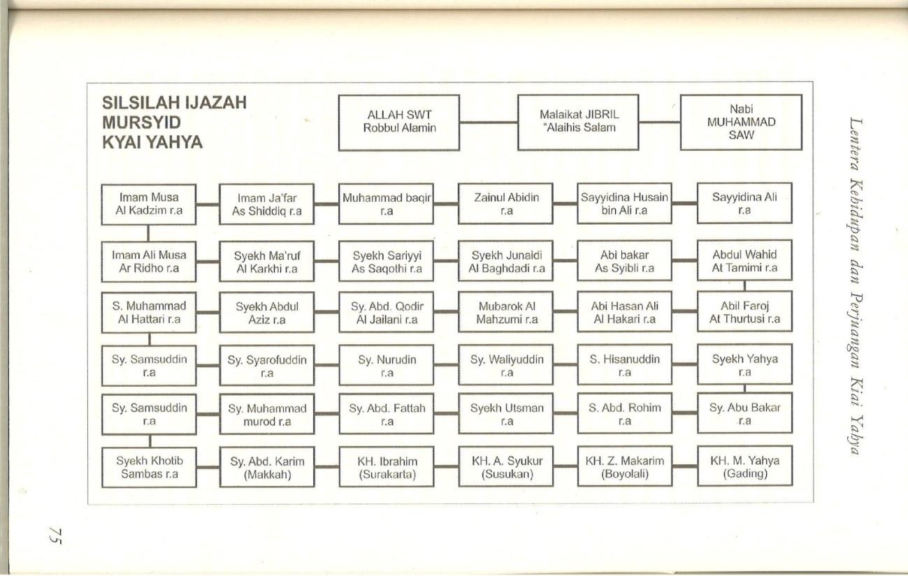

**The subjects in this pesantren**

**Table 1. Ula Level Subjects (Basic Level Education)**

|  |  |  |  |
| --- | --- | --- | --- |
| Ula I | Red II | Red III | Ula IV |
| Reading the Quran and Prayers. | Imla' wrote Arabic, Tajwid (Tuhfatul Athfal), Fiqh (Safinatun Najah Java), History (Khulasoh Nurul Yaqin). | Tajwid (Jazariyah), Fiqh (Safinatun Najah), Tawhid (Aqidatul Awam), Sharaf (Al-Amtsilatu at-Tashrifiyyah), Practice reading the Qur'an (Juz amma). | Fiqh (Sullamutaufiq), Tauhid (Bad'ul Amali), Sharaf (Al-Amtsilatu at-Tashrifiyyah), Nahwu (Jurumiyah). |

**Table 2. Wustho Level Subjects (Middle Level Education)**

|  |  |  |
| --- | --- | --- |
| Wustho I | Wustho II | Wustho 3 |
| Nahwu (Imriti I), Sharaf (Kailani), Fiqh (Fathul Qarib I), Tafsir (al-Jalalain), Hadith (Abi Jamroh), Arabic (Al-Arabiyah I). | Nahwu (Imriti II), I'rab (Qawaidul I'rob), Fiqh (Fathul Qarib II), Tafsir (al-Jalalain II), Hadith (Bulughul Maram I), Arabic (Al-Arabiyyah II). | Nahwu (Fathu Robbil Bariyyah), Balaghoh (Qowaidul Lughoh al-Arabiyyah), Fiqh (Syawir Fathul Qorib), Tasir (Al-Jalalain III), Hadith (Bulughul Maram II), Faraidh (Syarah Nadhom Ar Rohbiyyah). |

**Table 3. Ulya Level Subjects (Upper Level Education)**

|  |  |  |
| --- | --- | --- |
| Ulya I | Ulya II | Ulya III |
| Fiqh (Fathul Muin I), Ushulul Fiqih (Al-Mabadiul Awwaliyah), Nahwu (Alfiyyah Ibnu Aqil), Tauhid (Ummul Barahin). | Fiqh (Fathul Muin II), Ushul Fiqh (Faraidhul Bahiyyah), Nahwu (Alfiyyah Ibnu Aqil), Knowledge of Hadith (Manhaj Dzawin Nadhzor), Tauhid (Ummul Barahin). | Fiqh (Fathul Muin III), Nahwu (Alfiyyah Ibnu Aqil), Hisab (Sullamun Nayyiroin), Arudh (Mukhtar as-syafi), Balaghoh (Jauharul Makmun) |

**Schedule of Sunnah or non-formal recitation of the Miftahul Huda Gading Islamic Boarding School in Malang**

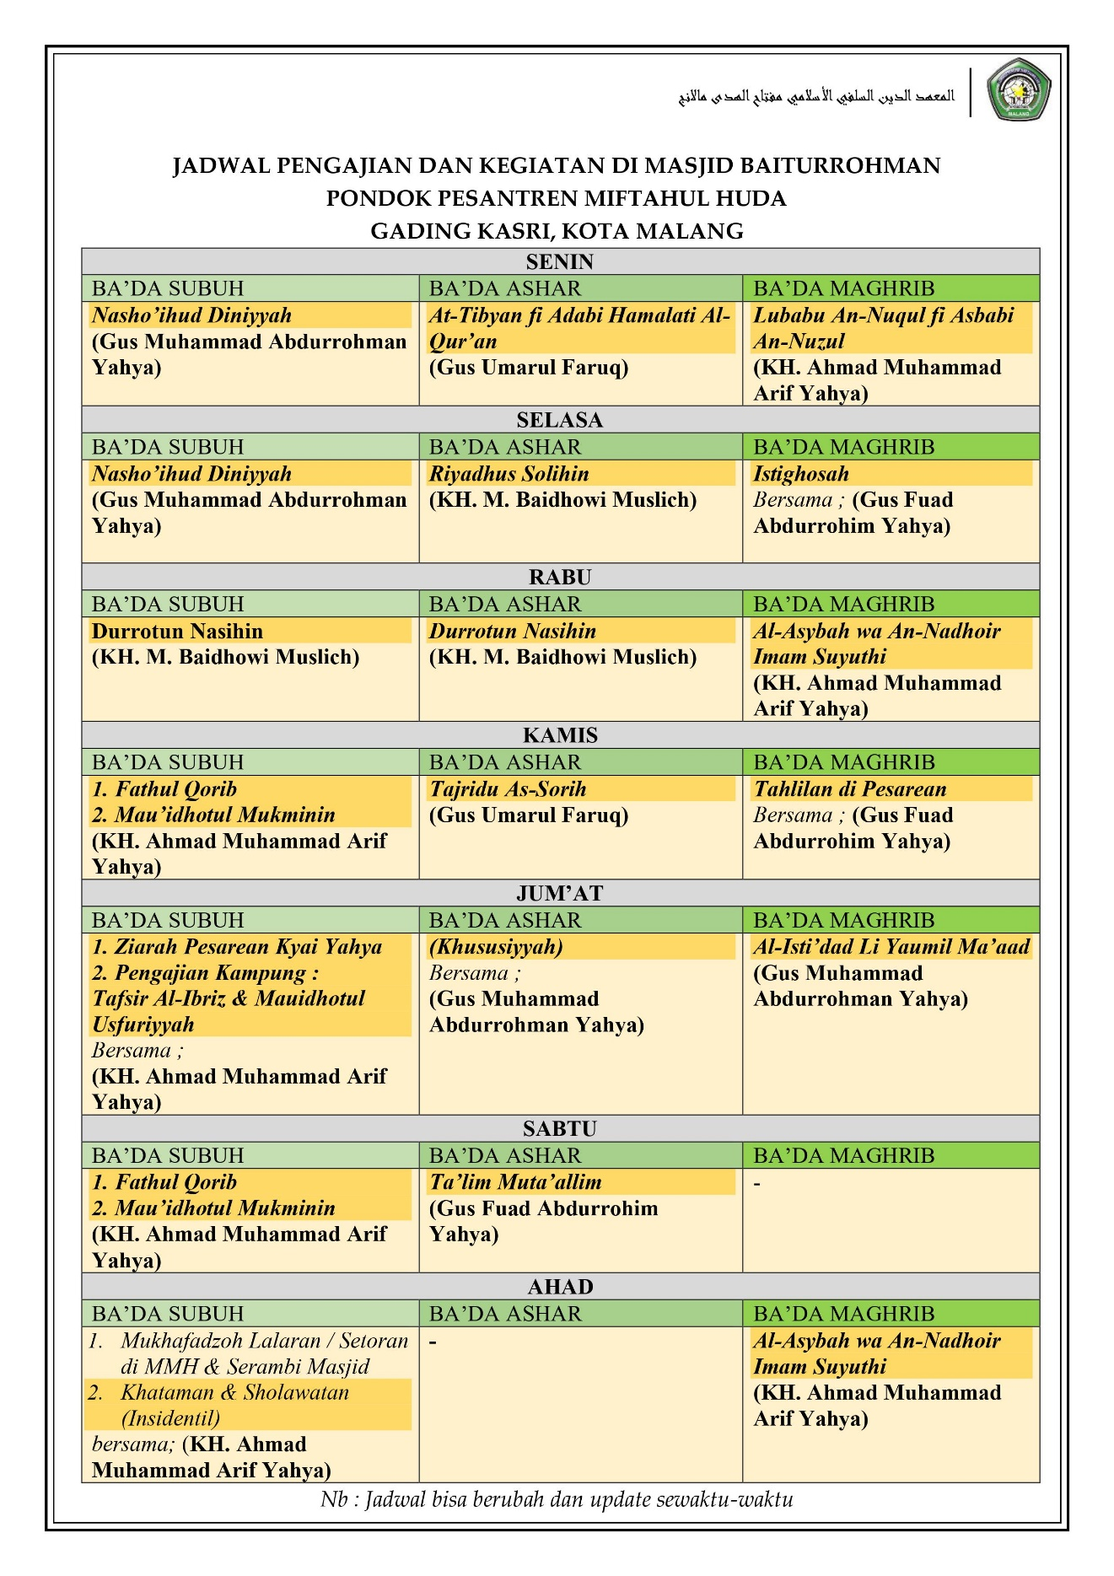

1. **Documentation**

