**STATISTIC GRAPHICS**

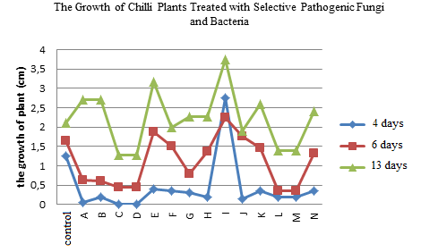

Figure 6. The chart of the growth of chilli seeds treated with selective pathogenic fungi and bacteria

**PHOTO**

|  |  |  |  |  |
| --- | --- | --- | --- | --- |
| **Figure 1**. A red chili infected with a pathogenic fungus | **Figure 2**. Pathogenic fungi isolate from infected chilies | | **Figure 3**. Spore of *Fusarium oxysporum* (Magnification 100x) | |
| **Figure 4.** The absence of a clear zone | | | **Figure 5**. isolate have a clear zone | |

**TABLE**

Table 1.The result of observations single isolates

| **Isolate name** | **Color of colony** | **Colony Morfology** | **Surface** | **Gram** | **Cell Morfology** |
| --- | --- | --- | --- | --- | --- |
| A | White (opaque) | Round shaped | Flat |  | Bacil |
| B | Pink | Irregular | Flat | - | Coccus |
| C | Red | Irregular | Flat | - | Coccus |
| D | Red | Irregular | Convex | - | Coccus |
| E | White (opaque) | Round shaped | Convex | - | Bacil |
| F | White | Irregular | Flat | - | Coccus |
| G | Yellow | Irregular | Flat | - | Bacil |
| H | White | Round shaped | Flat | - | Bacil |
| I | White | Round shaped | Convex | - | Coccus |
| J | White (opaque) | Round shaped | Flat | - | Bacil |
| K | White (opaque) | Irregular | Flat | - | Bacil |
| L | White (opaque) | Irregular | Flat | + | Bacil |
| M | White (opaque) | Irregular | Flat | + | Bacil |
| N | White (opaque) | Round shaped | Convex | - | Bacil |