PHOTO 2

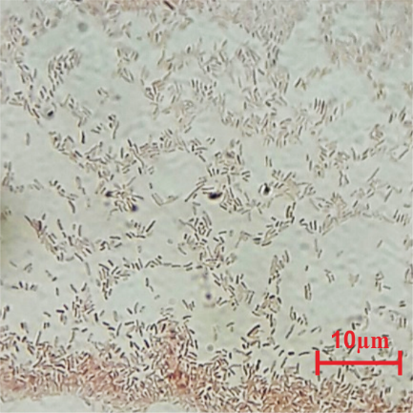  Figure 7a. Azotobacter sp. | 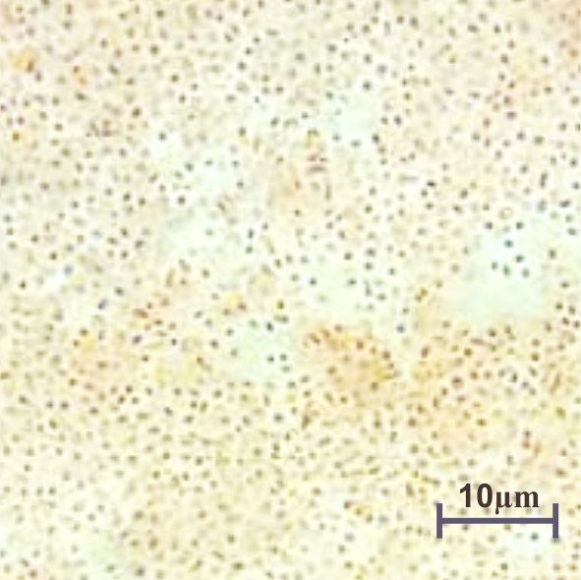  Figure 7b. Azospirillum sp. | 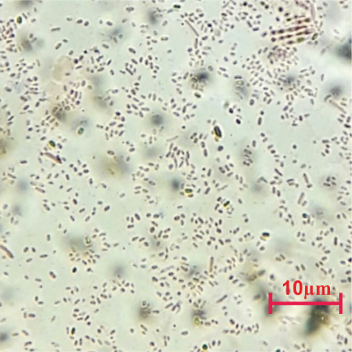  Figure 7c. Pseudomonas sp.
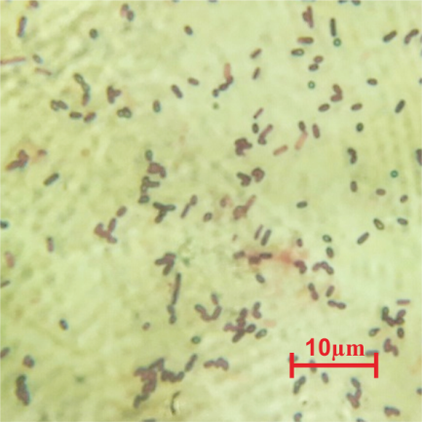  Figure 7d. Serratia sp. | 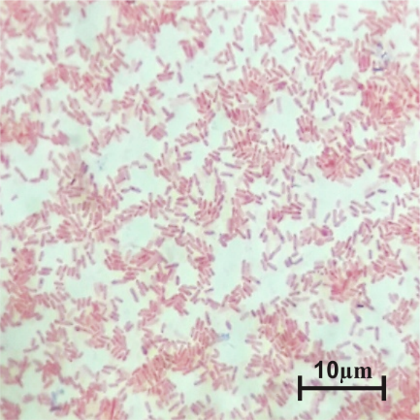  Figure 7e. Beijerinckia sp.

