Figure:
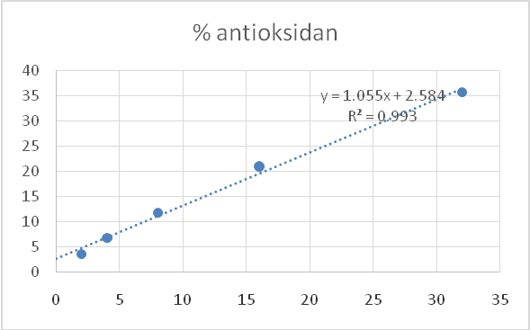  Maceration extract simplicia methanol solvent | 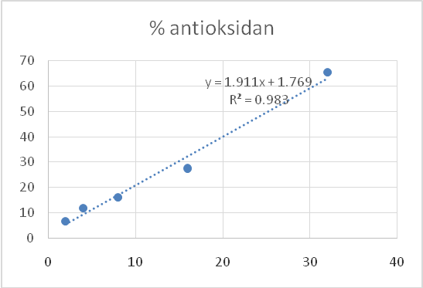  Fresh maceration methanol solvent
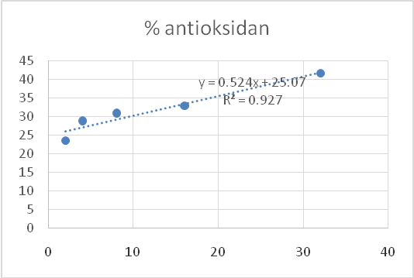  Maceration extract simplicia ethanol solvent | 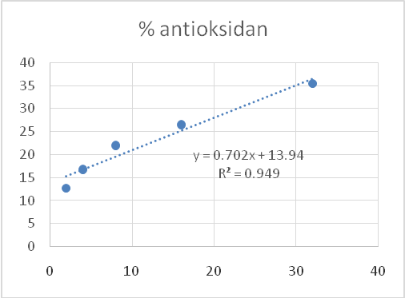  Ascorbic acid (control)

Figure 1. The relationship curve % of antioxidant activity in the various extract of pomegranate, figs, grapes, and olive

Tables:

Table 1. Phytochemistry test methanol extract of pomegranate, grape, fig, and olive
No | Test | Result | Standard
1 | Alkaloid test | Green (-) | White sediment (Mayer)  Yellow-red sediment (Dragendorff)
2 | Polyphenol test | Blackish blue (+) | Red, green, purple or deep black
3 | Flavonoid test | Orange (++) | Red, yellow or orange
4 | Saponin test | There is no foam (-) | A stable foam form
5 | Tanin test | Blue (+) | Blackish blue
6 | Steroid/  Triterpenoid test | Blue-green (+)  Black- blue (-) | Blue or green  Red or purple

Table 2. The IC50 extract of pomegranate, grape, fig, and olive in the different solvent
Type of extract | Line Equation | Y value | X value or IC50
Maceration extract simplicia methanol solvent | y = 1.055x + 2.5847 | 50 | 44.94
Fresh maceration methanol solvent | y = 0.5922x + 19.214 | 50 | 25.22
Maceration extract simplicia ethanol solvent | y=0.524x + 25.07 | 50 | 47.54
Ascorbic acid (control) | y=0.702x + 13.94 | 50 | 51.33

Table 3. Antioxidant activity based on IC50 value
IC50 | Antioxidant Activity
< 50 ppm | Very strong
50 – 100 ppm | Strong
100 – 150 ppm | Medium
150 – 200 ppm | Weak

