REGRESSION

/DESCRIPTIVES MEAN STDDEV CORR SIG N

/MISSING LISTWISE

/STATISTICS COEFF OUTS R ANOVA COLLIN TOL CHANGE ZPP

/CRITERIA=PIN(.05) POUT(.10)

/NOORIGIN

/DEPENDENT Kinerja_Perusahaan

/METHOD=ENTER ESOP.

**Regression**

|  |  |  |
| --- | --- | --- |
| **Notes** | | |
| Output Created | | 04-MAY-2021 00:59:23 |
| Comments | |  |
| Input | Active Dataset | DataSet0 |
| Filter | <none> |
| Weight | <none> |
| Split File | <none> |
| N of Rows in Working Data File | 8 |
| Missing Value Handling | Definition of Missing | User-defined missing values are treated as missing. |
| Cases Used | Statistics are based on cases with no missing values for any variable used. |
| Syntax | | REGRESSION  /DESCRIPTIVES MEAN STDDEV CORR SIG N  /MISSING LISTWISE  /STATISTICS COEFF OUTS R ANOVA COLLIN TOL CHANGE ZPP  /CRITERIA=PIN(.05) POUT(.10)  /NOORIGIN  /DEPENDENT Kinerja_Perusahaan  /METHOD=ENTER ESOP. |
| Resources | Processor Time | 00:00:00,03 |
| Elapsed Time | 00:00:00,16 |
| Memory Required | 2448 bytes |
| Additional Memory Required for Residual Plots | 0 bytes |

|  |  |  |  |
| --- | --- | --- | --- |
| **Descriptive Statistics** | | | |
|  | Mean | Std. Deviation | N |
| Kinerja_Perusahaan | 2.47500 | 2.493277 | 8 |
| ESOP | .01288 | .012609 | 8 |

|  |  |  |  |
| --- | --- | --- | --- |
| **Correlations** | | | |
|  | | Kinerja_Perusahaan | ESOP |
| Pearson Correlation | Kinerja_Perusahaan | 1.000 | .708 |
| ESOP | .708 | 1.000 |
| Sig. (1-tailed) | Kinerja_Perusahaan | . | .025 |
| ESOP | .025 | . |
| N | Kinerja_Perusahaan | 8 | 8 |
| ESOP | 8 | 8 |

|  |  |  |  |
| --- | --- | --- | --- |
| **Variables Entered/Removeda** | | | |
| Model | Variables Entered | Variables Removed | Method |
| 1 | ESOPb | . | Enter |

|  |
| --- |
| a. Dependent Variable: Kinerja_Perusahaan |
| b. All requested variables entered. |

|  |  |  |  |  |  |  |  |  |  |
| --- | --- | --- | --- | --- | --- | --- | --- | --- | --- |
| **Model Summary** | | | | | | | | | |
| Model | R | R Square | Adjusted R Square | Std. Error of the Estimate | Change Statistics | |  |  |  |
| R Square Change | F Change |  |  |  |
| 1 | .708a | .501 | .418 | 1.902207 | .501 | 6.026 |  |  |  |

|  |  |  |  |
| --- | --- | --- | --- |
| **Model Summary** | | | |
| Model | Change Statistics | | |
| df1 | df2 | Sig. F Change |
| 1 | 1 | 6 | .049 |

|  |
| --- |
| a. Predictors: (Constant), ESOP |

|  |  |  |  |  |  |  |
| --- | --- | --- | --- | --- | --- | --- |
| **ANOVAa** | | | | | | |
| Model | | Sum of Squares | df | Mean Square | F | Sig. |
| 1 | Regression | 21.805 | 1 | 21.805 | 6.026 | .049b |
| Residual | 21.710 | 6 | 3.618 |  |  |
| Total | 43.515 | 7 |  |  |  |

|  |
| --- |
| a. Dependent Variable: Kinerja_Perusahaan |
| b. Predictors: (Constant), ESOP |

|  |  |  |  |  |  |  |  |  |  |  |  |
| --- | --- | --- | --- | --- | --- | --- | --- | --- | --- | --- | --- |
| **Coefficientsa** | | | | | | | | | | | |
| Model | | Unstandardized Coefficients | | Standardized Coefficients | t | Sig. |  |  |  |  |  |
| B | Std. Error | Beta |  |  |  |  |  |
| 1 | (Constant) | .673 | .996 |  | .676 | .524 |  |  |  |  |  |
| ESOP | 139.975 | 57.021 | .708 | 2.455 | .049 |  |  |  |  |  |

|  |  |  |  |  |  |  |
| --- | --- | --- | --- | --- | --- | --- |
| **Coefficientsa** | | | | | | |
| Model | | Correlations | | | Collinearity Statistics | |
| Zero-order | Partial | Part | Tolerance | VIF |
| 1 | (Constant) |  |  |  |  |  |
| ESOP | .708 | .708 | .708 | 1.000 | 1.000 |

|  |
| --- |
| a. Dependent Variable: Kinerja_Perusahaan |

|  |  |  |  |  |  |
| --- | --- | --- | --- | --- | --- |
| **Collinearity Diagnosticsa** | | | | | |
| Model | Dimension | Eigenvalue | Condition Index | Variance Proportions | |
| (Constant) | ESOP |
| 1 | 1 | 1.737 | 1.000 | .13 | .13 |
| 2 | .263 | 2.572 | .87 | .87 |

|  |
| --- |
| a. Dependent Variable: Kinerja_Perusahaan |

REGRESSION

/DESCRIPTIVES MEAN STDDEV CORR SIG N

/MISSING LISTWISE

/STATISTICS COEFF OUTS R ANOVA COLLIN TOL CHANGE ZPP

/CRITERIA=PIN(.05) POUT(.10)

/NOORIGIN

/DEPENDENT Kinerja_Perusahaan

/METHOD=ENTER FAI.

**Regression**

|  |  |  |
| --- | --- | --- |
| **Notes** | | |
| Output Created | | 04-MAY-2021 00:59:46 |
| Comments | |  |
| Input | Active Dataset | DataSet0 |
| Filter | <none> |
| Weight | <none> |
| Split File | <none> |
| N of Rows in Working Data File | 8 |
| Missing Value Handling | Definition of Missing | User-defined missing values are treated as missing. |
| Cases Used | Statistics are based on cases with no missing values for any variable used. |
| Syntax | | REGRESSION  /DESCRIPTIVES MEAN STDDEV CORR SIG N  /MISSING LISTWISE  /STATISTICS COEFF OUTS R ANOVA COLLIN TOL CHANGE ZPP  /CRITERIA=PIN(.05) POUT(.10)  /NOORIGIN  /DEPENDENT Kinerja_Perusahaan  /METHOD=ENTER FAI. |
| Resources | Processor Time | 00:00:00,03 |
| Elapsed Time | 00:00:00,03 |
| Memory Required | 2448 bytes |
| Additional Memory Required for Residual Plots | 0 bytes |

|  |  |  |  |
| --- | --- | --- | --- |
| **Descriptive Statistics** | | | |
|  | Mean | Std. Deviation | N |
| Kinerja_Perusahaan | 2.47500 | 2.493277 | 8 |
| FAI | 46.72413 | 6.500492 | 8 |

|  |  |  |  |
| --- | --- | --- | --- |
| **Correlations** | | | |
|  | | Kinerja_Perusahaan | FAI |
| Pearson Correlation | Kinerja_Perusahaan | 1.000 | .588 |
| FAI | .588 | 1.000 |
| Sig. (1-tailed) | Kinerja_Perusahaan | . | .063 |
| FAI | .063 | . |
| N | Kinerja_Perusahaan | 8 | 8 |
| FAI | 8 | 8 |

|  |  |  |  |
| --- | --- | --- | --- |
| **Variables Entered/Removeda** | | | |
| Model | Variables Entered | Variables Removed | Method |
| 1 | FAIb | . | Enter |

|  |
| --- |
| a. Dependent Variable: Kinerja_Perusahaan |
| b. All requested variables entered. |

|  |  |  |  |  |  |  |  |  |  |
| --- | --- | --- | --- | --- | --- | --- | --- | --- | --- |
| **Model Summary** | | | | | | | | | |
| Model | R | R Square | Adjusted R Square | Std. Error of the Estimate | Change Statistics | |  |  |  |
| R Square Change | F Change |  |  |  |
| 1 | .588a | .345 | .236 | 2.178812 | .345 | 3.166 |  |  |  |

|  |  |  |  |
| --- | --- | --- | --- |
| **Model Summary** | | | |
| Model | Change Statistics | | |
| df1 | df2 | Sig. F Change |
| 1 | 1 | 6 | .125 |

|  |
| --- |
| a. Predictors: (Constant), FAI |

|  |  |  |  |  |  |  |
| --- | --- | --- | --- | --- | --- | --- |
| **ANOVAa** | | | | | | |
| Model | | Sum of Squares | df | Mean Square | F | Sig. |
| 1 | Regression | 15.032 | 1 | 15.032 | 3.166 | .125b |
| Residual | 28.483 | 6 | 4.747 |  |  |
| Total | 43.515 | 7 |  |  |  |

|  |
| --- |
| a. Dependent Variable: Kinerja_Perusahaan |
| b. Predictors: (Constant), FAI |

|  |  |  |  |  |  |  |  |  |  |  |  |
| --- | --- | --- | --- | --- | --- | --- | --- | --- | --- | --- | --- |
| **Coefficientsa** | | | | | | | | | | | |
| Model | | Unstandardized Coefficients | | Standardized Coefficients | t | Sig. |  |  |  |  |  |
| B | Std. Error | Beta |  |  |  |  |  |
| 1 | (Constant) | -8.058 | 5.969 |  | -1.350 | .226 |  |  |  |  |  |
| FAI | .225 | .127 | .588 | 1.779 | .125 |  |  |  |  |  |

|  |  |  |  |  |  |  |
| --- | --- | --- | --- | --- | --- | --- |
| **Coefficientsa** | | | | | | |
| Model | | Correlations | | | Collinearity Statistics | |
| Zero-order | Partial | Part | Tolerance | VIF |
| 1 | (Constant) |  |  |  |  |  |
| FAI | .588 | .588 | .588 | 1.000 | 1.000 |

|  |
| --- |
| a. Dependent Variable: Kinerja_Perusahaan |

|  |  |  |  |  |  |
| --- | --- | --- | --- | --- | --- |
| **Collinearity Diagnosticsa** | | | | | |
| Model | Dimension | Eigenvalue | Condition Index | Variance Proportions | |
| (Constant) | FAI |
| 1 | 1 | 1.992 | 1.000 | .00 | .00 |
| 2 | .008 | 15.433 | 1.00 | 1.00 |

|  |
| --- |
| a. Dependent Variable: Kinerja_Perusahaan |

REGRESSION

/DESCRIPTIVES MEAN STDDEV CORR SIG N

/MISSING LISTWISE

/STATISTICS COEFF OUTS R ANOVA COLLIN TOL CHANGE ZPP

/CRITERIA=PIN(.05) POUT(.10)

/NOORIGIN

/DEPENDENT Kinerja_Perusahaan

/METHOD=ENTER ESOP FAI

/SCATTERPLOT=(*SRESID ,*ZRESID)

/RESIDUALS DURBIN HISTOGRAM(ZRESID) NORMPROB(ZRESID)

/SAVE RESID.

**Regression**

|  |  |  |
| --- | --- | --- |
| **Notes** | | |
| Output Created | | 04-MAY-2021 01:00:46 |
| Comments | |  |
| Input | Active Dataset | DataSet0 |
| Filter | <none> |
| Weight | <none> |
| Split File | <none> |
| N of Rows in Working Data File | 8 |
| Missing Value Handling | Definition of Missing | User-defined missing values are treated as missing. |
| Cases Used | Statistics are based on cases with no missing values for any variable used. |
| Syntax | | REGRESSION  /DESCRIPTIVES MEAN STDDEV CORR SIG N  /MISSING LISTWISE  /STATISTICS COEFF OUTS R ANOVA COLLIN TOL CHANGE ZPP  /CRITERIA=PIN(.05) POUT(.10)  /NOORIGIN  /DEPENDENT Kinerja_Perusahaan  /METHOD=ENTER ESOP FAI  /SCATTERPLOT=(*SRESID ,*ZRESID)  /RESIDUALS DURBIN HISTOGRAM(ZRESID) NORMPROB(ZRESID)  /SAVE RESID. |
| Resources | Processor Time | 00:00:05,55 |
| Elapsed Time | 00:00:28,73 |
| Memory Required | 2912 bytes |
| Additional Memory Required for Residual Plots | 664 bytes |
| Variables Created or Modified | RES_1 | Unstandardized Residual |

|  |  |  |  |
| --- | --- | --- | --- |
| **Descriptive Statistics** | | | |
|  | Mean | Std. Deviation | N |
| Kinerja_Perusahaan | 2.47500 | 2.493277 | 8 |
| ESOP | .01288 | .012609 | 8 |
| FAI | 46.72413 | 6.500492 | 8 |

|  |  |  |  |  |
| --- | --- | --- | --- | --- |
| **Correlations** | | | | |
|  | | Kinerja_Perusahaan | ESOP | FAI |
| Pearson Correlation | Kinerja_Perusahaan | 1.000 | .708 | .588 |
| ESOP | .708 | 1.000 | .775 |
| FAI | .588 | .775 | 1.000 |
| Sig. (1-tailed) | Kinerja_Perusahaan | . | .025 | .063 |
| ESOP | .025 | . | .012 |
| FAI | .063 | .012 | . |
| N | Kinerja_Perusahaan | 8 | 8 | 8 |
| ESOP | 8 | 8 | 8 |
| FAI | 8 | 8 | 8 |

|  |  |  |  |
| --- | --- | --- | --- |
| **Variables Entered/Removeda** | | | |
| Model | Variables Entered | Variables Removed | Method |
| 1 | FAI, ESOPb | . | Enter |

|  |
| --- |
| a. Dependent Variable: Kinerja_Perusahaan |
| b. All requested variables entered. |

|  |  |  |  |  |  |  |  |  |  |  |
| --- | --- | --- | --- | --- | --- | --- | --- | --- | --- | --- |
| **Model Summaryb** | | | | | | | | | | |
| Model | R | R Square | Adjusted R Square | Std. Error of the Estimate | Change Statistics | |  |  |  |  |
| R Square Change | F Change |  |  |  |  |
| 1 | .711a | .505 | .307 | 2.075717 | .505 | 2.550 |  |  |  |  |

|  |  |  |  |  |
| --- | --- | --- | --- | --- |
| **Model Summaryb** | | | | |
| Model | Change Statistics | | | |
| df1 | df2 | Sig. F Change |  |
| 1 | 2 | 5 | .172 | 2.207 |

|  |
| --- |
| a. Predictors: (Constant), FAI, ESOP |
| b. Dependent Variable: Kinerja_Perusahaan |

|  |  |  |  |  |  |  |
| --- | --- | --- | --- | --- | --- | --- |
| **ANOVAa** | | | | | | |
| Model | | Sum of Squares | df | Mean Square | F | Sig. |
| 1 | Regression | 21.972 | 2 | 10.986 | 2.550 | .172b |
| Residual | 21.543 | 5 | 4.309 |  |  |
| Total | 43.515 | 7 |  |  |  |

|  |
| --- |
| a. Dependent Variable: Kinerja_Perusahaan |
| b. Predictors: (Constant), FAI, ESOP |

|  |  |  |  |  |  |  |  |  |  |  |  |
| --- | --- | --- | --- | --- | --- | --- | --- | --- | --- | --- | --- |
| **Coefficientsa** | | | | | | | | | | | |
| Model | | Unstandardized Coefficients | | Standardized Coefficients | t | Sig. |  |  |  |  |  |
| B | Std. Error | Beta |  |  |  |  |  |
| 1 | (Constant) | -.892 | 8.014 |  | -.111 | .916 |  |  |  |  |  |
| ESOP | 124.941 | 98.443 | .632 | 1.269 | .260 |  |  |  |  |  |
| FAI | .038 | .191 | .098 | .197 | .852 |  |  |  |  |  |

|  |  |  |  |  |  |  |
| --- | --- | --- | --- | --- | --- | --- |
| **Coefficientsa** | | | | | | |
| Model | | Correlations | | | Collinearity Statistics | |
| Zero-order | Partial | Part | Tolerance | VIF |
| 1 | (Constant) |  |  |  |  |  |
| ESOP | .708 | .494 | .399 | .400 | 2.503 |
| FAI | .588 | .088 | .062 | .400 | 2.503 |

|  |
| --- |
| a. Dependent Variable: Kinerja_Perusahaan |

|  |  |  |  |  |  |  |
| --- | --- | --- | --- | --- | --- | --- |
| **Collinearity Diagnosticsa** | | | | | | |
| Model | Dimension | Eigenvalue | Condition Index | Variance Proportions | | |
| (Constant) | ESOP | FAI |
| 1 | 1 | 2.690 | 1.000 | .00 | .02 | .00 |
| 2 | .306 | 2.964 | .01 | .41 | .00 |
| 3 | .004 | 27.019 | .99 | .57 | 1.00 |

|  |
| --- |
| a. Dependent Variable: Kinerja_Perusahaan |

|  |  |  |  |  |  |
| --- | --- | --- | --- | --- | --- |
| **Residuals Statisticsa** | | | | | |
|  | Minimum | Maximum | Mean | Std. Deviation | N |
| Predicted Value | .60800 | 5.19754 | 2.47500 | 1.771682 | 8 |
| Std. Predicted Value | -1.054 | 1.537 | .000 | 1.000 | 8 |
| Standard Error of Predicted Value | .850 | 2.014 | 1.226 | .360 | 8 |
| Adjusted Predicted Value | -8.92433 | 4.48110 | 1.18089 | 4.386577 | 8 |
| Residual | -2.355224 | 2.984838 | .000000 | 1.754301 | 8 |
| Std. Residual | -1.135 | 1.438 | .000 | .845 | 8 |
| Stud. Residual | -1.350 | 1.721 | .131 | 1.085 | 8 |
| Deleted Residual | -3.335982 | 10.124334 | 1.294110 | 4.348434 | 8 |
| Stud. Deleted Residual | -1.515 | 2.412 | .194 | 1.289 | 8 |
| Mahal. Distance | .299 | 5.716 | 1.750 | 1.719 | 8 |
| Cook's Distance | .000 | 7.466 | 1.060 | 2.593 | 8 |
| Centered Leverage Value | .043 | .817 | .250 | .246 | 8 |

|  |
| --- |
| a. Dependent Variable: Kinerja_Perusahaan |

**Charts**

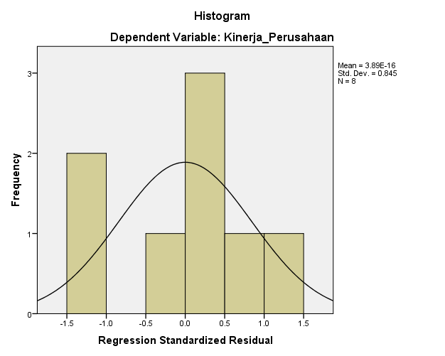

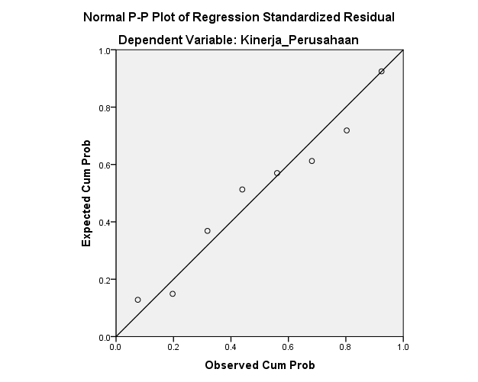

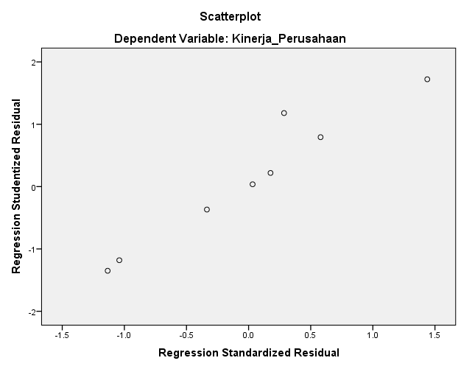

NPAR TESTS

/RUNS(MEDIAN)=RES_1

/MISSING ANALYSIS.

**NPar Tests**

|  |  |  |
| --- | --- | --- |
| **Notes** | | |
| Output Created | | 04-MAY-2021 01:02:06 |
| Comments | |  |
| Input | Active Dataset | DataSet0 |
| Filter | <none> |
| Weight | <none> |
| Split File | <none> |
| N of Rows in Working Data File | 8 |
| Missing Value Handling | Definition of Missing | User-defined missing values are treated as missing. |
| Cases Used | Statistics for each test are based on all cases with valid data for the variable(s) used in that test. |
| Syntax | | NPAR TESTS  /RUNS(MEDIAN)=RES_1  /MISSING ANALYSIS. |
| Resources | Processor Time | 00:00:00,02 |
| Elapsed Time | 00:00:00,16 |
| Number of Cases Alloweda | 786432 |

|  |
| --- |
| a. Based on availability of workspace memory. |

|  |  |
| --- | --- |
| **Runs Test** | |
|  | Unstandardized Residual |
| Test Valuea | .21646 |
| Cases < Test Value | 4 |
| Cases >= Test Value | 4 |
| Total Cases | 8 |
| Number of Runs | 4 |
| Z | -.382 |
| Asymp. Sig. (2-tailed) | .703 |

|  |
| --- |
| a. Median |

NPAR TESTS

/K-S(NORMAL)=RES_1

/MISSING ANALYSIS.

**NPar Tests**

|  |  |  |
| --- | --- | --- |
| **Notes** | | |
| Output Created | | 04-MAY-2021 01:02:27 |
| Comments | |  |
| Input | Active Dataset | DataSet0 |
| Filter | <none> |
| Weight | <none> |
| Split File | <none> |
| N of Rows in Working Data File | 8 |
| Missing Value Handling | Definition of Missing | User-defined missing values are treated as missing. |
| Cases Used | Statistics for each test are based on all cases with valid data for the variable(s) used in that test. |
| Syntax | | NPAR TESTS  /K-S(NORMAL)=RES_1  /MISSING ANALYSIS. |
| Resources | Processor Time | 00:00:00,00 |
| Elapsed Time | 00:00:00,10 |
| Number of Cases Alloweda | 786432 |

|  |
| --- |
| a. Based on availability of workspace memory. |

|  |  |  |
| --- | --- | --- |
| **One-Sample Kolmogorov-Smirnov Test** | | |
|  | | Unstandardized Residual |
| N | | 8 |
| Normal Parametersa,b | Mean | .0000000 |
| Std. Deviation | 1.75430068 |
| Most Extreme Differences | Absolute | .141 |
| Positive | .141 |
| Negative | -.140 |
| Test Statistic | | .141 |
| Asymp. Sig. (2-tailed) | | .200c,d |

|  |
| --- |
| a. Test distribution is Normal. |
| b. Calculated from data. |
| c. Lilliefors Significance Correction. |
| d. This is a lower bound of the true significance. |