SAGO PALM BIODIVERSITY at THE SERAM ISLAND
MALUKU PROVINCE, INDONESIA
by
Samin Botanri¹⁾, Dede Setiadi²⁾, Edi Guhardja³⁾, Ibnul Qayim⁴⁾,
and Lilik B. Prasetyo⁵⁾
¹⁾Lecturer at Agriculture Faculty, University of Darussalam Ambon
²⁾Professor at Departement of Biology NMF BAU
³⁾Professor (Emeritus) at Departement of Biology NMF BAU
⁴⁾Lecturer at Departement of Biology NMF BAU
⁵⁾Professor at Departement of CFR and Ecoexcursion Forestry Faculty BAU

ABSTRACT
Current issue about the emergence of biodiversity of sagu palm in Province of Maluku rises up a warm debate especially related to the amount of the sagu palm species. Aiming to go deeper on this matter, the research is conducted to clarify clearly the species of sagu palm cultivation in The Seram Island Province of Maluku. The research was conducted during the period of Mart to November 2009 in three sample regions namely Luhu of Seram Bagian Barat (SBB) distric, Sawai of Maluku Tengah (MT) distric, and Werinama of Seram Bagian Timur (SBT) distric. Analysis of genetic was done at the laboratory of plant biology Inter Center University (ICU) Bogor Agriculture University. Variety of palm sagu was approached closely using community similarity analysis popularly known as Index of Variety Shannon-Wiener (H’). Further, the genetic analysis using isozim method showed that sagu community in Seram Island shared community similarity included index value ranging from 60,66 – 80,92 %. Based on the test result index of Shannon-Wiener (H’), index variety analysis in all of cultivation phases of sagu palm community in Seram Island generally was indicated a very low H’ value ranging from 0,61 – 0,90. Clearly, the genetic analysis also illustrated there were only two kinds of sagu species in Seram Island namely M. rumphii Mart. M. sagus Rottb. The first species consists of three varieties mentioned as : 1) variety of microcanthum Becc., 2) sylvestre Becc., and 3) rotang Becc. On the other side, sagu species of M. sagu Rottb. has solely one variety which is molat Becc. Here, variety of microcanthum is divided by two kinds of variety namely tuni and makanaro.

Key words : Biodiversity, Metroxylon, community, species, and genetic.

INTRODUCTION
Biodiversity calls for all the living species on the earth including not only flora, fauna, fungi and microorganism but also all the genetic materials that these living species and ecology sistem variety bring on their living place as well. Kartono (2008) describes biodiversity has three levels namely: a). Biodiversity of genetic, referring to genetic information existed individually b). Biodiversity of species, explaining the amount of living species in a certain place, and c). Biodiversity of ecosystem, illustrating the habitat variety, biological community, and ecology processes existed in some specific ecosystems.
Related to the biodiversity of sagu palm, according to biodiversity of sagu palm based on Beccari (1918 in Flach, 1997), he argues that genus of Metroxylonhas two groups. Moreover he also mentiones that sagu palm has two groups. The first one goes to the sagu palm having row scales of fruit peel as many as 18 which then grouped in Eumetroxylon. Another one sets up for the amount of row scales of fruit peel ranging from 24-29 catagorized into Coelococcus. The first class or group called Eumetroxylon has two species stated as: Metroxylon sagu Rottb. and Metroxylon rumphii Mart. While the second class namely Coelococcus consists of seven species namely: M. squarosum Becc., M. warburgii Heim., M. upoluense Becc., M. vitiense Benth et Hook, M. amicarum Becc., M. salomonense Becc., and M. bougainvillense Becc.
According to Heyne (1950 in Notohadiprawiro dan Louhenapessy,1993) he defines that sagu palm is the genuine sagu included in genus of Metroxylon. This genuine sagu is then catagorized into two main groups based on the availability thorn in the leaf stem. The first group defined as thorny palm covers M. rumphii Mart as the main species in this group and the other species still included in this class are the species called as M. longispinum Mart., M. microcanthum Mart., and M. sylvestre Mart. Standing on another species which doesnt have thorn is M. sagu Rottb called as the main one with various forms.
McClatchey et al. (2006) conducts a botanical description on sagu palm genus of Metroxylon and further divides it into six species namely 1). M. amicarum (H.Wendland) Beccari, 2). M. Paulcoxii McClatchey, 3). M. sagu Rottboell, 4). M. salomonense (Warburg) Beccari, 5). M. vitiense (H. Wendland) H. Wendland ex Bentham & Hooker f., and 6).M. warburgii (Heim) Beccari. The spreading region of this various sagu palms covers South east Asia, Melanesia, and some islands in Micronesia and Polynesia. Based on the spreading of sagu palm map illustrated by Mc Clatchey it is clear that Indonesia, PNG, and part of islands in South Philliphin has solely one species of sagu palm namely M. sagu Rottb.
From the book written by Louhenapessy (2006), Bintoro (2008), and Rostiwati et al. (2008) it has been found that Maluku island has five kinds of sagu palms namely: 1). Metroxylon rumphii Mart. (sagu tuni), 2). M. sagu Rottb. (molat),3). M. Sylvestre Mart. (ihur), 4). M. longispinum Mart. (makanaru), and 5). M. microcanthum Mart. (duri rotan). Various persoectives given by various scholars above depicts some pros and cons toward the amount of sagu palm. That is why another scientific research is considered necessary to clarify the exact amount of sagu palm species cultivation in Province of Maluku especially in Seram Island. This scientific research is then aimed to clarify the sagu palm species cultivated in Seram Island Maluku Province

MATERIAL AND METHOD

Time and Place of Research
The research was conducted in Seram Island which is known as the biggest island in Maluku Province with more or less ±18.000 km². The research was also conducted for 9 months started from Mart to November 2009. The observation was done into three sample regions namely: 1) Luhu of Seram Bagian Barat (SBB) Distric, 2) Sawai of Maluku Tengah (MT) Distric, dan 3) Werinama of Seram Bagian Timur (SBT) Distric. Genetic analysis was finalised in the plant biology laboratory of Inter Center University (ICU) Bogor Agriculture University.

Material and Method of Research
In this study the sagu palm was located in vegetation exposure where several various kinds of plants grow up together in avcertain cluster or community. In this context the sagu palm community is then equalized to sample region, so each of sample region was assumed as community. The observation activity was conducted in square tenement or compartment. The size of the square tenement is suitable with the phase of vegetation sprouting. For seedling, the observations is done on the tenement of 2 m x 2 m, phase of clum (sapling/sepihan) measured for 5 m x 5 m, pole of 10 m x 10 m, and tree of 20 m x 20 m. Vegetation observation to study biodiversity was conducted through some stages as described in figure 2. The observed variables were : a). Plantation species, b). The amount of each species, c). The density of each samle unit, and d). coverage. Figure of each stage of sagu palm was illustrated in scheme 1.

Vegetation Observatiom
Species Observation
Species Classification
Similarity Community Analysis
Species Biodiversity Analysis
Genetic Analysis (Isozim)

Figure 1. Study Stage of Sagu Palm Biodiversity

Biodiversity of Community
For the sake of explaining biodiversity of community of sagu palm in Seram Island, Maluku Province, analysis of community similarity was used whereaas one sample region or area was also assumed as sagu community as well. The analysis of community similarity was conducted through index of similairty (IS) (Smith 1980 in Setiadi et al. 1989), given as :
where :
IS : Index of Similarity
a : Amount of important value of the first stand
b : Amount of important value of the first stand
w : the smallest amount for each observed stand

To determine the similarity level between sagu community in this context one single sagu community to another, some criteria were then used : very high index of similarity (IS > 75 %), high index of similairty (50 % < IS < 75 %), low index of similarity (25 % < IS < 50 %), and very low index of similarity (IS < 25 %) (Krebs, 1999).

Biodiversity of Species
This analysis was aimed to explain biodiversity of species for each sagu community sample area or region as a sagu palm community. The amount of Index of Biodiversity of species (Shannon-Wiener H’) was set up as below (Ludwig dan Reynolds, 1988) :

H’ = -∑[(n.i/N)log(n.i/N)]

where :
H’ : Index of Biodiversity
n.i : important value of each kind
N : total amount of important value

Theoretically, index of biodiversity of Shannon (H’) ranged from 0-7. If the value of H’ ≤ 1, then it could be concluded that the vegetation species of biodiversity was very low instead. If the value was 1 < H’ ≤ 2 it was said that the index of biodiversity was low, if the value was 2 < H’ ≤ 3 index of biodiversity was included as medium, and if the value was 3 < H’ ≤ 4 the index of biodiversity was assumed high and for the last if the value of H’ > 4, so the index of biodiversity was then catagorized as very high (Soegianto, 1994).

Biodiversity of Genetic
Analysis of genetic was aimed to classify the sagu palm species as there was tendency that the different point of view related to the amount of sagu palm species existed in Seram Island Maluku Province specifically and in Indonesia generally. The specific analysis to explain these differences of point of view was conducted through what was called as method of tapioca flour gel electroforesis or either isozim or isoenzim method (Hartana, 2003). Further, the method utilized for kinds of enzym dye namely 1). enzym of Aspartat Aminotransferase (AAT), 2). enzym of Asam Phosphatase (ACP), 3). enzym of Peroksidase (PER), dan 4). enzym of Esterase (EST).
The result of analysis was used to clarify sagu palm species in Seram Island, Maluku Province. To go deeper, the species clarification was based on two widely identified point of views namely thise clarification followed by experts of sagu palm species in Maluku or indonesia in general. Another point of view stood as the clarification described clearly by Beccari (1918 in Flach 1997). The division of clarification of sagu palm species in Seram Island was illustrated as follow in Table 1.

Table 1. Species of sagu in Seram Island, Maluku
No. | Name of area | Name of species in general* | Name of species according to Beccari  (1918 in Flach 1997)
No. | Name of area | Name of species in general* | Species | Variety | Subvar.
1.  2.  3.  4.  5. | Tuni sagu  Makanaru sagu  Ihur sagu  Durirotan sagu  Molat sagu | M. rumphii Mart.  M. longispinum Mart.  M. sylvestre Mart.  M. micracanthum Mart.  M. sagu Rottb. | M. rumphii Mart.  M. rumphii Mart.  M. rumphii Mart.  M. rumphii Mart.  M. sagu Rottb. | Micracanthum Becc.  Micracanthum Becc.  Sylvestre Becc.  Rotang Becc.  Molat Becc. | Tuni  Makanaro  -  -  -
Source : * Haryanto and Pangloli (1992), Louhenapessy (2006), Bintoro (2008), Rostiwati et al. (2008).

RESULTS AND DISCUSSION

Community Level Biodiversity
The result of index of similarity analysis done in Luhu-SBB sample area I, and in Sawai-MT as sample area II, Luhu-SBB sample area I and Werinama-SBT sample area III, Sawai-MT sample area II and Werinama-SBT as sample area III showed that the sagu palm community in Seram Island shared the index of similarity which was included as high catagory ranged from 60,66 – 80,92 %. (mean of 65,76 %) (Table 2).

Table 2. Index of similarity of sagu community in Seram Island, Maluku Province
No. | Cultivation Phase | Index of Community Similarity (%)
 | Cultivation Phase | I x II | I x III | II x III | Mean
1. | Tree | 60,95 | 60,95 | 80,92 | 67,61
2. | Pole | 57,14 | 57,52 | 61,42 | 58,69
3. | Sapihan | 74,91 | 71,60 | 76,47 | 74,33
4. | Seedling | 65,92 | 60,66 | 60,66 | 62,41
 | Mean | 64,73 | 62,68 | 69,87 | 65,76
Information : Data is gathered from the data mean of Luhu SBB sample area I, Sawai MT sample area II, and Werinama SBT sample area III, 2009.

Based on the cultivation phase, it seems that the highest similarity of a community of sagu lies on the weaning phase reaching 74,33 %, and on the other hand the lowest similarity of community goes on respectively on pole phase for 58,69 %, seedling phase for 62,41 %, and tree phase for 67,61 %. The similarity index of community among sample areas or regions in all phases of sagu growth shows a high catagory of sagu species index of similarity in Seram Island, Maluku Province valued as mean index of 65,76 %. The amount shows that there is a natural similarity of sagu community in Seram Island. High value of similarity index is caused by the formation of cluster which grows massively through longitudinal rhyzome growth in all sample areas or regions. Thus, the longitudinal rhyzome forms a new individual which then shape its own cluster as a result.
A high value of IS in Seram Island lies on the similarity of either growth environment or habitat condition will be placed by homogen individual creature also from of course the same species, as that creature has naturally developed adaptation mechanism and tolerance toward its own habitat. The similarity of vegetation community of sagu in Seram Island, Maluku Province is propelled also by the society activity cultivating and growing sagu palm sporadically over thousand years ago. It is then in line with Loveless (1983 in Setiadi, 2005) proposing that other factors determining the existence of botany species or community is not only caused as a part of the influence of physics and chemistry factor, but also both animals and human take a big contribution to the growth of vegetation itself.

Biodiversity of Species Level
The index result analysis of species biodiversity according to Shannon (H’) index to all the phases of sagu growth in sample areas or regions depicts the fact that index of species biodiversity is included as very low index given as H’ ranging from 0,61 – 0,90, except for seedling stadium or phase in sample I area of Luhu-SBB which has H’ sebesar 1,18 (Table 3).

Table 3. Index of Biodiversity of species in sagu community in Seram Island, Maluku Province
No. | Grouwth Phase | Index of Shannon (H’)
No. | Grouwth Phase | Sample I area  Luhu-SBB | Sampel II area  Sawai-MT | Sample III area  Werinama-SBT | Mean
1. | Tree | 0,61 | 0,61 | 0,65 | 0,62
2. | Pole | 0,64 | 0,68 | 0,89 | 0,74
3. | Weaning | 0,75 | 0,71 | 0,90 | 0,79
4. | Seedling | 1,18 | 0,92 | 0,95 | 1,02
 | Mean | 0,79 | 0,73 | 0,85 | 0,79
Information: Data described is taken from mean data of sampel I area of Luhu SBB, sample II area of Sawai MT, and sample III area of Werinama SBT, 2009.

In general, index of biodiversity species in Seram Island, Maluku Province is included as very low catagory. It means so far that sagu palm community spread on overall sample areas or regions doesn not share any different on the index of species biodiversuty. This phenomenon provides a clue that the community of sagu palm cultivated naturally in Seram island, Maluku Province has already reached both climax and stable community. Barbour et al. (1987) makes the point that species biodiversity is the important species giving an important information related to the activity of one specific community. He also explains that the wider the sample area, the more species will be located. If that happens, the high value of species index biodiversity will then be higher. Low index value of species biodiversity is generally met onits climax community. In addition, a very stable community, widespread regional and homogen, has lower index value of species biodiversity as well compared to mozaik forest form. Sometimes, the value index is regionally bothered by fire, wind, flood, infection, and human intervention periodically. Usually, after the disturbance is over, the increase on teh species biodiversity reaches a point where the community also has a climax. Then, the appearance of climax will tend on the other hand the decrease of biodiversity index.
The result of analysis depicted on Table 3 is considered relevant to argument of Barbour et al. (1987) stating that there is a low index of species biodiversity in all sample areas and growth phase. He also argues that the species biodiversity is included in relatively similar catagory. It shows that the environment of habitat in sample areas or regios are relatively homogenous meaning some intrusions will not drastically cause significant detriment.

Biodiversity of Genetic Level
The result of enzym analysis or enzym isolation mentions there are some interpretations obtained from three kinds of dye enzym out of four. These are called as enzym of AAT, ACP, and PER. On the other hand, the dye process using enzym of Esterase (EST) results in imperfect dye process. The three kinds of dye enzym resulting good interpretation can be described as follows in Figure 2.
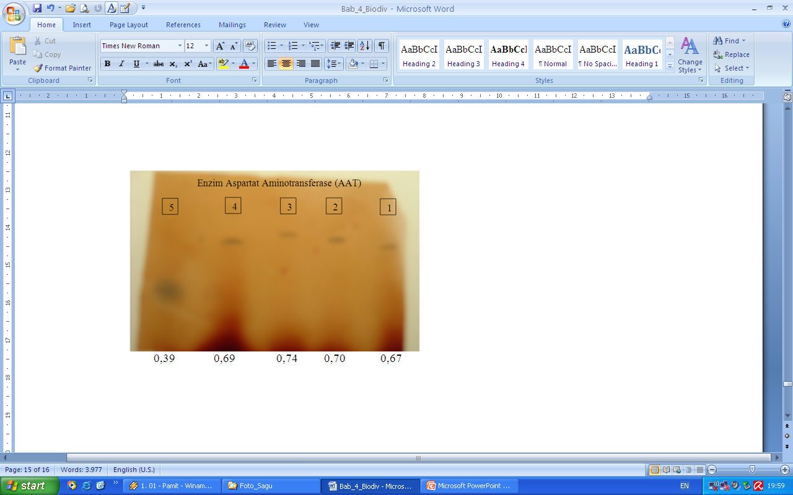
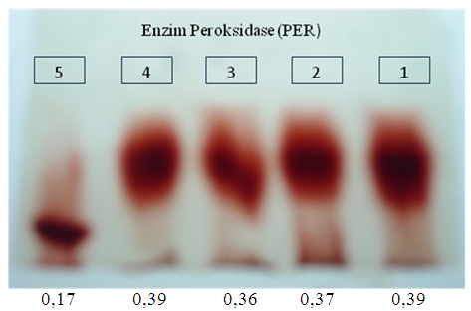
a
b

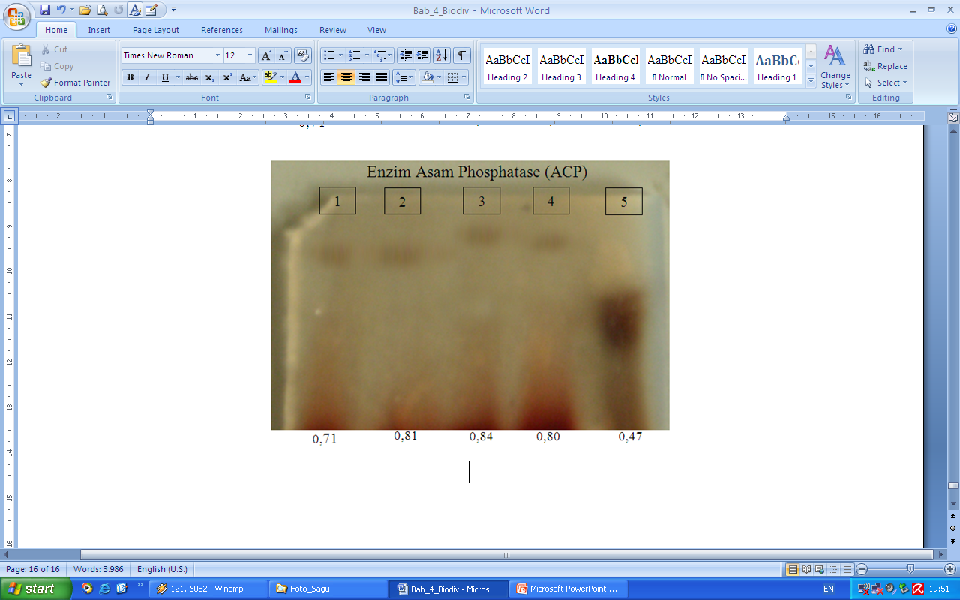
c
Information :
1 = M. rumphii Mart.
2 = M.sylvestre Mart.
3 = M. longispinum Mart.
4 = M. microcanthum Mart.
5 = M. sagu Rottb.

Figure 2. Zimogram isozym (a) Aspartat Aminotransferase (AAT), (b) Asam Phosphatase (ACP), and (c) Peroksidase (PER)

Figure 2 clearly illustrates the trend of isozym tape from five analysed sagu species showing two tape isozym trends. Species of M. rumphii Mart., M. sylvestre Mart., M. longispinum Mart., and M. micrtocanthum Mart. Form isozym tape trend into one specific group, while on the other hand, M. sagu Rottb. Separately forms its own tape trend. Four sagu species forming the first isozym tape trend is clearly a sagu species with thorn. The second isozym tape trend is M. sagu Rottb. which stands for the non thorn sagu species. To sum up, it can be concluded that there are only two kinds of sagu species cultivating and growing in Seram Island, Maluku Province from knowingly five kinds of sagu species after all. These both two species by Beccari (1918 in Flach, 1997) are catagorized into species of Metroxylon rumphii Mart. for a thorn one and Metroxylon sagu Rottb. for those non thorn sagu species. It can then also said that the research goes along with Beccari (1918 in Flach, 1997).
Based on Sarkar (1970 in Flach, 1997), he states that there are 16 (2n = 32) chromosom found in sagu palm. The amount is then corrected by the result of research of Verhaar (1976 in Flach, 1997) who finds out that non thorn sagu species (M. sagu Rottb.) has chromosom as many as 13 (2n = 26). From that findings, it can be concluded that thorn sagu species M. rumphii Mart owns 16 chromosom and another species called M. sagu Rottb. has clearly13 chromosom.
As it is explained previously, from all five sagu species spread all over the world, two of them namely M. rumphii Mart. and M. sagus Rottb. are cultivated and grown in Seram Island, Maluku Province. Then Beccari (1918 in Flach, 1997) groups these two species into four varieties for yaitu M. rumphii Mart. consisting of three varieties namely : 1) variety of microcanthum Becc., 2) variety of sylvestre Becc., and 3) variety of rotang Becc. On the other side, the rest of another one sagu species called as M. sagu Rottb. solely owns one kind of variety standing as variety of molat Becc. Further division of variety microcanthum is divided into two subvarieties namely yaitu subvariety of tuni and subvariety of makanaro. The result of genetic analysis using isozym reinforce more the argument of Beccari commenting that the classification system in sagu species is named after biological species terminology.
It is crystal clear then, based on the recent research above, there is a scientific correction about the amount of sagu species located in Seram Island, Maluku Province, Indonesia. It can be explored also from the research that according to Botanica Sistematica issued by FAO (2007), the sagu species namely M. longispinum Mart., M. microcanthum Mart, and M. sylvestre Mart are not existed seen clearly from the eight sagu cpecies classification spread all over the world. Additionaly, there are only two kinds of sagu species which are called M. rumphii Mart. and M. elatum Mart made by Martius (1838 in FAO 2007). The summary of sagu species amount according to Beccari (1918 in Flach 1997) and other marked experts are illustrated below in Figure 3.
Species
Variety
Subvariety

Tuni
M. rumphii Mart.
Microcanthum

Sagu
Makanaro
Sylvestre

Rotang

M. sagu Rottb.
Molat

Figure 3. the amount of sagu species in Seram Island, Maluku Province according to Beccari (1918 in Flach 1997)

Specific case takes place in molat variety from species M. sagu Rottb. as mentioned previously by Beccari (19181 in Flach, 1997). Still on the same track with the result of sagu genetic research conducted in PNG by Kjaer et al. (2004) using AFLP methods, it then can be summed up that taxonomically , M. sagu species merely consists of one single species. Further he also explains that morfology distribution pattern geographically does not reflect genetic variety pattern. It means there is morfology variety in M. sagu Rottb. species and the morfology similarity all all areas of PNG does not have anything to do with the genetic difference.

CONCLUSION AND SUGGESTION
Based on the classification in biology species, sagu palm cultivating and growing in Seram Island, Maluku Province consists of two species only namely 1). Metroxylon rumphii Mart., and 2). Metroxylon saguRottb. Species of sagu called M. rumphii Mart. consists of three varieties namely 1). Variety of microcanthum Becc., 2). Variety of sylvestre Becc., and 3). Variety of rotang Becc. Species of M. sagu Rottb as it is known only has the variety called as molat. Variety of microcanthum has two subvarieties known as subvariety as tuni Becc. and subvariety of makanaro Becc. The analysis of genetic is considered important to do using sharper marker to strengthen or test the accuracy of clarification test for the already existed species whether it is in Seram Island in Maluku Province or other areas/regions as well.

References
Barbour GM, Burk JK, Pitts WD. 1987. Terrestrial Plant Ecology. New York : Benyamin/Cumming Publishing. Inc.
Bintoro HMH. 2008. Bercocok Tanam Sagu. Bogor : IPB Press (in Indonesian).
[FAO] Food and Agriculture Organization. 2007. Botanica sistematica. http://www.homolaicus.com/scienza/erbario/utility/botanica_sistematica/hypertext/1251.htm. [21 Februari 2010].
Flach M. 1997. Promoting the Conservation and Use of Underutilized and Neglected Crops. Sago Palm, Metroxylon sagu, Rottb. Wageningen Agriculture University, Netherlands. International Plant Genetic Resources Institute, Rome. pp 76. http://www.ipgri.cgiar.org/Publications/ pdf/238.pdf. [11 Agustus 2008].
Haryanto B, Pangloli P. 1992. Potensi dan Pemanfaatan Sagu. Yogyakarta : Kanisus (in Indonesian).
Hartana A. 2003. Elektroforesis sebagai alat pelacak marka molekul biologi. Materi pelatihan singkat Teknik Analisis dengan Metode dan Peralatan mutakhir di Bidang Hayati dan Kimia. Kerjasama antara Pusat Studi Ilmu Hayati Lembaga Penelitian IPB dengan Direktorat Jenderal Pendidikan Tinggi, Departemen Pendidikan Nasional. Bogor, 21-25 Oktober 2003. hlm 25-31 (in Indonesian).
Kartono AP. 2006. Ekologi kuantitatif konservasi keanekaragaman hayati. Laboratorium Ekologi Satwaliar, Departemen Konservasi Sumberdaya Hutan dan Ekowisata. Fakultas Kehutanan IPB (tidak dipublikasikan) (in Indonesian).
Kjaer A, Barfodi A, Asmussen CB, Seberg O. 2004. Investigation of genetic and morphological variation in the sago palm (Metroxylon sagu; Arecaceae) in Papua Newe Guinea. J Ann Bot 94 (1) : 109-117.
Krebs CJ. 1999. Ecological Methodology. Canada : Addison-Welsey Longman, Inc.
Louhenapessy JE. 2006. Potensi dan Pengelolaan sagu di Maluku. Makalah disampaikan pada Lokakarya Sagu dengan tema Sagu dalam Revitalisasi Pertanian Maluku. Ambon 29-31 Mei 2006 (in Indonesian).
Ludwig AJ, & Reynolds JF. 1988. Statistical Ecology. A Primer on Methods and Computing. New York : John Willey & Sons.
McClatchey W, Manner HI, Elevitch CR. 2006. Metroxylon amicarum, M. paulcoxii, M. sagu, M. salomonense, M. vitiense, and M. warburgii (sago palm). Species Profile for Pacific Island Agroforestry. Traditional Tree Initiative. http://www.agroforestry.net/tti/Metroxylon-sagopalm.pdf. [7 Agustus 2008].
Notohadiprawiro T, Louhenapessy JE. 1993. Potensi sagu dalam penganekaragaman bahan pangan pokok ditinjau dari persyaratan lahan. Di dalam : Pemanfaatan dan Pengelolaan Hutan Sagu dalam Rangka Pengembangan Bagian Timur Wilayah Indoensia Khususnya Provinsi Maluku. Prosiding Simposium Sagu Nasional; Ambon, 12-13 Oktober 1992. Ambon : Fakultas Pertanian Universitas Pattimura. hlm 99-106 (in Indonesian).
Rostiwati T et al. 2008. Sagu (Metroxylon spp) sebagai sumber energi bioetanol potensial. Pusat Penelitian dan Pengembangan Hutan Tanaman, Badan Penelitian dan Pengembangan Kehutanan, Departemen Kehutanan (in Indonesian).
Setiadi D. 2005. Keanekaragaman spesies tingkat pohon di Taman Wisata Alam Ruteng, Nusa Tenggara Timur. J Biodiversitas 6 (2) : 118-122 (in Indonesian).
Setiadi D, Muhadiono I, Yusron A. 1989. Penuntun Praktikum Ekologi. Departemen Pendidikan dan Kebudayaan, Direktorat Jenderal Pendidikan Tinggi, Pusat Antar Universitas Ilmu Hayat, Institut Pertanian Bogor. Bogor (in Indonesian).
Soegianto A. 1994. Ekologi Kuantitatif, Metode Analisis Populasi dan Komunitas. Surabaya : Usaha Nasional (in Indonesian).

