SEMIOTIC SIGNS IN AVENGERS : ENDGAME MOVIE

Tia Rachel Rahayu, Lili Awaludin, S.S., M.A., Yoga Sudarisman, M.A.

Faculty of Adab and Humanities, State Islamic
University of Sunan Gunung Djati Bandung

Abstract
This research is a semiotic study of signs used to analyze the signs of hostility in the Avengers: Endgame Movie. The researcher uses the semiotic theory of Charles Sanders Peirce. There are two problem formulations taken in this study, namely the type of semiotic sign by focusing on the sign of hostility contained in the Avengers: Endgame movie and the meaning contained in the sign. The purpose of this study was to determine the types of semiotic signs based on the focus on signs of hostility contained in the Avengers: Endgame movie and how a film conveys the meaning of the content/message that can be applied in everyday life. Then, it has important values ​​that can motivate and refer to social realities in society. The researcher uses qualitative research because a series of words represent the data. In the producer of data collection, the researcher selects films and watches the films, collecting and categorizing signs that indicate the form of the hostility of the actors. Then interpret the meaning of the sign that has been obtained. The results show that in the Avengers: endgame movie, there are signs of hostility that can be seen when the Avengers are willing to sacrifice to fight and protect the universe to stop evil.

Keywords: Semiotics, Sign, Meaning, Hostility, Movie.

INTRODUCTION
Semiotics is a very diverse field that includes various types of signs conveyed through various media and channels, socially regulated sign systems, and from the conditions of signification or the making of meanings from signs (Prior, 2014, p. 2). Etymologically, semiotic comes from the Greek word "semiotics," which means " sign " (Noth, 1995, p. 15). Signs are the basis of all communication humans and sign brokers can communicate with each other. Signs are defined as based on pre-developed social rules. Semiotic is the study of a wide range of events, objects, and entire cultures assigned Invalid source specified..
Semiotics is known as sketches depicting a whole covering the historical mix of several resource semiotics, including spoken language, embodied gestures and actions, written text, music, touch, environmental perception, and film. According to Pierces, semiotic include the process of identifying and clarifying signs. Pierces divides it into meaning triangles based on signs, objects, and interpretants. The sign is divided into three topics, namely: qualisign, sinsign, and legisign. Next, based on the object, it is divided into icons, indexes, and symbols. Then the last one is interpretant, which includes to rheme, dicent sign an argument (Prior, 2014, p. 3).
Semiotics in Peirce may be a triadic show which describes the relationship between the sign/representation, the object, and the interpretant. Based on the definition of Peirce (1920) :
"I define a Sign as anything which is so determined by something else, called it is an object, and so determines an effect upon a person, which effect I call it is interpretant, that the latter is thereby mediately determined by the former (Peirce 1902: 478)."
The sign is the signifier. The interpretant is the understanding that we have of the object connection. For Peirce, the interpretant is central to the substance of the sign. A sign meant as it was being translated. The sign's meaning is shown within the interpretation that it creates in sign clients (Afisi, 2020, p. 272).
The research limits the problem to signs of hostility. It is to answer the following questions :
- What are the semiotic signs of hostility found in Avengers: Endgame based on Peirce's Theory?
- Based on Peirce's Theory, what are the meanings of the semiotic signs of hostility in Avengers: Endgame?
METHOD
This research used descriptive qualitative research using content analysis methodology because this research examines a movie. The content analysis was used to explore a range of 'texts' from interview conversation transcripts, social science, narrative form of films, tv programs, the content of newspapers and magazines on publishing programs and publications. Content analysis coverage was introduced by Harold Lasswell (1927) in a systemic way to research mass media. According to Lasswell, Lerner, and Pool (1952:32) said that content analysis is based on the view that verbal behavior is a mode of human conduct, that symbol flow is a part of event flow, and that the mechanism is an element of the historical process communication Content analysis is a method that attempts to describe what is said in a given place at a given time, with optimal objectivity, accuracy, and generality.
The research report has six sections, (1) formulating research questions and hypotheses, (2) sampling selected data sources, (3) making categories used in the analysis, (4) collecting data on a sample of documents that have been selected and conducting coding, (5) making scales and items based on specific criteria for assessing the data, and (6) interpretation of the data obtained (Macnamara, 2005, pp. 1-2).
The research was done through several steps of collectingthe data. These are some steps in colleting data :
- Selecting the movie, Avengers: Endgame movies
- After the movie had been selected, the researcher downloaded a movie entitled "Avengers: Endgame" on the internet. It was taken from: https://149.56.24.226/avengers-endgame-2019/.
- Watching the movie to understand the story and researcher
- Finding signs of hostility and the meaning in Avengers: Endgame as the object of this research.
The steps of the research in analyzing data are :
- Formulating research questions and hypotheses.
Formulating and hypotheses is the first step in initiating research that explores the uncertainties in the realm of concern and demonstrates the need for deliberate research.
- Sampling selected data sources.
The next step, sampling signs in movie scenes, is used for focusing on topics, and each sampling was sequenced for further explanation.
- Categorizing and collecting data on a sample of documents that have been selected and conducting coding.
The last step categorizing and collecting, is used for each sample based on the topic.
- Interpretation of the meaning of the data obtained.
The researcher explains the data to provide a simple understanding and ensure that the marks are relevant to the topic. Then, interpret the meaning contained in the data result.
FINDINGS AND DISCUSSION
- The Signs of Hostility between The Avengers and Thanos.
Sign
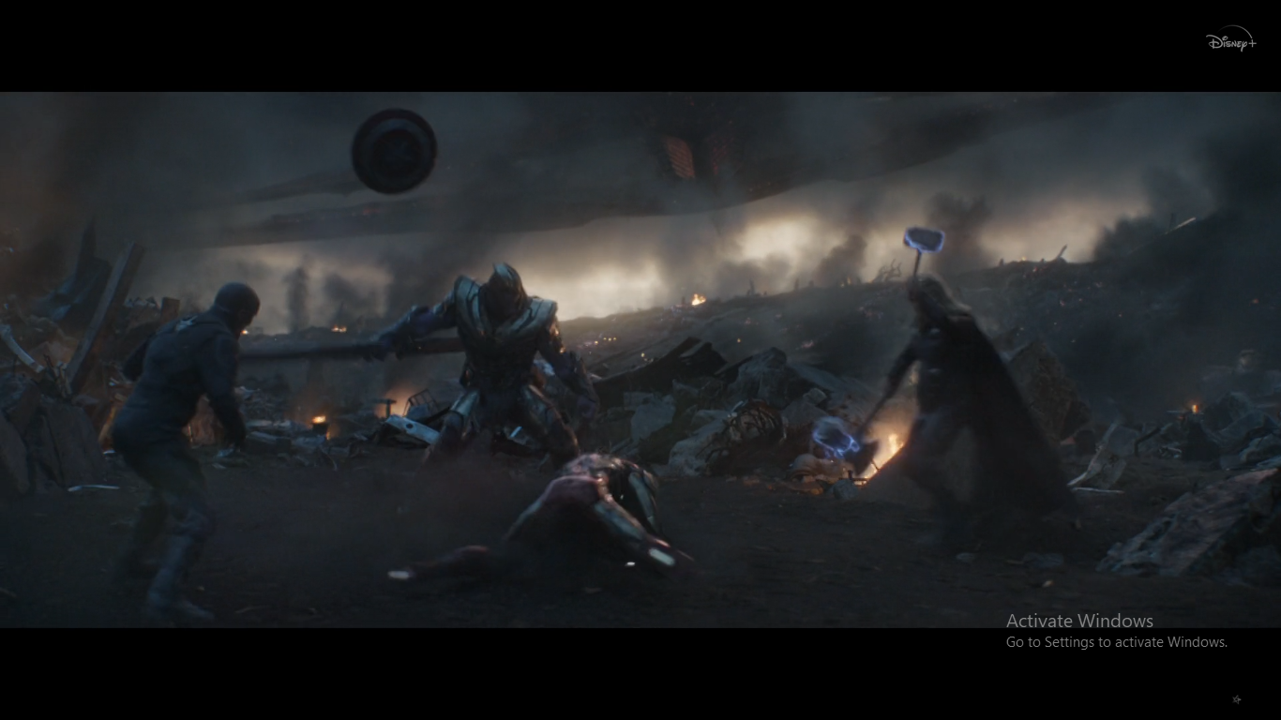
picture 8.1
Times : 02:09:40
The sign in the pictures above refers to the qualisign when there is a loud sound from the clash of Iron Man's laser swords and Thanos' adamantium. The sign refers to the sinsign because the clash on Thanos' sword was the beginning of the Avengers' war against Thanos. The battle is in the form of the responsibility of the Avengers to protect the universe.
Object | Interpretant
Shooting 8.1 is a Long Shot, which is the entire picture that shows the situation in the pictures. The object in the pictures refers to the icon because of the shield that Captain America put up to fight Thanos and protect himself from counterattacks from enemies made of metal combined with vibranium against all bullets and bombs. In addition, Thor's Mjolnir and Stormbreaker are his mainstay weapons that can be used both as close-range and long-range weapons. Mjolnir's hammer can emit lightning. Even Thor can fly by twirling the hammer. And for Stormbreaker to be his second weapon after losing the Hammer of Mjolnir in the Thor: Ragnarok sequel against Hela. This ax is as tough as Mjolnir, and it was made after going through various struggles that almost took Thor's life. At the time of making this ax, Thor was accompanied by Rocket and Groot. Groot sacrificed his hand to hold Stormbeaker voluntarily. The object in the image above refers to the index because of the fight between the Avengers and Thanos. Thanos wants to reclaim the six infinity stones obtained by the Avengers on a mission to restore half the population that has been lost. However, the Avengers try to protect the stone and will never give it to Thanos, who has an evil mission of destroying the universe and replacing it with a new life as Thanos wants. | The interpreter in the pictures above refers to the rheme because it looks like Thanos, surrounded by attacks given alternately by Captain America, Iron Man, and Thor. The attack carried out aims to kill Thanos, who has an evil mission.

CONCLUSION
Based on the analysis that has been done, it can be concluded that there are signs of hostility to be conveyed in the Avengers: Endgame film. Using Charles Sanders Peirce's analysis, researchers found scenes showing hostility in the Avengers: Endgame film. It is depicted in the scene at the beginning of the shooting attack that came unexpectedly from Thanos' spaceship towards the Avengers headquarters. The attack carried out by Thanos aims to stop the Avengers. They are saving the earth because they have lost half the population due to Thanos' evil intentions with the help of the power of six stones to destroy the universe in the sequel Avengers: Infinity War. Then it continues to become a very large war conflict between the Avengers and Thanos.

REFERENCES
Afisi, O. T. (2020). The Concept of Semiotics In Charles Sanders Peirce's Pragmatism. TRENDS IN SEMANTICS AND PRAGMATICS, 272.
Creswell, J. W. (2003). Research Design : Qualitative, Quantitative and Mixed Methods Approaches (2nd ed.). Dalam J. W. Creswell, Research Design : Qualitative, Quantitative and Mixed Methods Approaches (hal. 13). Thousand Oaks: SAGE Publications.
Eco, U. (1979). A Theory of Semiotika. Bloomington: Indiana University.
Macnamara, J. (2005). Media Content Analysis : Its Uses, Benefits and Best Practice Methodology. researchgate, 1-2.
Noth, W. (1995). Handbook of Semiotics. Bloomington: Indiana University Press.
Prior, P. (2014). Semiotics. In C. L. Street, The Roudledge Companion to English Studies (p. 2). London: Routledge.

