**Winstep 3.73: Rasch Model Analysis**

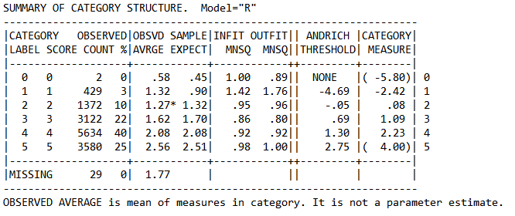

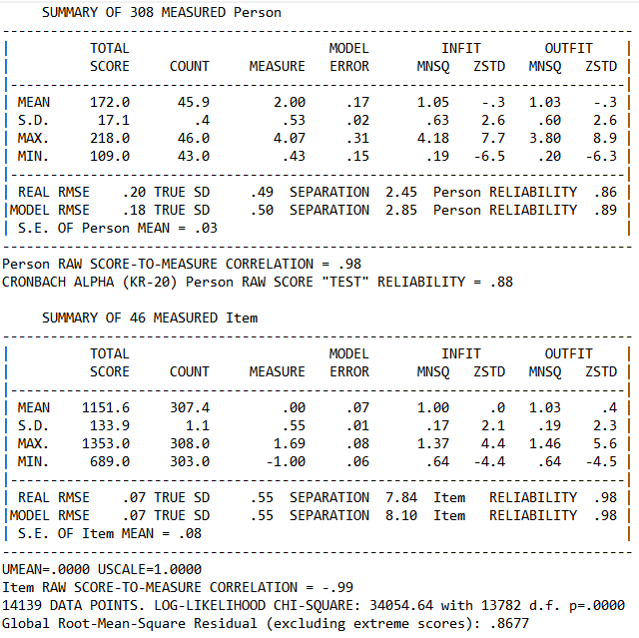

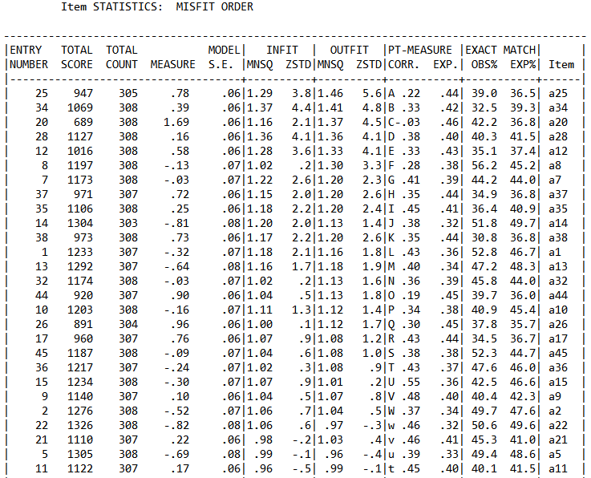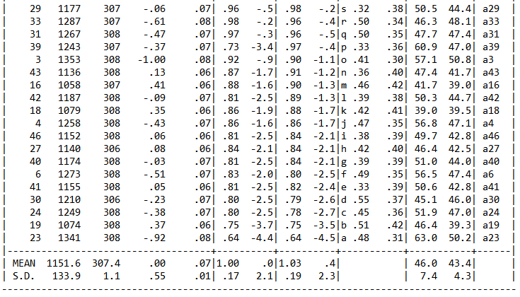

**IBM SPSS 23: Principal Component Analysis (PCA)**

|  |  |  |  |  |  |  |
| --- | --- | --- | --- | --- | --- | --- |
| **KMO and Bartlett's Test** | | | | | | |
| Kaiser-Meyer-Olkin Measure of Sampling Adequacy. | | | | | .822 | |
| Bartlett's Test of Sphericity | | Approx. Chi-Square | | | 1358.244 | |
| Df | | | 190 | |
| Sig. | | | .000 | |
| **Total Variance Explained** | | | | | | | | | | | | |
| Component | Initial Eigenvalues | | | | | Extraction Sums of Squared Loadings | | | | Rotation Sums of Squared Loadings | | |
| Total | | % of Variance | Cumulative % | | Total | | % of Variance | Cumulative % | Total | % of Variance | Cumulative % |
| 1 | 5.541 | | 27.705 | 27.705 | | 5.541 | | 27.705 | 27.705 | 2.848 | 14.241 | 14.241 |
| 2 | 1.683 | | 8.416 | 36.121 | | 1.683 | | 8.416 | 36.121 | 2.336 | 11.682 | 25.922 |
| 3 | 1.500 | | 7.501 | 43.622 | | 1.500 | | 7.501 | 43.622 | 2.134 | 10.671 | 36.594 |
| 4 | 1.386 | | 6.929 | 50.551 | | 1.386 | | 6.929 | 50.551 | 1.992 | 9.962 | 46.555 |
| 5 | 1.087 | | 5.437 | 55.988 | | 1.087 | | 5.437 | 55.988 | 1.525 | 7.623 | 54.178 |
| 6 | 1.037 | | 5.185 | 61.173 | | 1.037 | | 5.185 | 61.173 | 1.399 | 6.995 | 61.173 |
| 7 | .933 | | 4.663 | 65.836 | |  | |  |  |  |  |  |
| 8 | .782 | | 3.911 | 69.747 | |  | |  |  |  |  |  |
| 9 | .751 | | 3.755 | 73.502 | |  | |  |  |  |  |  |
| 10 | .736 | | 3.679 | 77.181 | |  | |  |  |  |  |  |
| 11 | .629 | | 3.147 | 80.328 | |  | |  |  |  |  |  |
| 12 | .624 | | 3.120 | 83.448 | |  | |  |  |  |  |  |
| 13 | .556 | | 2.781 | 86.229 | |  | |  |  |  |  |  |
| 14 | .538 | | 2.692 | 88.920 | |  | |  |  |  |  |  |
| 15 | .504 | | 2.519 | 91.439 | |  | |  |  |  |  |  |
| 16 | .460 | | 2.298 | 93.738 | |  | |  |  |  |  |  |
| 17 | .330 | | 1.651 | 95.389 | |  | |  |  |  |  |  |
| 18 | .325 | | 1.624 | 97.013 | |  | |  |  |  |  |  |
| 19 | .308 | | 1.542 | 98.555 | |  | |  |  |  |  |  |
| 20 | .289 | | 1.445 | 100.000 | |  | |  |  |  |  |  |
| Extraction Method: Principal Component Analysis. | | | | | | | | | | | | |

|  |  |  |  |  |  |  |
| --- | --- | --- | --- | --- | --- | --- |
| **Rotated Component Matrixa** | | | | | | |
|  | Component | | | | | |
| 1 | 2 | 3 | 4 | 5 | 6 |
| malu7 | .767 |  |  |  |  |  |
| malu5 | .754 |  |  |  |  |  |
| malu6 | .721 |  |  |  |  |  |
| malu8 | .536 | .410 |  |  |  |  |
| malu15 | .472 |  |  |  |  |  |
| malu4 | .441 |  |  |  |  |  |
| malu19 |  | .796 |  |  |  |  |
| malu20 |  | .753 |  |  |  |  |
| malu18 |  | .655 |  |  |  |  |
| malu12 |  |  | .744 |  |  |  |
| malu14 |  |  | .599 |  |  |  |
| malu13 |  |  | .566 |  |  |  |
| malu17 |  | .516 | .524 |  |  |  |
| malu1 |  |  |  | .806 |  |  |
| malu2 |  |  |  | .678 |  |  |
| malu3 |  |  |  | .607 |  |  |
| malu10 |  |  |  |  | .828 |  |
| malu9 |  |  |  |  | .766 |  |
| malu16 |  |  |  |  |  | .777 |
| malu11 |  |  |  |  |  | .678 |
| Extraction Method: Principal Component Analysis.  Rotation Method: Varimax with Kaiser Normalization. | | | | | | |
| a. Rotation converged in 7 iterations. | | | | | | |

**IBM SPSS 23: Non Paramentric Test, Correlation Matrix, and Reliability Analysis**

|  |  |  |  |  |  |
| --- | --- | --- | --- | --- | --- |
| **One-Sample Kolmogorov-Smirnov Test** | | | | | |
|  | | al-Haya’ 20 | Full_scs | Brief_scs | al-Haya’ 16 |
| N | | 232 | 232 | 232 | 232 |
| Normal Parametersa,b | Mean | 78.7759 | 116.7802 | 41.7371 | 64.5259 |
| Std. Deviation | 9.82186 | 15.75596 | 6.85122 | 8.30267 |
| Most Extreme Differences | Absolute | .058 | .055 | .054 | .078 |
| Positive | .045 | .055 | .054 | .035 |
| Negative | -.058 | -.027 | -.039 | -.078 |
| Test Statistic | | .058 | .055 | .054 | .078 |
| Asymp. Sig. (2-tailed) | | .060c | .083c | .098c | .002c |
| a. Test distribution is Normal. | | | | | |
| b. Calculated from data. | | | | | |
| c. Lilliefors Significance Correction. | | | | | |

|  |  |  |  |  |  |  |  |  |  |  |  |  |
| --- | --- | --- | --- | --- | --- | --- | --- | --- | --- | --- | --- | --- |
| **Correlations** | | | | | | | | | | | | |
|  | | | Brief_scs | Full_scs | al-Haya’ 16 | fac1_scs | fac2_scs | fac3_scs | fac4_scs | fac5_scs | al-Haya’ 20 |
| Spearman's rho | Brief_scs | Correlation Coefficient | 1.000 | .919** | .333** | .748** | .699** | .664** | .882** | .627** | .408** |
| Sig. (2-tailed) | . | .000 | .000 | .000 | .000 | .000 | .000 | .000 | .000 |
| N | 232 | 232 | 232 | 232 | 232 | 232 | 232 | 232 | 232 |
| Full_scs | Correlation Coefficient | .919** | 1.000 | .345** | .835** | .793** | .734** | .836** | .747** | .427** |
| Sig. (2-tailed) | .000 | . | .000 | .000 | .000 | .000 | .000 | .000 | .000 |
| N | 232 | 232 | 232 | 232 | 232 | 232 | 232 | 232 | 232 |
| al-Haya’ 16 | Correlation Coefficient | .333** | .345** | 1.000 | .392** | .164* | .441** | .257** | .294** | .967** |
| Sig. (2-tailed) | .000 | .000 | . | .000 | .012 | .000 | .000 | .000 | .000 |
| N | 232 | 232 | 232 | 232 | 232 | 232 | 232 | 232 | 232 |
| fac1_scs | Correlation Coefficient | .748** | .835** | .392** | 1.000 | .486** | .568** | .641** | .670** | .430** |
| Sig. (2-tailed) | .000 | .000 | .000 | . | .000 | .000 | .000 | .000 | .000 |
| N | 232 | 232 | 232 | 232 | 232 | 232 | 232 | 232 | 232 |
| fac2_scs | Correlation Coefficient | .699** | .793** | .164* | .486** | 1.000 | .498** | .616** | .426** | .256** |
| Sig. (2-tailed) | .000 | .000 | .012 | .000 | . | .000 | .000 | .000 | .000 |
| N | 232 | 232 | 232 | 232 | 232 | 232 | 232 | 232 | 232 |
| fac3_scs | Correlation Coefficient | .664** | .734** | .441** | .568** | .498** | 1.000 | .543** | .525** | .523** |
| Sig. (2-tailed) | .000 | .000 | .000 | .000 | .000 | . | .000 | .000 | .000 |
| N | 232 | 232 | 232 | 232 | 232 | 232 | 232 | 232 | 232 |
| fac4_sc | Correlation Coefficient | .882** | .836** | .257** | .641** | .616** | .543** | 1.000 | .517** | .323** |
| Sig. (2-tailed) | .000 | .000 | .000 | .000 | .000 | .000 | . | .000 | .000 |
| N | 232 | 232 | 232 | 232 | 232 | 232 | 232 | 232 | 232 |
| fac5_scs | Correlation Coefficient | .627** | .747** | .294** | .670** | .426** | .525** | .517** | 1.000 | .341** |
| Sig. (2-tailed) | .000 | .000 | .000 | .000 | .000 | .000 | .000 | . | .000 |
| N | 232 | 232 | 232 | 232 | 232 | 232 | 232 | 232 | 232 |
| al-Haya’ 20 | Correlation Coefficient | .408** | .427** | .967** | .430** | .256** | .523** | .323** | .341** | 1.000 |
| Sig. (2-tailed) | .000 | .000 | .000 | .000 | .000 | .000 | .000 | .000 | . |
| N | 232 | 232 | 232 | 232 | 232 | 232 | 232 | 232 | 232 |
| **. Correlation is significant at the 0.01 level (2-tailed). | | | | | | | | | | | | |
| *. Correlation is significant at the 0.05 level (2-tailed). | | | | | | | | | | | | |

|  |  |  |  |  |  |  |  |  |  |  |
| --- | --- | --- | --- | --- | --- | --- | --- | --- | --- | --- |
| **Correlations** | | | | | | | | | | |
|  | | al-Haya’ 20 | Brief_scs | Full_scs | al-Haya’ 16 | fac1_scs | fac2_scs | fac3_scs | fac4_scs | fac5_scs |
| al-Haya’ 20 | Pearson Correlation | 1 | .436** | .471** | .971** | .454** | .265** | .547** | .348** | .381** |
| Sig. (2-tailed) |  | .000 | .000 | .000 | .000 | .000 | .000 | .000 | .000 |
| N | 232 | 232 | 232 | 232 | 232 | 232 | 232 | 232 | 232 |
| Brief_scs | Pearson Correlation | .436** | 1 | .906** | .368** | .770** | .686** | .682** | .879** | .661** |
| Sig. (2-tailed) | .000 |  | .000 | .000 | .000 | .000 | .000 | .000 | .000 |
| N | 232 | 232 | 232 | 232 | 232 | 232 | 232 | 232 | 232 |
| Full_scs | Pearson Correlation | .471** | .906** | 1 | .390** | .859** | .810** | .762** | .841** | .771** |
| Sig. (2-tailed) | .000 | .000 |  | .000 | .000 | .000 | .000 | .000 | .000 |
| N | 232 | 232 | 232 | 232 | 232 | 232 | 232 | 232 | 232 |
| al-Haya’ 16 | Pearson Correlation | .971** | .368** | .390** | 1 | .410** | .175** | .473** | .282** | .330** |
| Sig. (2-tailed) | .000 | .000 | .000 |  | .000 | .007 | .000 | .000 | .000 |
| N | 232 | 232 | 232 | 232 | 232 | 232 | 232 | 232 | 232 |
| fac1_scs | Pearson Correlation | .454** | .770** | .859** | .410** | 1 | .519** | .616** | .652** | .695** |
| Sig. (2-tailed) | .000 | .000 | .000 | .000 |  | .000 | .000 | .000 | .000 |
| N | 232 | 232 | 232 | 232 | 232 | 232 | 232 | 232 | 232 |
| fac2_scs | Pearson Correlation | .265** | .686** | .810** | .175** | .519** | 1 | .515** | .638** | .440** |
| Sig. (2-tailed) | .000 | .000 | .000 | .007 | .000 |  | .000 | .000 | .000 |
| N | 232 | 232 | 232 | 232 | 232 | 232 | 232 | 232 | 232 |
| fac3_scs | Pearson Correlation | .547** | .682** | .762** | .473** | .616** | .515** | 1 | .553** | .551** |
| Sig. (2-tailed) | .000 | .000 | .000 | .000 | .000 | .000 |  | .000 | .000 |
| N | 232 | 232 | 232 | 232 | 232 | 232 | 232 | 232 | 232 |
| fac4_scs | Pearson Correlation | .348** | .879** | .841** | .282** | .652** | .638** | .553** | 1 | .557** |
| Sig. (2-tailed) | .000 | .000 | .000 | .000 | .000 | .000 | .000 |  | .000 |
| N | 232 | 232 | 232 | 232 | 232 | 232 | 232 | 232 | 232 |
| fac5_scs | Pearson Correlation | .381** | .661** | .771** | .330** | .695** | .440** | .551** | .557** | 1 |
| Sig. (2-tailed) | .000 | .000 | .000 | .000 | .000 | .000 | .000 | .000 |  |
| N | 232 | 232 | 232 | 232 | 232 | 232 | 232 | 232 | 232 |
| **. Correlation is significant at the 0.01 level (2-tailed). | | | | | | | | | | |

**Scale: al-Haya’ 20**

|  |  |
| --- | --- |
| **Reliability Statistics** | |
| Cronbach's Alpha | N of Items |
| .842 | 20 |

|  |  |  |  |  |
| --- | --- | --- | --- | --- |
| **Item-Total Statistics** | | | | |
|  | Scale Mean if Item Deleted | Scale Variance if Item Deleted | Corrected Item-Total Correlation | Cronbach's Alpha if Item Deleted |
| malu1 | 74.8448 | 90.262 | .253 | .842 |
| malu2 | 75.0345 | 85.592 | .472 | .832 |
| malu3 | 74.4009 | 90.181 | .387 | .836 |
| malu4 | 74.5345 | 86.562 | .594 | .828 |
| malu5 | 74.5302 | 86.822 | .482 | .832 |
| malu6 | 75.0000 | 86.355 | .464 | .832 |
| malu7 | 74.7371 | 84.385 | .569 | .827 |
| malu8 | 75.2888 | 85.141 | .496 | .831 |
| malu9 | 74.4698 | 90.951 | .335 | .838 |
| malu10 | 74.5948 | 91.047 | .326 | .838 |
| malu11 | 75.8664 | 90.220 | .186 | .849 |
| malu12 | 74.9612 | 89.085 | .329 | .839 |
| malu13 | 74.4698 | 89.211 | .435 | .834 |
| malu14 | 74.4267 | 86.488 | .612 | .828 |
| malu15 | 74.5345 | 87.289 | .461 | .833 |
| malu16 | 75.4914 | 90.277 | .202 | .847 |
| malu17 | 74.8966 | 86.266 | .483 | .832 |
| malu18 | 74.8966 | 86.898 | .504 | .831 |
| malu19 | 74.7586 | 86.348 | .517 | .830 |
| malu20 | 75.0043 | 86.403 | .524 | .830 |

**Scale: al-Haya’ 16**

|  |  |
| --- | --- |
| **Reliability Statistics** | |
| Cronbach's Alpha | N of Items |
| .843 | 16 |

|  |  |  |  |  |
| --- | --- | --- | --- | --- |
| **Item-Total Statistics** | | | | |
|  | Scale Mean if Item Deleted | Scale Variance if Item Deleted | Corrected Item-Total Correlation | Cronbach's Alpha if Item Deleted |
| malu1 | 60.5948 | 63.013 | .286 | .845 |
| malu2 | 60.7845 | 59.806 | .462 | .835 |
| malu3 | 60.1509 | 63.549 | .388 | .838 |
| malu5 | 60.2802 | 60.627 | .488 | .833 |
| malu6 | 60.7500 | 60.335 | .462 | .835 |
| malu7 | 60.4871 | 58.848 | .558 | .829 |
| malu8 | 61.0388 | 59.691 | .470 | .834 |
| malu9 | 60.2198 | 63.852 | .364 | .839 |
| malu10 | 60.3448 | 63.950 | .354 | .840 |
| malu13 | 60.2198 | 62.432 | .461 | .835 |
| malu14 | 60.1767 | 60.415 | .617 | .827 |
| malu15 | 60.2845 | 60.836 | .480 | .833 |
| malu17 | 60.6466 | 60.567 | .461 | .835 |
| malu18 | 60.6466 | 61.268 | .469 | .834 |
| malu19 | 60.5086 | 60.087 | .534 | .830 |
| malu20 | 60.7543 | 60.238 | .534 | .830 |

**Scale: factor 1**

|  |  |
| --- | --- |
| **Reliability Statistics** | |
| Cronbach's Alpha | N of Items |
| .758 | 5 |

|  |  |  |  |  |
| --- | --- | --- | --- | --- |
| **Item-Total Statistics** | | | | |
|  | Scale Mean if Item Deleted | Scale Variance if Item Deleted | Corrected Item-Total Correlation | Cronbach's Alpha if Item Deleted |
| malu5 | 15.5431 | 9.357 | .526 | .716 |
| malu6 | 16.0129 | 8.818 | .564 | .701 |
| malu7 | 15.7500 | 8.318 | .659 | .665 |
| malu8 | 16.3017 | 9.129 | .459 | .741 |
| malu15 | 15.5474 | 9.894 | .431 | .746 |

**Scale: factor 2**

|  |  |
| --- | --- |
| **Reliability Statistics** | |
| Cronbach's Alpha | N of Items |
| .772 | 4 |

|  |  |  |  |  |
| --- | --- | --- | --- | --- |
| **Item-Total Statistics** | | | | |
|  | Scale Mean if Item Deleted | Scale Variance if Item Deleted | Corrected Item-Total Correlation | Cronbach's Alpha if Item Deleted |
| malu17 | 11.6681 | 5.296 | .525 | .745 |
| malu18 | 11.6681 | 5.296 | .620 | .694 |
| malu19 | 11.5302 | 5.272 | .594 | .707 |
| malu20 | 11.7759 | 5.447 | .562 | .724 |

**Scale: factor 3**

|  |  |
| --- | --- |
| **Reliability Statistics** | |
| Cronbach's Alpha | N of Items |
| .685 | 2 |

|  |  |  |  |  |
| --- | --- | --- | --- | --- |
| **Item-Total Statistics** | | | | |
|  | Scale Mean if Item Deleted | Scale Variance if Item Deleted | Corrected Item-Total Correlation | Cronbach's Alpha if Item Deleted |
| malu13 | 4.3491 | .670 | .521 | . |
| malu14 | 4.3060 | .646 | .521 | . |

**Scale: factor 4**

|  |  |
| --- | --- |
| **Reliability Statistics** | |
| Cronbach's Alpha | N of Items |
| .630 | 3 |

|  |  |  |  |  |
| --- | --- | --- | --- | --- |
| **Item-Total Statistics** | | | | |
|  | Scale Mean if Item Deleted | Scale Variance if Item Deleted | Corrected Item-Total Correlation | Cronbach's Alpha if Item Deleted |
| malu1 | 8.1164 | 2.268 | .529 | .393 |
| malu2 | 8.3060 | 2.239 | .488 | .464 |
| malu3 | 7.6724 | 3.511 | .333 | .665 |

**Scale: factor 5**

|  |  |
| --- | --- |
| **Reliability Statistics** | |
| Cronbach's Alpha | N of Items |
| .593 | 2 |

|  |  |  |  |  |
| --- | --- | --- | --- | --- |
| **Item-Total Statistics** | | | | |
|  | Scale Mean if Item Deleted | Scale Variance if Item Deleted | Corrected Item-Total Correlation | Cronbach's Alpha if Item Deleted |
| malu9 | 4.1810 | .599 | .422 | . |
| malu10 | 4.3060 | .594 | .422 | . |

**Scale: full scale self-control**

|  |  |
| --- | --- |
| Cronbach's Alpha | N of Items |
| .875 | 36 |

|  |  |  |  |  |
| --- | --- | --- | --- | --- |
|  | Scale Mean if Item Deleted | Scale Variance if Item Deleted | Corrected Item-Total Correlation | Cronbach's Alpha if Item Deleted |
| sc1 | 113.3060 | 235.114 | .495 | .870 |
| sc2 | 113.9569 | 231.167 | .516 | .869 |
| sc3 | 113.6034 | 228.388 | .556 | .867 |
| sc4 | 112.9698 | 232.523 | .487 | .869 |
| sc5 | 113.0690 | 240.922 | .212 | .875 |
| sc6 | 113.1595 | 228.065 | .610 | .867 |
| sc7 | 112.9440 | 237.395 | .341 | .872 |
| sc8 | 113.1207 | 229.206 | .483 | .869 |
| sc9 | 114.2328 | 233.651 | .359 | .872 |
| sc10 | 113.9784 | 225.311 | .644 | .865 |
| sc11 | 114.1638 | 242.319 | .149 | .876 |
| sc12 | 113.5647 | 240.230 | .269 | .873 |
| sc13 | 112.7414 | 244.444 | .096 | .877 |
| sc14 | 113.6552 | 224.565 | .631 | .865 |
| sc15 | 112.7802 | 237.306 | .384 | .871 |
| sc16 | 113.5259 | 235.670 | .344 | .872 |
| sc17 | 115.2974 | 252.556 | -.218 | .880 |
| sc18 | 112.5431 | 240.379 | .342 | .872 |
| sc19 | 114.5043 | 236.078 | .332 | .872 |
| sc20 | 114.0216 | 235.484 | .367 | .872 |
| sc21 | 112.7112 | 233.721 | .430 | .870 |
| sc22 | 113.4957 | 239.463 | .264 | .874 |
| sc23 | 113.7284 | 226.813 | .574 | .867 |
| sc24 | 113.4741 | 241.419 | .174 | .876 |
| sc25 | 114.8319 | 258.288 | -.418 | .884 |
| sc26 | 114.3707 | 239.533 | .232 | .874 |
| sc27 | 113.4914 | 235.783 | .432 | .871 |
| sc28 | 114.0345 | 227.419 | .577 | .867 |
| sc29 | 113.5862 | 226.780 | .592 | .867 |
| sc30 | 113.3448 | 240.876 | .218 | .874 |
| sc31 | 113.6336 | 226.069 | .625 | .866 |
| sc32 | 113.2759 | 231.759 | .518 | .869 |
| sc33 | 113.5172 | 232.788 | .410 | .871 |
| sc34 | 113.2026 | 230.699 | .452 | .870 |
| sc35 | 112.1638 | 241.592 | .251 | .874 |
| sc36 | 113.3060 | 233.893 | .438 | .870 |

**Scale: brief scale self-control**

|  |  |
| --- | --- |
| Cronbach's Alpha | N of Items |
| .783 | 13 |

|  |  |  |  |  |
| --- | --- | --- | --- | --- |
|  | Scale Mean if Item Deleted | Scale Variance if Item Deleted | Corrected Item-Total Correlation | Cronbach's Alpha if Item Deleted |
| sc1 | 38.2629 | 41.407 | .460 | .766 |
| sc2 | 38.9138 | 39.153 | .526 | .758 |
| sc3 | 38.5603 | 37.944 | .569 | .752 |
| sc4 | 37.9267 | 39.938 | .479 | .763 |
| sc6 | 38.1164 | 38.233 | .595 | .751 |
| sc13 | 37.6983 | 44.965 | .082 | .798 |
| sc17 | 40.2543 | 48.519 | -.214 | .809 |
| sc22 | 38.4526 | 42.872 | .250 | .784 |
| sc28 | 38.9914 | 37.758 | .573 | .752 |
| sc29 | 38.5431 | 38.492 | .510 | .759 |
| sc30 | 38.3017 | 43.640 | .189 | .789 |
| sc31 | 38.5905 | 36.918 | .648 | .743 |
| sc32 | 38.2328 | 39.495 | .523 | .759 |