**Sustainable Ecotourism Development In *Negeri* Lumoli, Maluku-Indonesia: Sociology Studies**

**Elsina Titaley**

1Sociology Study Program, Faculty of Social and Political Sciences, Pattimura University, Ambon, Indonesia

E-mail: titaleyelsina2017@gmail.com

**Abstract**

The potential development of the tourism sector is often associated with its role as one of the strengths of the source of income contribution to regional income. Sociologically, Maluku, which consists of a series of islands, both large and small, with various beauties, makes Maluku an amazing tourism place in cultural customs and natural scenery. In this context, tourism development must refer to sustainable tourism development in *Negeri* Lumoli, Maluku-Indonesia, which has good tourism and culture. This research aimed to explain how to develop waterfalls as ecotourism for sustainable tourism development in *Negeri* Lumoli. The development of sustainable tourism refers to the World Tourism Organization, which includes environmentally, economically, and socio-culturally sustainable components. One form of sustainable tourism is ecotourism. The tourism process is carried out by protecting and minimizing environmental impacts, maximizing benefits for residents, and maximizing tourist satisfaction. The development of an area into an ecotourism area will, of course, foster hope in the community so that ecotourism can positively influence people's lives and the living environment. In this ecotourism research conducted in *Negeri* Lumoli, related to the existence of waterfalls, the results of the study indicate that community expectations from ecotourism development can support three important components of the community's economy, ecology that is still maintained, and socio-cultural sustainability, so that in the end it becomes a destination for tourism. superior and sustainable tourism.

Keywords: sustainable tourism, ecotourism development, socio-cultural life, economy, ecology.

**Abstrak**

Potensi pengembangan sektor pariwisata sering dikaitkan dengan perannya sebagai salah satu kekuatan sumber pendapatan kontribusi terhadap pendapatan daerah. Secara sosiologis, Maluku yang terdiri dari rangkaian pulau baik besar maupun kecil dengan berbagai keindahan menjadikan Maluku sebagai tempat wisata yang menakjubkan dalam adat budaya dan pemandangan alamnya. Dalam konteks ini, pembangunan pariwisata harus mengacu pada pembangunan pariwisata berkelanjutan di Negeri Lumoli, Maluku-Indonesia yang memiliki pariwisata dan budaya yang baik. Penelitian ini bertujuan untuk menjelaskan bagaimana mengembangkan air terjun sebagai ekowisata untuk pembangunan pariwisata berkelanjutan di Negeri Lumoli. Pengembangan pariwisata berkelanjutan mengacu pada World Tourism Organization, yang meliputi komponen lingkungan, ekonomi, dan sosial budaya yang berkelanjutan. Salah satu bentuk pariwisata berkelanjutan adalah ekowisata. Proses pariwisata dilakukan dengan melindungi dan meminimalkan dampak lingkungan, memaksimalkan manfaat bagi penduduk, dan memaksimalkan kepuasan wisatawan. Pengembangan suatu kawasan menjadi kawasan ekowisata tentunya akan menumbuhkan harapan di masyarakat agar ekowisata dapat memberikan pengaruh positif bagi kehidupan masyarakat dan lingkungan hidup. Dalam penelitian ekowisata yang dilakukan di Negeri Lumoli ini, terkait keberadaan air terjun, hasil penelitian menunjukkan bahwa harapan masyarakat terhadap pengembangan ekowisata dapat mendukung tiga komponen penting ekonomi masyarakat, ekologi yang masih terjaga, dan keberlanjutan sosial budaya, sehingga pada akhirnya menjadi tujuan wisata. pariwisata yang unggul dan berkelanjutan.

Kata kunci: pariwisata berkelanjutan, pengembangan ekowisata, kehidupan sosial budaya, ekonomi, ekologi.

INTRODUCTION

As one of the industries that play a major role in community development, the tourism industry has great potential to be developed sustainably (Horng et al., 2017). All countries in the world support and encourage the acceleration of implementing the concept of sustainable tourism after the COVID-19 pandemic (Jena & Dwivedi, 2021). Sustainable tourism is expected to impact the environment, society, culture, and economy in the present and the future, both for local communities and entrepreneurs. Of course, it must still pay attention to tourism protocols related to health, safety, comfort, and environmental sustainability (Mellon & Bramwell, 2016; Lesar et al., 2020). The government plays an important role in the development of sustainable tourism, among others, through policies, regulations, funding, and the promotion and dissemination of this concept for now and in the future. (Hall, 2019; Matiku et al., 2021).

The positive impacts of tourism include providing a growing source of opportunity for business development and job creation and stimulating investment and support for services, even in fairly remote communities (Cianga, 2017). In addition, it also brings real economic value from natural and cultural resources (Ren et al., 2019). It can result in direct income from visitor spending on local community conservation and increased conservation support. It can also force intercultural understanding and peace (Comerio & Strozzi, 2019). For this reason, awareness and knowledge of sustainable tourism development are very important. The development of sustainable tourism also needs to pay attention to several things, as follows, 1) optimally utilize environmental resources, which are key elements in tourism development, maintain important ecological processes and help to conserve natural resources and biodiversity, 2) respect socio-cultural authenticity. Host communities, preserving their buildings and living cultural heritage and traditional values, and contributing to intercultural understanding and increasing tolerance, 3) ensuring economic projects are viable in the long term, providing distributed socio-economic benefits to all stakeholders equitably, including stable employment and income-generating opportunities and social services for local communities, and contributing to poverty alleviation (WTO, 2005).

One form of sustainable tourism is ecotourism (Mtapuri & Giampiccoli, 2019). Ecotourism is a tourism product that is currently being developed in Indonesia (Kia, 2021). The concept of ecotourism is developing as a form of effort to fight the negative effects of mass tourism which continues to grow and harms the environment (Wondirad, 2019). This ecotourism concept existed at least in the mid-1960s when Hetzer put forward the four pillars of responsible tourism, including minimizing environmental impacts, maximizing benefits for residents, respecting source countries, and maximizing tourist satisfaction (Fang et al., 2018). Even so, Hetzer himself defines ecotourism as "a form of tourism based on natural and archaeological resources such as caves, fossil sites, and archaeological sites (Khah & Wani, 2011). This initial concept has placed the protection of nature as the main function above the function of making money.

These ecotourism principles are in line with the concept of sustainable development. They can be used to guide the development and management of nature-based tourism and apply to local communities, tourists, and managers (Rivera & Gutierrez, 2019). There are several versions of the ecotourism principle which, according to Fennell (2008), among others, 1) interest in nature, 2) contribution to conservation, 3) reliance on parks and protected areas, 4) long-term benefits or benefits for local communities, 5) education and studies, 6) low impact and non-consumptive, 7) sustainable, 8) responsible and ethical management, 9) enjoying and appreciating culture, and (10) small-scale and adventurous. By looking at these principles, ecotourism will be related to the environmental values ​​adopted by the community. Because the community's environmental values can be different, it is not surprising that at the end of ecotourism, the concept is often understood differently and adapted to the goals of each community. (Carballo & León, 2018).

Maluku, an archipelagic province, has large and small islands with various riches in each of the islands. Maluku is used as a tourist destination with the image of marine tourism (Huwae et al., 2020). Considering that Maluku is an archipelagic province, it has a natural wealth of beautiful beaches and a wealth of marine tourist attractions. It is supported by mountainous nature and historical objects (Asnawi et al., 2018). Maluku Province's tourism development policy is based on sustainable development, which aligns with the direction of tourism development at the national level, namely to improve the quality of humans, culture, and the environment. (Chairy & Syahrivar, 2019).

One of the tourist attractions in Maluku, precisely in the West Seram Regency, *Negeri* Lumoli, has mountainous tourist attractions that are still beautiful where there are waterfalls arranged on several levels. The location of the *Negeri* Lumoli waterfall is in the middle of the forest, so to reach the waterfall location, the tourist has to travel several hours. As the existence of the waterfall, the location of the *Negeri* Lumoli waterfall can be an ecotourism place that offers natural beauty and is a tourist destination that not only offers a place for people to travel to unwind but also offers natural beauty and the existing socio-cultural life in the community in *Negeri* Lumoli. Therefore, this ecotourism concept can offer opportunities to learn about the natural environment and other ecosystem elements that exist in nature and the socio-cultural life that exists in the local community (Titaley et al., 2018). Ecotourism is a natural area to conserve the environment and improve the welfare of local communities (Rahman et al., 2021). Ecotourism is a form of nature-based tourism that seeks to conserve it ecologically, socio-culturally, and economically by providing opportunities for appreciation and learning about the natural environment or other specific elements. (Salman et al., 2021).

It means that a waterfall tourist spot in *Negeri* Lumoli can be used as a tourist destination that can bring people who travel to know, understand, and learn about nature and the socio-cultural existence of the people in *Negeri* Lumoli. Therefore, it is not only from the point of view of the economy that was developed but also how to see from the ecological point of view of tourist destinations and the social life of the community that needs to be considered in order to realize sustainable tourism development in Indonesia, especially in *Negeri* Lumoli, West Seram Regency, Maluku Province. Based on the description above, this research was conducted to explain how to develop waterfalls in *Negeri* Lumoli as ecotourism for sustainable tourism development in *Negeri* Lumoli.

RESEARCH METHOD

This research was qualitative in the form of a case study. This approach was expected to gain a deep understanding of ecotourism and community development in *Negeri* Lumoli. The location determination was carried out intentionally, based on the consideration that 1) *Negeri* Lumoli with its unspoiled waterfalls to be used as ecotourism destinations, 2) the social and cultural conditions of the community are still firmly held, 3) the economic development of the community is still very minimal. Key informants were determined purposively according to the research context. The aim was that the data obtained were data from competent sources. Based on these considerations, the key informants in the study consisted of the Head of Government (King of the *Negeri* Lumoli), the Tourism Office of West Seram Regency, Staff of *Negeri*, and Representatives of the *Negeri* Lumoli Community as many as 3 people.

Field data collection was carried out through in-depth interviews and non-participant observations. In-depth interviews were conducted with the assistance of a guide questionnaire prepared in advance for key informants. Meanwhile, observations were made on several social situations as planned in the observation guide. It was to see and observe the pattern of life of the community members in *Negeri* Lumoli, especially the behavior of the community members as a reflection of the actions and values ​​that exist in society. Data validation was also carried out using the triangulation method regarding the field data collection process. Triangulation is a data validity checking technique that utilizes something other than the data for checking purposes or as a comparison against the data (Creswell, 2014). The data analysis process in this study used three activity lines, namely, data reduction, data presentation, conclusion drawing, or verification (Miles & Huberman, 1984).

RESULTS AND DISCUSSION

**Public knowledge of ecotourism objects in Lumoli**

Knowledge is awareness and understanding of certain aspects of reality (Carter, 2013). In addition, knowledge is also the result of human sensing or someone knowing about an object through the five senses he has (Novelia et al., 2021). In a sense, knowledge production is influenced by the intensity of attention and perception of the object. A person's knowledge is mostly obtained through the sense of hearing and the sense of sight. It is the knowledge of *Negeri* Lumoli about the meaning of Ecotourism. Knowledge is a mix of framed experiences, values, contextual information, and expert insights that provide a framework for evaluating and incorporating new experiences and information (Dulipovici & Baskerville, 2015; Aly, 2019). Therefore, people are expected to understand that it is important to ensure that natural, social and cultural resources can be utilized for tourism development from generation to generation in sustainable tourism development. It is not just the current generation without reducing future generations. It is developing very quickly, so community participation is needed to maximize every positive impact of tourism development and minimize negative impacts.

Lumoli people, in general, do not know well the meaning of Ecotourism. People only know that Ecotourism in their area is a waterfall tourist attraction. However, tourism activities that are environmentally sound by prioritizing aspects of nature conservation, socio-cultural, economic, and local community empowerment, and aspects of learning and education have not been fully understood by the community. It is because government agencies, through related agencies and other institutions, have not disseminated information to the public regarding the development of the ecotourism potential of the Lumoli waterfall as an object of nature-based, socio-cultural, and economic Ecotourism.

The waterfall is generally known as the Lumoli waterfall. However, for the people of the *Negeri* Lumoli, the waterfall has a name in the traditional/local language (alune language), namely *Telepipi* waterfall. Based on information from the community, the meaning of the name *Telepipi* cannot be conveyed to outsiders because the waterfall is one of the places considered sacred and protected by the ancestors of the people of the *Negeri* Lumoli. The *Telepipi* waterfall has existed since time immemorial because it is formed naturally. The *Telepipi* waterfall or Lumoli waterfall location is in a highland area. It is approximately 1 km from the residential area. The time needed to travel from the residential area to the waterfall location is about 1-2 hours away. Along the way to Lumoli/*Telepipi* Waterfall, people or tourists can enjoy the beautiful natural scenery in the form of small and large green trees and also enjoy the fresh and cool air. The waterfall consists of three levels. Large stones are formed naturally and flow by swift and clear water at each level. The *Telepipi* waterfall has been managed jointly by the *Negeri* Lumoli, even though the waterfall is on land owned by Matarumah Lumapuy and Matarumah Matital. In addition, no regulations have been established to regulate and manage the waterfall tourist attraction. The Lumoli community conveys only prohibitions or appeals to visitors and tourists. When they are at the location, they are not allowed to say bad words and damage plants around the waterfall because this place is a place that is considered sacred.

Lumoli waterfall or *Telepipi* began to be widely known by the public, both local, domestic and international, in 2015-2017. In the previous year, several residents of Maluku descent, especially from the *Negeri* Lumoli who lived in the Netherlands, had visited and documented the waterfall. However, the results of their documentation were exposed on personal social media. The existence of the waterfall was not well known to the general public. In early 2015, the government of West Seram Regency carried out the road eviction to the location of the *Telepipi* waterfall. The eviction of the road only reached the hardening stage and was not continued at the asphalting stage. With the eviction and paving of the road to the waterfall, it is very helpful for the community and tourists to access the waterfall because it can be accessed by using 2-wheeled vehicles or 4-wheeled vehicles to shorten travel time. Based on the information, the eviction of the road to the waterfall tourist attraction was carried out to support the filming process for the film Salawaku which was released for the first time at the 2016 Tokyo International Film Festival. Then the film began to be shown in all Indonesian cinemas with support from the Indonesian Creative Economy Agency on 23 February 2017. Salawaku also premiered at the Dutch Asian Cinema Film Festival and the Shanghai International Film Festival. In making the film Salawaku, Lumoli Waterfall (*Telepipi*) became one of the locations for filming to show the potential of the natural beauty of the mountains and the beauty of the coast and sea in eastern Indonesia especially in the West Seram Regency. In addition, Lumoli waterfall (Teleppipi) has also been visited by a private TV station (Trans7) through the program My Trip my Adventure and Jejak Petualang, where the natural beauty of the waterfall and also the unique culture of traditional dances, traditional food, and crafts. The handicrafts of the people of *Negeri* Lumoli are shown in the program shows.

The people of the *Negeri* Lumoli admit that with the filming of Salawaku and broadcasts of the Trans7 TV station to the Indonesian people and even the international world, the waterfall used as a location for shooting began to be widely known by the public both local communities in West Seram Regency, Maluku people and also the international community. It is evidenced by many tourist visits from outside Maluku, such as from the islands of Java and Sulawesi, and foreign tourists from Spain and the Netherlands. They visited the waterfall tourism object in the period 2016 to early 2019. The community informed that the intensity of tourist visits is mostly on Friday, Saturday, and Sunday. In addition, the natural beauty of the Lumoli waterfall (*Telepipi*) can only be enjoyed by tourists from 9 am to 3 pm WIT (eastern indonesian time) because the air temperature at 4 pm WIT has started to feel cold and the distance to return to *Negeri* Lumoli or the district capital (Piru ) is quite far. It takes a long time, so tourists or visitors do not spend the night at the waterfall location or on the way home. The cold air temperature and the absence of supporting facilities such as guest houses or lodging at the waterfall location make tourists or visitors unable to stay at the waterfall location.

The Lumoli waterfall (*Telepipi*), a natural tourist attraction usually crowded and widely known by the public, is no longer visited by tourists. In mid-2019, the access road to the waterfall location was damaged due to rainwater erosion. The discontinuation of the paving of the road resulted in damage to the access road to the tourist location. In addition, the wooden bridge made of logs also experienced decay, causing the bridge to collapse and be carried away by water. To access the Lumoli waterfall (*Telepipi*), local people and tourists must take it on foot through damaged and slippery roads when it rains and takes approximately 2-3 hours of travel. However, some tourists ventured to go to the waterfall tourist location because they might have a hobby for adventure and enjoy the mountainous nature. The regional and provincial governments have not repaired the condition of damaged roads. It could be due to the Corona Virus (Covid-19) outbreak that hit the world so that all development budgets were diverted to deal with the Covid-19 outbreak.

**Natural resource potential**

Geographically, *Negeri* Lumoli is in a highland area. The natural resources on land can be developed for the benefit of the people of *Negeri* Lumoli. In addition to the *Telepipi* waterfall as a tourist destination that is already popular and widely known by the public, the natural forest panorama looks green. It contains plants that can support the development of waterfalls as sustainable ecotourism. Around the waterfall, many long-lived plants belong to the community, such as Lasa Wood Trees, Durian Trees, Clove Trees, Nutmeg Trees, Damar Trees, Coconut Trees, Palm Trees and there are also garden products in the form of short-lived plants that are planted and managed by the community. These plants are always maintained and cared for by the community because the production from these plants can meet the living needs of *Negeri* Lumoli (Titaley, 2018). Forest products in *Negeri* Lumoli are shown in Table 1.

The potential of natural resources in the form of forest products can be developed by the people of the *Negeri* Lumoli and the local government to support the existence of the *Telepipi* waterfall as a tourist attraction from 2015 to 2019 was visited by tourists. However, it is now rarely visited due to damaged access roads to the waterfall. Suppose the government is serious about redeveloping the waterfall through road infrastructure construction. In that case, the potential of natural resources in the form of forest products can be utilized for ecotourism development. The strategy for using forest products to support ecotourism development is the role of the government to empower local communities in the form of training, capacity building, financial/capital assistance in the form of assistance for Micro, Small, and Medium Enterprises (MSMEs) so that the community has the ability and opportunity to manage the results of the forest such as short-lived plants (bananas, cassava, taro, and others) as culinary snacks and sold to tourists or visitors. The reality that has happened so far is that the people of *Negeri* Lumoli have these natural resources. Their management is still limited only to daily consumption. Meanwhile, long-lived plants such as Durian and Coconut can be fruits that are in great demand by tourists in general. In addition to providing satisfaction for tourists, they can also provide economic benefits for the community. In addition, there is also the tradition of harvesting cloves, nutmeg and the tradition of processing water from palm trees (mayang) into brown sugar or Sopi traditional liquor. These traditions can be displayed to tourists so that tourists can also learn about the local knowledge of the Lumoli people in managing natural resources in *Negeri* Lumoli.

**Table 1. Benefits And Uses of Forest Products In The Land of Lumoli**

|  |  |  |
| --- | --- | --- |
| **Types of Plants** | **Category** | **Benefits and Uses** |
| Langsat Tree | Long-lived Plant | This tree protects the area around the waterfall river flow from landslides or abrasion. |
| Durian tree | Long-lived Plant | The fruit can be sold during the harvest season |
| Clove Tree | Long-lived Plant | The fruit can be sold during the harvest season |
| Nutmeg Tree | Long-lived Plant | The fruit can be sold during the harvest season |
| Palm Tree (*mayang*) | Long-lived Plant | The liquid is used as raw material for the production of *sopi* and palm sugar |
| Resin Tree | Long-lived Plant | The sap can be sold as raw material for the production of cosmetic tools |
| Coconut tree | Long-lived Plant | The fruit can be sold during the harvest season |
| Sago Tree | Long-lived Plant | The contents of tree trunks are produced for local food needs (*Papeda*, sago plates and sago sugar), |
| Areca Tree | Long-lived Plant | The fruit is consumed daily by people aged over 50 years and is also used for traditional processes (eating betel nut). |
| Cassava | Short Life Plants | Consumed daily to replace rice and also made snacks |
| tubers | Short Life Plants | Consumed daily to replace rice and also made snacks |
| Banana | Short Life Plants | Consumed daily to replace rice and also made snacks |

Based on information from the community, several visitors conveyed information to the public that the lumoli waterfall can cure several diseases so that visitors do not only come and bathe but can also be used for the healing process in the form of natural therapy. However, no scientific testing has been carried out by a competent party. In addition, there is also information from one of the visitors who works at the Indonesian Institute of Sciences (LIPI) conveying information to the public that the rocks contained in the waterfall have their structure and uniqueness because these rocks can develop or grow naturally and also can not be overgrown with moss which can cause the slippery surface of the stone. The information presented by the visitors above can also be used as an object of research and learning for researchers and students.

**Socio-cultural and historical potential**

*Negeri* Lumoli is one of the traditional lands in the West Seram Regency and is included in the Three *Batang Air* Customary Institution, namely *Batang Air* Eti or *Eti Batai*. Although it has its origins as a customary land, it still uses the village government system to implement the government system. There has not been a Regional Regulation that regulates customary lands in the West Seram Regency so that most *Negeri* run a village government system and are led by the Village Head Officer. (Titaley & Pariela, 2021).

As a traditional *Negeri*, of course, the *Negeri* Lumoli have living habits attached to customs and passed down from generation to generation by the ancestors of the Lumoli people. The customs that are still maintained and are often carried out are the War Dance (*Cakalele*) as a traditional dance that is often held to welcome the arrival of important guests who want to visit *Negeri* Lumoli or guests who visit the West Seram Regency. The *Sapaelake* Dance is a dance carried out to welcome the arrival of state officials such as governors, ministers, and others. There is also the *Maru-maru* Dance which is always carried out when there are traditional ceremonies in the country, such as the Inauguration of the King and Traditional Weddings. There is also the Rice Field Dance (*Raba ala*). This dance is usually carried out before the indigenous people of *Negeri* Lumoli carry out planting rice fields. In addition to traditional dances, there are also traditional rituals that must be carried out by the Lumoli people, such as traditional rituals for the inauguration of kings and rituals for carrying out traditional weddings. In addition to traditional dances and rituals, several places are considered sacred in the *petuanan*area of ​​the *Negeri* Lumoli. They cannot be visited by outsiders, one of which is the Old *Negeri*, where the ancestors and parents first settled and formed a union or *Negeri*, which in the *alune*language called *hena*. In addition, there is also a fort or place of defense called Fort Batumete. This fort was built by the ancestors of the Lumoli people in the form of a stone structure and was used as a place of defense when fighting with the Potugis army. According to information from the community, the Batumete fort can accommodate approximately 17 people. Inside the fort, there is a bed where the bedposts are made of wood, and the top is bamboo. The wooden and bamboo poles used to make the bed still stand strong and have not been damaged by age. There is also a tunnel cave (*Loopgraf*) which the people of Lumoli call *Loharap*. According to the old story, the Japanese army made the cave a refuge during World War II. The location of the Batumete fort and the Japanese cave or *loopgraph* is not far from the location of the *Telepipi* waterfall so that these three objects have the potential to be developed as ecotourism areas with environmental, historical, and cultural perspectives. In addition to the potential of natural resources, history, and culture, the people of *Negeri* Lumoli also have the potential for handicrafts made from several types of plants. The potential of these handicrafts can be described in Table 2

**Table 2. Handicraft Potential**

|  |  |  |
| --- | --- | --- |
| **Craft Type** | **Raw material** | **Function** |
| Mat | Mat | Sleeping mats |
| Nyiru | Loleba or Bamboo | Ta place to filter rice and also a place to put vegetables |
| Bakul or Sokat | Loleba | Place to put garden produce |
| Lopa-lopa | Sago Petals | Hanging Bag / *Sahane* |
| Kakoya | Palm tree leaf bones (*mayang*) | As a cover for the head and body from rainy and hot weather |
| Bubu | Bamboo | Shrimp trap |
| Kamboti | Coconut Leaf | A place to put fruit and also as a place to put supplies |

The data in Table 2 can explain that the people of *Negeri* Lumoli have the potential of natural resources and socio-cultural resources that can be empowered to support sustainable ecotourism development. However, these resources cannot be managed and developed optimally to provide economic benefits for the community. The community admits that their handicrafts have only been made for the sake of school children's work and also for personal interests. They have not dared to produce in large quantities because the marketing network constrains them. For this reason, there is a need for cooperation from the government to reactivate the waterfall tourism potential, which becomes a magnet or attracts visitors through the construction of damaged road and bridge infrastructure. If access roads and bridges are repaired, it will automatically attract tourists to visit waterfall attractions so that these handicraft products can be produced in large quantities and offered to tourists as special souvenirs of the *Negeri* Lumoli people

**The development of tourist attractions in the *Negeri* Lumoli for sustainable tourism**

Ecotourism is one of the environmentally friendly tourism activities by prioritizing aspects of nature conservation, social, cultural, and economic empowerment of local communities, and aspects of learning and education (Pasape et al., 2015); (Açiksöz et al., 2016). Lumoli Waterfall tourist attraction is one of the natural tourist destinations located in a mountainous area. The location of this waterfall is in the territory of the *Negeri* Lumoli. *Negeri* Lumoli itself is one of the traditional lands in the West Seram Regency. As shown in Figure 1, Lumoli Waterfall has not yet been considered by the government for a sustainable ecotourism area.

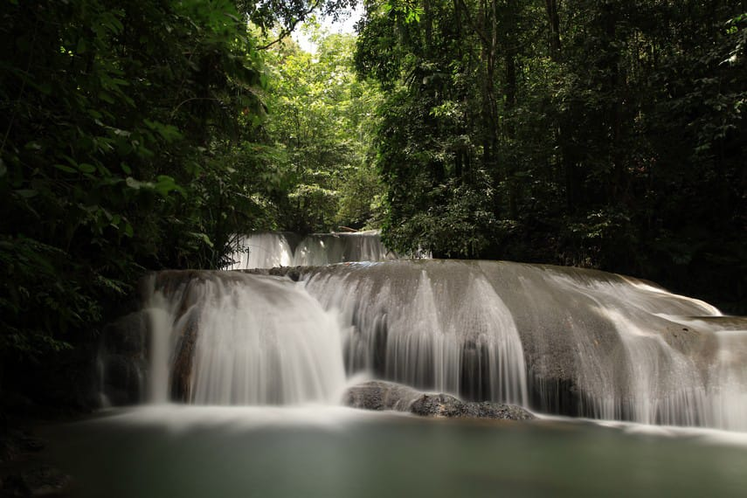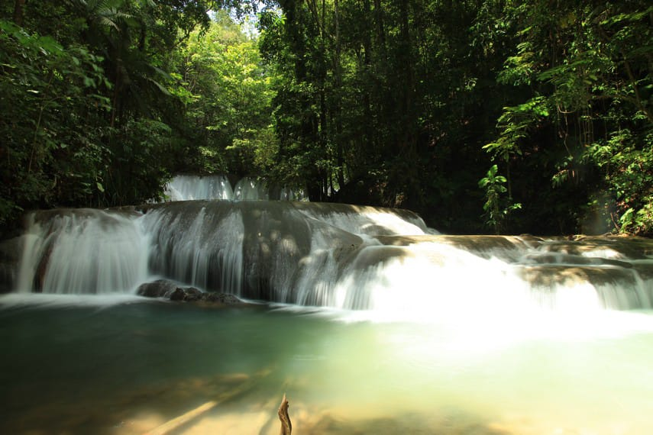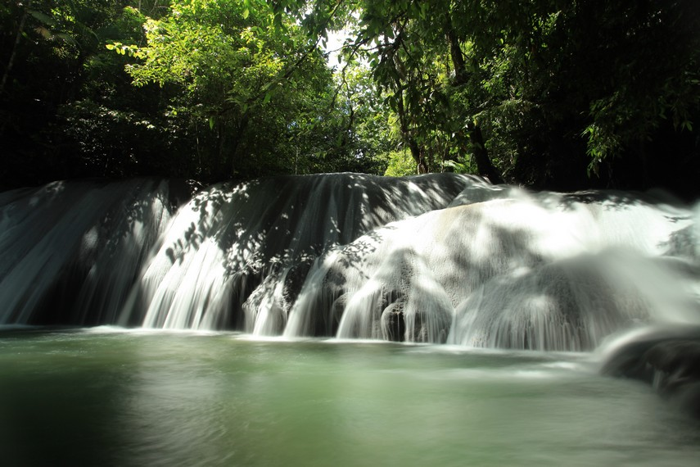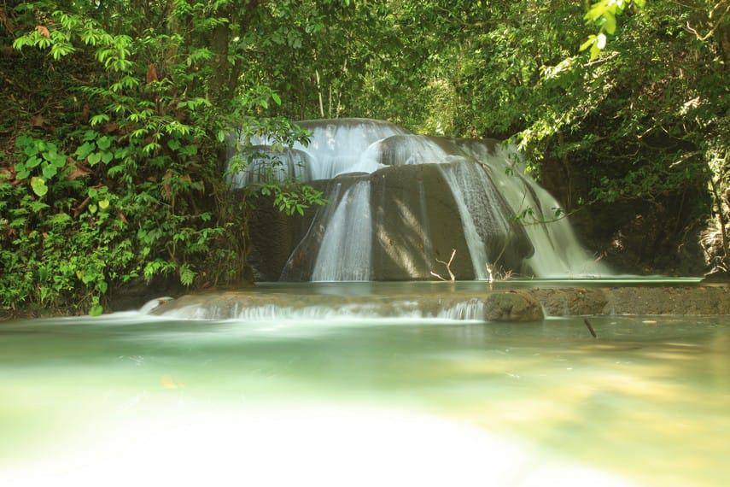

**Figure 1.** Lumoli Waterfall (*Telepipi*) which is photographed from all angles to show the beauty of the waterfall

As a traditional *Negeri*, of course, the people of *Negeri* Lumoli have socio-cultural characteristics and customs inherent in their social life. Besides socio-cultural and historical resources, *Negeri* Lumoli has abundant natural resource potential, but these potentials have not been managed. This explanation can illustrate that *Negeri* Lumoli has the potential for ecotourism but has not been developed optimally by the community and the government to support the development of ecotourism in *Negeri* Lumoli sustainable tourism. It is hoped that if the development of the potential of natural resources, socio-cultural and historical resources in *Negeri* Lumoli is carried out optimally and comprehensively, it will provide great benefits for local communities, tourists, preserve the natural environment and contribute to education. Therefore, cooperation from the central government, provincial governments, regional governments, *Negeri* governments, traditional institutions, educational institutions, and community participation and support for the sustainable development of Lumoli's ecotourism is needed. The community also has hope for the government to rebuild damaged road and bridge infrastructure to attract tourists to visit again. The government is also expected to carry out community empowerment in the form of training and capacity building and also provide financial assistance or business capital so that people can have the ability to manage and develop the potential of existing resources.

CONCLUSION

The low level of knowledge of the people of *Negeri* Lumoli regarding Ecotourism is because there are no government agencies through related agencies and also other institutions conducting socialization to the community related to the development of the ecotourism potential of Lumoli Waterfall as an object of ecotourism based on nature, social culture and economy. The damage to access to ecotourism sites is also an obstacle for the community to manage. Therefore, local governments must solve the problems of infrastructures in *Negeri* Lumoli. The potential of natural resources and socio-cultural and historical potential can be an attraction that supports sustainable tourism in *Negeri* Lumoli. The community has various types of long-lived plants such as Lasa Wood Trees, Durian Trees, Clove Trees, Nutmeg Trees, Damar Trees, Coconut Trees, and Palm Trees. There are also garden products in the form of short-lived plants planted and managed by the community. The Empowerment of local communities in the form of training, capacity building, financial/capital assistance in the form of assistance for Micro, Small, and Medium Enterprises (MSMEs) is needed so that the community has the ability and opportunity to manage forest products such as short-lived plants as culinary snacks and sold to tourists or visitors. Meanwhile, long-lived plants such as durian and coconut are fruits in great demand by tourists. The tradition consists of harvesting cloves, nutmeg and processing water from palm trees (*mayang*) into brown sugar or *Sopi*traditional liquor. The local community's traditions can also be an attraction for tourists to learn about the local knowledge of the Lumoli people. Traditions that are still being preserved have been passed down to this day, and the local community has not understood even locations that contain historical values as potential. In addition, if the community develops handicrafts, it is expected to help the community's economic benefits. The sustainable development of Lumoli's ecotourism requires the support of the central government, provincial governments, regional governments, and the involvement of the *Negeri* government, traditional institutions, educational institutions, and community participation. The government policy is important to rebuild infrastructure, to show efforts and commitments to implement community empowerment in the form of training and capacity building, as well as providing financial assistance or business capital to local communities.

**ACKNOWLEDGEMENT**

This research was funded by the Rector of the University of Pattimura which is a material expenditure fund for research activities for educators/lecturers with a decree no. 1349/UN13/SK/2021, led by Elsina Titaley.

**REFERENCES**

Açiksöz, S., Cetinkaya, G. C., Uzun, O., Erduran Nemutlu, F., & Ilke, E. F. (2016). Linkages among ecotourism, landscape and natural resource management, and livelihood diversification in the region of Suʇla Lake, Turkey. *International Journal of Sustainable Development and World Ecology*, *23*(1), 15–27. https://doi.org/10.1080/13504509.2015.1086906

Aly, B. (2019). The emergence of EU defense research policy: from innovation to militarization, innovation, technology, and knowledge management. *Defence Studies*, *19*(2), 205–206. https://doi.org/10.1080/14702436.2019.1586435

Asnawi, A., Kartini, D., Afiff, F., & Rufaidah, P. (2018). “City marketing: Scale development and measurement indicators applicated to Maluku province- Indonesia.” *Cogent Business and Management*, *5*(1), 1–15. https://doi.org/10.1080/23311975.2018.1525827

Carballo, R. R., & León, C. J. (2018). The influence of artistically recreated nature on the image of tourist destinations: Lanzarote’s art, cultural and tourism visitor centres and their links to sustainable tourism marketing. *Journal of Sustainable Tourism*, *26*(2), 192–204. https://doi.org/10.1080/09669582.2017.1338292

Carter, M. J. (2013). The Hermeneutics of frames and framing: An examination of the media’s construction of reality. *SAGE Open*, *3*(2), 1–12. https://doi.org/10.1177/2158244013487915

Chairy, & Syahrivar, J. (2019). Bika Ambon of Indonesia: History, culture, and its contribution to tourism sector. *Journal of Ethnic Foods*, *6*(2), 2–7. https://doi.org/10.1186/s42779-019-0006-6

Cianga, N. (2017). the Impact of Tourism Activities. a Point of View. *Risks and Catastrophes Journal*, *20*(1/2017), 25–40. https://doi.org/10.24193/rcj2017_02

Comerio, N., & Strozzi, F. (2019). Tourism and its economic impact: A literature review using bibliometric tools. *Tourism Economics*, *25*(1), 109–131. https://doi.org/10.1177/1354816618793762

Creswell, John W. 2014. *Research* *Design, Qualitatives, Quantitative, and Mixed Methods Approcahes (Fourth Edition)*. United State of America: Sage Publications.

Dulipovici, A., & Baskerville, R. (2015). An eduction model of disciplinary emergence: The ripples of knowledge management. *Knowledge Management Research and Practice*, *13*(2), 115–133. https://doi.org/10.1057/kmrp.2013.34

Fang, W. T., Lien, C. Y., Huang, Y. W., Han, G., Shyu, G. S., Chou, J. Y., & Ng, E. (2018). Environmental literacy on ecotourism: A study on student knowledge, attitude, and behavioral intentions in China and Taiwan. *Sustainability (Switzerland)*, *10*(6). https://doi.org/10.3390/su10061886

Fennell, D. A. (2008). Ecotourism – 3rd edition. London: Routledge, 17-31.

Hall, C. M. (2019). Constructing sustainable tourism development: The 2030 agenda and the managerial ecology of sustainable tourism. *Journal of Sustainable Tourism*, *27*(7), 1044–1060. https://doi.org/10.1080/09669582.2018.1560456

Horng, J. S., Hsu, H., & Tsai, C. Y. (2017). The conceptual framework for ethics and corporate social responsibility in Taiwanese tourism industry. *Asia Pacific Journal of Tourism Research*, *22*(12), 1274–1294. https://doi.org/10.1080/10941665.2017.1391854

Huwae, V. E., Noermijati, N., Rofiaty, R., & Sabil, A. (2020). The mediating role of destination value , tourist satisfaction , and tourist engagement on the relationship between destination image and tourist loyalty in Maluku, Indonesia. *Leisure/Loisir*, *44*(4), 587–620. https://doi.org/10.1080/14927713.2020.1815563

Jena, R. K., & Dwivedi, Y. (2021). Prioritizing the barriers to tourism growth in rural India: an integrated multi-criteria decision making (MCDM) approach. *Journal of Tourism Futures*, *January*. https://doi.org/10.1108/JTF-10-2020-0171

Khah, S. A., & Wani, K. A. (2011). Ecotourism and the impact of the conventional tourism. *International Journal of Science and Nature*, *2*(3), 432–442

Kia, Z. (2021). Ecotourism in indonesia: local community involvement and the affecting factors. *Journal of Governance and Public Policy*, *8*(2), LAYOUTING. https://doi.org/10.18196/jgpp.v8i2.10789

Lesar, L., Weaver, D., & Gardiner, S. (2020). Beyond certification: an empirically expanded quality control tool ‘multiverse’ for sustainable tourism. *Journal of Sustainable Tourism*, *28*(10), 1625–1645. https://doi.org/10.1080/09669582.2020.1745218

Matiku, S. M., Zuwarimwe, J., & Tshipala, N. (2021). Sustainable tourism planning and management for sustainable livelihoods. *Development Southern Africa*, *38*(4), 524–538. https://doi.org/10.1080/0376835X.2020.1801386

Mellon, V., & Bramwell, B. (2016). Protected area policies and sustainable tourism: influences, relationships and co-evolution. *Journal of Sustainable Tourism*, *24*(10), 1369–1386. https://doi.org/10.1080/09669582.2015.1125909

Mtapuri, O., & Giampiccoli, A. (2019). Tourism, community-based tourism and ecotourism: a definitional problematic. *South African Geographical Journal*, *101*(1), 22–35. https://doi.org/10.1080/03736245.2018.1522598

Miles, M. B. & Huberman, A. M. (1984). *Qualitative Data Analysis: A Sourcebook of New Methods*. California; SAGE publications Inc.

Novelia, S., Aulya, Y., & Regiyanti, E. (2021). The Effect of breast self-examination (BSE) class on knowledge and practice of breast self-examination among adolescent girls. *Nursing and Health Sciences Journal (NHSJ)*, *1*(1), 49–53. https://doi.org/10.53713/nhs.v1i1.16

Pasape, L., Anderson, W., & Lindi, G. (2015). Assessment of indicators of sustainable ecotourism in Tanzania. *Anatolia*, *26*(1), 73–84. https://doi.org/10.1080/13032917.2014.912244

Rahman, M. K., Masud, M. M., Akhtar, R., & Hossain, M. M. (2021). Impact of community participation on sustainable development of marine protected areas: Assessment of ecotourism development. *International Journal of Tourism Research*, *January*, 1–11. https://doi.org/10.1002/jtr.2480

Ren, T., Can, M., Paramati, S. R., Fang, J., & Wu, W. (2019). The impact of tourism quality on economic development and environment: Evidence from Mediterranean Countries. *Sustainability*, *11*(8), 1-17. https://doi.org/10.3390/su11082296

Rivera, J. P. R., & Gutierrez, E. L. M. (2019). A framework toward sustainable ecotourism value chain in the Philippines. *Journal of Quality Assurance in Hospitality and Tourism*, *20*(2), 123–142. https://doi.org/10.1080/1528008X.2018.1492495

Salman, A., Jaafar, M., Mohamad, D., & Malik, S. (2021). Ecotourism development in Penang Hill: a multi-stakeholder perspective towards achieving environmental sustainability. *Environmental Science and Pollution Research*, *28*(31), 42945–42958. https://doi.org/10.1007/s11356-021-13609-y

Titaley, E. (2018). Pela Dan Gandong Culture As Basic of A Network Formation For Poverty Alleviation In The Village. *Advances in Social Sciences Research Journal*, *5*(3). https://doi.org/10.14738/assrj.53.4247

Titaley, E., Kanto, S., Wisadirana, D., & Mardiyono, M. (2018). Article-9 Poverty and local potentials. [*Ecology, Environment and Conservation, 23*(3), 63-75.](http://www.envirobiotechjournals.com/journal_details.php?jid=3)

Titaley, E., & Pariela, T. D. (2021). Isolation : The Root Cause of Indigenous Poverty in Lumoli Village. *Journal of Hunan University, 48*(6), 172-182

Wondirad, A. (2019). Does ecotourism contribute to sustainable destination development, or is it just a marketing hoax? Analyzing twenty-five years contested journey of ecotourism through a meta-analysis of tourism journal publications. *Asia Pacific Journal of Tourism Research*, *24*(11), 1047–1065. https://doi.org/10.1080/10941665.2019.1665557

WTO. (2005). Making Tourism More Sustainable – A Guide for Policy Makers (English version). Word Tourism Organization. DOI: 10.18111/9789284408214.