**THE INFLUENCE OF DECENTRALIZATION POLICY AND FAMILY HOPE PROGRAM ON SOCIAL WELFARE IN URBAN AREAS THROUGH SOCIAL ASSISTANCE**

**Khairuddin Tampubolon1*, Elazhari2**

1,2Faculty of Administrative Sciences, Universitas Pembinaan Masyarakat Indonesia, Indonesia

*Corresponding Author email: khoir.tb@gmail.com

**Abstract**

Social welfare is one of the important indicators in assessing the success of regional development. In Indonesia, decentralization regulated in Law Number 23 of 2014 gives authority to local governments to manage and regulate affairs in their regions, including in terms of social welfare. One effort to improve social welfare is through the Family Hope Program (PKH), a conditional social assistance program that aims to reduce poverty and improve the quality of life of the poor. In Medan City, the implementation of decentralization policies and the PKH program is the main strategy in accelerating poverty alleviation and increasing public access to education, health, and other basic needs. Social assistance distributed through PKH is expected to have a direct impact on social welfare, both in the short and long term. However, the effectiveness of this policy still requires further study to understand its specific impact on the community in Medan City. The purpose of this study was to determine the effect of the Decentralization Policy and the Family Hope Program (PKH) on Social Welfare in Medan City with the Intervening Media of the Social Assistance Program. The sample used a purposive sampling technique to obtain respondents who were relevant to the study. The research method used is quantitative research, namely by distributing questionnaires to 100 respondents from the Medan City community, North Sumatra who received Social Assistance and the Family Hope Program (PKH). The results of this study: 1) There is an influence of the Decentralization Policy on the Social Welfare of the Medan City, North Sumatra with a value of 24.1%; 2) There is an influence of the Family Hope Program (PKH) on the Social Welfare of the Medan City, North Sumatra 45.7%; 3) The magnitude of the influence of the Social Assistance Program on Social Welfare partially is 2.5%; 4) The magnitude of the influence of the Decentralization Policy and the Family Hope Program (PKH) on Social Welfare in the Medan City with the Intervening Media of the Social Assistance Program is: 67.5% + 2.5% = 70%.

Keywords: Decentralization; Family Hope Program; Social Welfare; Social Assistance Program.

**PENGARUH KEBIJAKAN DESENTRALISASI DAN PROGRAM KELUARGA HARAPAN TERHADAP KESEJAHTERAAN SOSIAL DI PERKOTAAN MELALUI BANTUAN SOSIAL**

**Khairuddin Tampubolon1*, Elazhari2**

1,2Fakultas Ilmu Administrasi, Universitas Pembinaan Masyarakat Indonesia, Indonesia

*Corresponding Author email: khoir.tb@gmail.com

**Abstrak**

Kesejahteraan sosial merupakan salah satu indikator penting dalam menilai keberhasilan pembangunan suatu daerah. Di Indonesia, desentralisasi yang diatur dalam Undang-Undang Nomor 23 Tahun 2014 memberikan kewenangan kepada pemerintah daerah untuk mengelola dan mengatur urusan di wilayahnya, termasuk dalam hal kesejahteraan sosial. Salah satu upaya untuk meningkatkan kesejahteraan sosial adalah melalui Program Keluarga Harapan (PKH), sebuah program bantuan sosial bersyarat yang bertujuan untuk mengurangi kemiskinan dan meningkatkan kualitas hidup masyarakat miskin. Di Kota Medan, implementasi kebijakan desentralisasi dan program PKH menjadi strategi utama dalam mempercepat pengentasan kemiskinan dan meningkatkan akses masyarakat terhadap pelayanan pendidikan, kesehatan, dan kebutuhan dasar lainnya. Bantuan sosial yang disalurkan melalui PKH diharapkan mampu memberikan dampak langsung terhadap kesejahteraan sosial, baik dalam jangka pendek maupun panjang. Namun, efektivitas kebijakan ini masih memerlukan kajian lebih lanjut untuk memahami pengaruhnya secara spesifik terhadap masyarakat di Kota Medan. Tujuan penelitian ini utuk mengetahui pengaruh Kebijakan Desentralisasi dan Program Keluarga Harapan (PKH) terhadap Kesejahteraan Sosial di Kota Medan dengan Media Intervening Program Bantuan Sosial. Sampel menggunakan teknik purposive sampling untuk mendapatkan responden yang relevan dengan penelitian. Metode penelitian yang digunakan adalah penelitian kuantitatif yaitu dengan menyebar angket kepada 100 responden masyarakat Kota Medan Sumatera Utara yang menerima Bantuan Sosial dan Program Keluarga Harapan (PKH). Adapun hasil penelitian ini:1) Terdapat pengaruh Kebijakan Desentralisasi terhadap Kesejahteraan Sosial Kota Medan Sumatera Utara dengan nilai 24,1 %; 2) Terdapat pengaruh Program Keluarga Harapan (PKH) terhadap Kesejahteraan Sosial Kota Medan Sumatera Utara 45,7 %; 3) Besarnya pengaruh Program Bantuan Sosial terhadap Kesejahteraan sosial secara Parsial adalah 2,5 %; 4) Besarnya pengaruh Kebijakan Desentralisasi dan Program Keluarga Harapan (PKH) terhadap Kesejahteraan Sosial di Kota Medan dengan Media Intervening Program Bantuan Sosial adalah sebesar: 67,5 % + 2,5 % = 70 %.

Kata kunci: Desentralisasi; Program Keluarga Harapan; Kesejahteraan Sosial; Program Bantuan Sosial.

**INTRODUCTION**

Decentralization is one of the government's policies to give wider autonomy to regions in resource management and public policy. In the context of social welfare, decentralization allows regions to design and implement programs that are more in line with local conditions. One of the important national programs in improving social welfare is the Family Hope Program (PKH), which provides conditional social assistance to poor and vulnerable families.

The policy of decentralization in Indonesia was enacted based on Law No. 22 of 1999 concerning local government in early January 2001. Law No. 22 of 1999, Law No. 25 of 1999, and Government Regulation No. 105 of 2000 as well as the guidelines set by the Minister of Home Affairs above show that the beginning of 2001 was a runway for the decentralization of government massively and drastically, and can even be called an extraordinary leap in governance in this country. Of course, the embodiment of this decentralization is regional autonomy, where in this regional autonomy local governments have the right, authority, and obligation to regulate and manage their own households in accordance with the applicable laws and regulations.(Undang-undang, 1999).

Furthermore, Family Hope (PKH) is a program that provides cash assistance to Very Poor Households (RTSM), if they meet the requirements related to efforts to improve the quality of human resources (HR), namely education and health. However, in their implementation, decentralization and PKH policies often require further adjustments in order to be effective, especially in urban areas with high levels of social inequality. This is where the role of social assistance programs as an intervening medium becomes important. The social assistance program serves as a bridge that connects the policy of decentralization and the implementation of PKH to achieve the desired results in improving social welfare. Social assistance according to the Regulation of the Minister of Home Affairs Number 32 of 2011 is the provision of assistance in the form of money or basic necessities from local governments to individuals, families, and/or communities that are selective.(Undang-Undang, 2009).

All efforts made by the government above are for the purpose of social welfare. According to Law Number 11 of 2009 concerning Social Welfare, "welfare is a condition for the fulfillment of the material, spiritual, and social needs of citizens in order to live a decent life and be able to develop themselves so that they can carry out their social functions".(Undang-Undang, 2009). According to Pigou (1960), the economic theory of social welfare is a part of social welfare that can be directly or indirectly related to the measurement of money.(Pigou, 1960).

1. Problem Formulation
2. How does the policy of decentralization affect social welfare in urban areas?
3. How does the Family Hope Program (PKH) affect social welfare in urban areas?
4. Does social assistance programs as an intervening medium have a significant impact in strengthening the relationship between decentralization policies, PKH, and social welfare in urban areas?
5. Research Objectives
6. Analyze the influence of decentralization policies on social welfare in urban areas.
7. Analyze the influence of the Family Hope Program (PKH) on social welfare in urban areas.
8. Examine the role of social assistance programs as an intervening medium in improving social welfare through decentralization policies and PKH.
9. Research Benefits

This research is expected to provide benefits both academically and practically, especially for the formulation of social welfare policies in urban areas. In addition, the results of this study can be used as a reference in the development of social assistance policies and the implementation of PKH in the future.

**LITERATURE REVIEW**

1. **Decentralization Policy**

Decentralization based on the level or level of authority given to local governments is broadly divided into four types, namely:

1. *Deconcentration* : the handing over of a number of administrative authorities or responsibilities to a lower level in a government ministry.
2. *Delegation:* the transfer of responsibility for certain functions to the organization outside the regular bureaucratic structure and only controlled by the central government indirectly.
3. *Devolution* : the establishment and strengthening of government units on a subnational basis with substantial activities in the central government office.
4. *Privatization* : assigns all responsibilities or functions to a non-governmental organization or a private company that is independent of the government.(Rondinelli, 2020) Decentralization is the process of transferring authority from the central government to local governments. In the context of social welfare, decentralization provides opportunities for local governments to design and implement welfare programs that are in accordance with local needs.

The presence of Law No. 22 of 1999 and Law No. 25 of 1999 does not seem to be able to provide solutions related to Decentralization in Indonesia, especially regional fiscal decentralization. Therefore, the government then revised the two laws. Law No. 22 of 1999 was revised to Law No. 32 of 2004 concerning Regional Government and Law No. 25 of 1999 was revised to Law No. 33 of 2004 concerning Financial Balance between the Central Government and Regional Governments. Along with the running of the government, all laws and regulations that have been passed previously have undergone changes to be more optimal in their implementation in the field. In this case, Law No. 22 of 1999 was amended into Law No. 32 of 2004 concerning Regional Government which regulates the political and administrative authority and responsibilities of the central, provincial, city, and district governments in a decentralized structure. Meanwhile, Law No. 25 of 1999 was amended into Law No. 33 of 2004 concerning Financial Balance between the Central Government and Regional Governments, providing a legal basis for fiscal decentralization by establishing new rules on the distribution of revenue sources and transfers between governments.(Undang-undang, 2004).

The following will be explained about the differences in the content of laws on local government, starting from law number 22 of 1999, law number 32 of 2004, and law number 23 of 2014(Undang-undang, 2004) Viewed in terms of principles and the division of authority between the provincial government and the district/city as shown in Table 1 below:

Table 1. Differences in the content of Law no. 22 of 1999, Law no. 32 of 2004, and Law no. 23 of 2014

|  |  |  |  |  |  |  |  |  |  |
| --- | --- | --- | --- | --- | --- | --- | --- | --- | --- |
| No. | | Side | | Law No. 22 of 1999 | | Law No. 32 of 2004 | | Law No. 23 of 2014 | |
| 1 | Foundation | | Foundation  Decentralization  and deconcentration  for provincial areas and  Principles of Decentralization  to area  Regency/City | | There are nine principles used in the implementation of local government, namely the principle of legal certainty,  orderly  the administration of the State, public interest, openness, proportionality, professionalism, accountability,  efficiency and effectiveness. | | There is an additional principle of  law  previously that is  Principles of Justice | |
| 2 | Division of authority between governments  provinces with  Regency / City | | The focus of regional autonomy is focused on regional heads  (Regency/City)  not the provincial government. In addition, the provincial area is only an administrative area | | There are several affairs of the regency/city government with the province that overlap | | Some matters related to crossings  Regency/City Regions Submitted  its authority to the province,  while  Regency / City  only has the authority to regulate affairs within the region  Regency / City | |
|  |

Source: data made by researchers in 2024

The explanation of the difference in the content of the law on financial balance between the central government and local governments in Indonesia starting from law number 25 of 1999 to law number 33 of 2004 will be explained in the following table 2:

Table 2. Differences in the content of the Law on Financial Balance Between the Central Government and Regional Governments in Indonesia

|  |  |  |  |
| --- | --- | --- | --- |
| No. | Side | Law No. 25 of 1999 | Law No. 33 of 2004 |
| 1 | Regulation | There is no article that regulates or prohibits regions in an effort to increase Regional Original Revenue (PAD) | There is an article that regulates or prohibits regions in an effort to improve  Income Original Area  (PAD) |
| 2 | Income | Income from the superior government in the form of subsidies, assistance or rewards | Revenue from the superior government is in the form of a balance fund consisting of tax and non-tax revenue sharing, DAU and DAK |

Source: data made by researchers in 2024

1. **Family Hope Program (PKH)**

PKH is a conditional social assistance program that aims to reduce poverty and improve the quality of life of poor families through the provision of cash assistance related to the fulfillment of certain conditions, such as access to education and health. According to Sofianto, the Family Hope Program (PKH) aims to open access for poor families to get various health service facilities and educational services, as well as access to efforts to improve welfare for vulnerable groups, (Sofianto, 2020). Target Recipients of the Family Hope Program The Target or PKH assistance recipients are Poor Families (KM) and those who have a health component (pregnant women, postpartum mothers, toddlers, preschool children) and education components (elementary school equivalent, junior high school equivalent, high school equivalent) or children aged 6-12 years who have not completed 12 years of compulsory education. The recipient of assistance is a mother or an adult woman who takes care of children in the household concerned (if there is no mother, then grandmothers, aunts/aunts, or older sisters can be beneficiaries of assistance). As proof of PKH membership, a PKH participant card is given in the name of an adult mother or woman. The card is used to receive PKH assistance. Furthermore, the PKH card can function as a JAMKESMAS card for all families receiving the PKH as described in the 2009 JAMKESMAS implementation guidebook.(Kementrian Sosial, 2016). The basis for the implementation of the Family Hope Program (PKH) includes the Decree of the Coordinating Minister for People's Welfare as the Chairman of the Poverty Alleviation Coordination Team, No: 31/KEP/MENKO/- KESRA/IX/2007 concerning the "Family Hope Program Control Team" dated September 21, 2007; Decree of the Minister of Social Affairs of the Republic of Indonesia No.02A/HUK/2008 concerning the "Implementation Team of the Family Hope Program (PKH) in 2008" dated January 8, 2008.(Kementrian Sosial, 2016)

1. **Social Assistance Program as Media Intervening**

Social assistance programs are often used as interventions to ensure that implemented policies achieve the specified targets, especially in the context of PKH and decentralization. This program plays a role in improving the distribution of resources and encouraging the improvement of Social Welfare. Definition of social assistance According to the Center for Social Extension (Tristanto, 2020), it is a fund or goods transfer program intended to reduce poverty by distributing prosperity and protecting households from changes in income conditions, where the assistance is aimed at meeting the minimum level of decent living, and the minimum level of nutrition, as well as helping households to anticipate existing risks. Meanwhile, the definition of social assistance according to the Regulation of the Minister of Finance Number 254/PMK.05/2015 concerning Social Assistance Expenditure at State Ministries/Institutions is expenditure in the form of money transfers, basic necessities or services provided by the Government to the poor or unable to protect the community from the possibility of social risks and improve economic capabilities. According to Government Regulation Number 58 of 2005, the purpose of providing social assistance is to improve social welfare and overcome matters related to social risks.(Pemerintah, 2005). The criteria for receiving social assistance according to the Minister of Social Affairs Regulation Number 1 of 2019 are based on social problems, namely: a. Poverty b. Neglect c. Disability d. Remoteness e. Social disability or behavioral deviation f. Disaster victims g. Victims of violence, exploitation, discrimination, abuse of narcotics, psychotropics, and other addictive substances.(Peraturan Menteri, 2019).

Various types and amounts of social assistance are varied. Social assistance is also distributed to improve Social Welfare. The types of social assistance are as follows:

1. Family Hope Program (PKH)

The Family Hope Program is a program to provide conditional social assistance to poor families, namely poor families, especially pregnant women and children, to take advantage of various available health service facilities and educational service facilities as well as people with disabilities and the elderly by maintaining their social welfare level.(Peraturan Menteri, 2019)

1. Non-Cash Food Assistance (BPNT)

Non-Cash Food Assistance is a non-cash food social assistance from the government that is given to KPM every month through an electronic account mechanism that is used only to buy food at food traders in collaboration with banks.(Peraturan Menteri, 2019).

1. Cash Social Assistance (BST)

Cash Social Assistance (BST) is assistance in the form of money given to poor, underprivileged, and/or vulnerable families affected by the pandemic outbreak by

Rp.600,000/family/month.(Peraturan Menteri, 2019).

1. Provision of Contribution Assistance (PBI).

The Contribution Assistance Program is intended for community groups with middle to lower economic conditions or people who are underprivileged in the form of health insurance contributions that are deposited with BPJS Kesehatan every month.

The Pre-Employment Card program is a work competency and entrepreneurship development program in the form of cost assistance intended for job seekers, workers who have been laid off, or workers who need to improve their competence, including micro and small business actors.(Prakerjagoid, 2021).

1. **Social Welfare**

Social welfare refers to the conditions in which individuals or groups of people can meet their basic needs, including in terms of education, health, and adequate income to live a decent life. According to Suharto, with various opinions about social welfare from several figures, the concept of social welfare can be concluded, namely:

1. Able to meet all the needs needed by a person
2. An activity carried out by a social welfare institution that organizes social welfare businesses
3. A form of activity or effort carried out to achieve a prosperous life.(Edi, 2017).

The social welfare function aims to reduce problems caused by socio-economic changes, as well as create conditions that can improve social welfare. The following are the functions of social welfare stated by Fahrudin, namely:

1. Prevention function. In this case, welfare plays a role in preventing social problems that arise in society by creating new patterns in social relations.
2. Healing function. Social welfare serves to eliminate and improve physical and emotional inability in dealing with a problem so that it can function reasonably in society.
3. Development function. Social welfare plays a role in the process of Social Assistance Programs and social resources in the community.
4. Supporting functions. Social welfare plays a role in activities to help achieve the goals or fields of social services.(Adi, 2014).

According to Fahrudin, the main goals of social welfare include the fulfillment of daily needs, namely clothing, food, board, and access to education and health that are easy to reach. As well as making adjustments to the surrounding community, for example improving and developing a decent standard of living. (Adi, 2014). In addition to having a purpose and function, social welfare has components that must be considered that these components can later make a difference between social welfare activities and other activities. Fahrudin concluded that all of these components are:

* + 1. Formal organization

Organized social welfare efforts carried out by formal social institutions to gain recognition from the community for providing servants for providing services that are

is the main function of social welfare institutions.

* + 1. Funding

Fund mobilization is a shared responsibility because social welfare activities or businesses do not pursue profits.

* + 1. Human needs

Social welfare looks at all human needs, not only focusing on one aspect to meet all human needs. In order to meet all these aspects, formal institutions provide social welfare services.

* + 1. Professionalism

Social welfare services are of course carried out with predetermined processes and regulations.

* + 1. Legal and legislative apparatus

The importance of laws and regulations to carry out social welfare services in a structured and targeted manner.

* + 1. Community participation

Welfare activities involve all levels of society in order to provide benefits for the community itself.

* + 1. Data and information

Data and information are needed in providing social welfare services to facilitate the efficient delivery of services. (Adi, 2014).

**RESEARCH METHODS**

1. Research Approach

This study uses a quantitative approach with a survey method. Data will be collected through a questionnaire distributed to respondents who are beneficiaries of the Family Hope Program (PKH) in urban areas.

1. Population and Sample

The population in this study is all PKH recipient families in several urban areas. The sample was taken from the community in Medan City, North Sumatra using the purposive sampling technique to get respondents relevant to the research. With a sample of 100 people

1. Data Collection Techniques

Primary data was collected through questionnaires, while secondary data was obtained from government reports, journals, and literature related to decentralization policies, PKH, and social assistance programs.

1. Data Analysis Techniques

Regression data analysis using SPSS software version 26 (Ghozali, 2021)with a path analysis model to test the relationship between independent variables (decentralization and PKH), intervening variables (social assistance programs), and dependent variables (social welfare).

**RESULTS AND DISCUSSION**

The research was carried out by distributing questionnaires to people who received Social Assistance and the Family Hope Program (PKH) and several employees of the sub-district and sub-district offices. Then the questionnaire was recapped using Excell Office 2019. Next, it is processed using SPSS software version 26 (Ghozali, 2021) with the following results:

1. Test Data Validity and Reality

After testing, a summary of the results was obtained as follows:

Table 3. Results of Variable Valicity and Reliability Test X1,X2,Z and Y

|  |  |  |  |
| --- | --- | --- | --- |
| It | Variable | Validity Test | Reliability Test |
| 1 | Social Welfare | All rcounts (Y) > r table = 0.1986 | *Cronbach's Alpha*  (X1)=0.961>0.60 |
| 2 | Decentralization Policy | All rcalculate(X1)>r table = 0.1986 | *Cronbach's Alpha*  (X1)=0.945 >0.60 |
| 3 | Family Hope Program (PKH) | All rcalculate(X2)>r table = 0.1986 | *Cronbach's Alpha*  (X1)=0.957 >0.60 |
| 4 | Social Assistance Programs | All rcounts (Z) > r table = 0.1986 | *Cronbach's Alpha*  (X1)=0.952 >0.60 |

The source is processed by researchers in 2024.

Based on the table above, the results of the Validity and Reliability test of all variables, namely All rcalculated > r table = 0.1986, then it can be stated that the data is valid and **reliable.**

1. Results of the Normality Test with the One-Sample Kolmogorov-Smirnov Test

Table 4. One-Sample Kolmogorov-Smirnov Test

|  |  |  |
| --- | --- | --- |
|  | | Unstandardized Residual |
| N | | 96 |
| Normal Parametersa,B | Mean | .0000000 |
| Std. Deviation | 6.36005897 |
| Most Extreme Differences | Absolute | .081 |
| Positive | .081 |
| Negative | -.047 |
| Test Statistic | | .081 |
| Asymp. Sig. (2-Tailed) | | .124c |
| A. Test Distribution Is Normal. | | |
| B. Calculated From Data. | | |
| C. Lilliefors Significance Correction. | | |

The source is processed by researchers in 2024.

Based on the table above, the results of *the Kolmogorov-Smirnov normality test*, obtained the results of *the Asymp. Sig.* 0.124 > 0.05, thus the results of the *Kolomogorov-Smirnov* test above have met the normality requirements with a value of Sig. > α= 0.05. This, it can be concluded that the tested data has **a normal data distribution.**

1. Skewnes and Curtosis Test Results

Table 5. Skewnes and Kurtosis Test

|  |  |  |  |  |  |
| --- | --- | --- | --- | --- | --- |
|  | N | Skewness | | Curtosis | |
| Statistics | Statistics | Std. Error | Statistics | Std. Error |
| Unstandardized Residual | 96 | .334 | .246 | -.097 | .488 |
| Valid N (listwise) | 96 |  |  |  |  |

The source is processed by researchers in 2024.

Based on the table above, it can be seen that the *Skewness Statistic value* is 0.097 > -2 and the Kurtosis *Statistic* value is 0.334 < 2. So it can be stated that the tested data has a normal data distribution.

1. Results of the Normality Test by looking at the Histogram

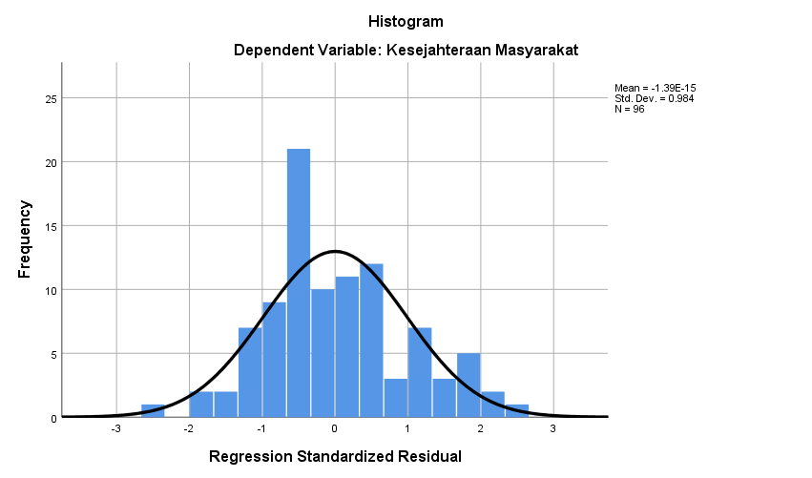

Picture 1. Normality Test Histogram

The source is processed by researchers in 2024.

1. Results of the Normality Test with P-P Plot Diagram

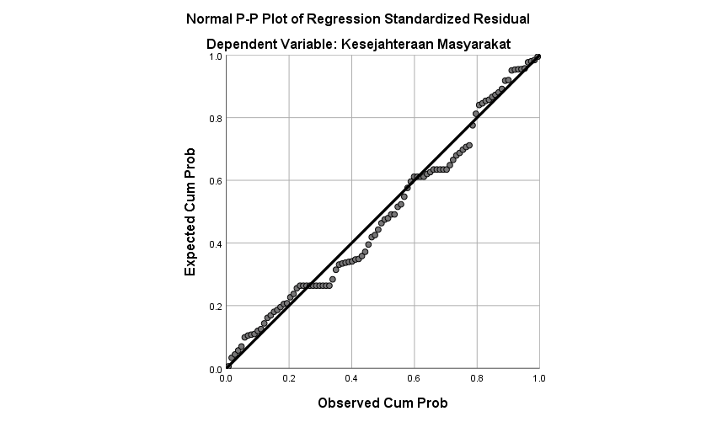

Picture 2. Normality with P-P Plot Diagram

The source is processed by researchers in 2024.

1. Heteroscedasticity Test Results

Table 6. Heteroscedasticity test by looking at the significance value

|  |  |  |  |  |  |  |
| --- | --- | --- | --- | --- | --- | --- |
| Coefficientsa | | | | | | |
| Type | | Unstandardized Coefficients | | Standardized Coefficients | t | Sig. |
| B | Std. Error | Beta |  |  |
| 1 | (Constant) | 18.147 | 5.503 |  | 3.298 | .001 |
| Decentralization Policy | -.122 | .040 | -.310 | -3.045 | .213 |
| Family Hope Program (PKH) | .057 | .073 | .103 | .778 | .438 |
| Social Assistance Programs | -.090 | .063 | -.186 | -1.440 | .153 |
| a. Dependent Variable: RES2 | | | | | | |

The source is processed by researchers in 2024.

1. Results of Heteroscedasticity Test with Scatterplot Diagram

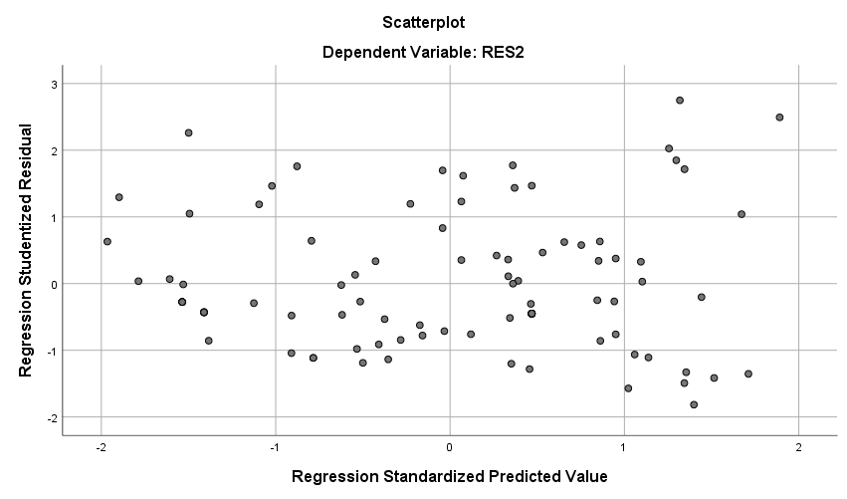

Picture 3. Heteroscedasticity Test with Scatterplot Diagram

The source is processed by researchers in 2024.

From the test results in the figure above, it is shown that there is no clear pattern, and the dots spread above and below the 0 axis on the Y axis, so the indication is that there is no heteroscedasticity.

1. Multiple Linear Regression Test Results

Table 7. Results of Multiple Linear Regression Test X1,X2 and Z to Y

|  |  |  |  |  |  |
| --- | --- | --- | --- | --- | --- |
| Model Summaryb | | | | | |
| Type | R | R Square | Adjusted R Square | Std. Error of the Estimate | Durbin-Watson |
| 1 | .730a | .781 | .757 | 6.463 | 1.7551 |
| a. Predictors: (Constant), Social Assistance Program, Decentralization Policy, Family Hope Program (PKH) | | | | | |
| b. Dependent Variable: Social Welfare | | | | | |

The source is processed by researchers in 2024.

Based on the table above, it is known that the value *of R Square* = 0.781. This shows that 78.1% of Social Welfare (Y) is influenced by Decentralization Policy (X1), and Communication (X2), while the remaining (100% - 78.1%) i.e. 21.9% of Social Welfare (Y) is influenced by other variables outside this study.

Table 8. Multiple Linear Regression Test Results X1,X2 to Y

|  |  |  |  |  |
| --- | --- | --- | --- | --- |
| Model Summary | | | | |
| Type | R | R Square | Adjusted R Square | Std. Error of the Estimate |
| 1 | .525a | .675 | .660 | 6.451 |
| a. Predictors: (Constant), Family Hope Program (PKH), Decentralization Policy | | | | |

The source is processed by researchers in 2024.

Based on the table above, it is known that the value *of R Square* = 0.675. This shows that 67.5% of Social Welfare (Y) is influenced by Decentralization Policy (X1), and Communication (X2), while the remaining 32.5% of Social Welfare (Y) is influenced by other variables outside this study.

1. TEST Result T (Partial)

Table 9. Test T (Partial) X1,X2 and Z against Y

|  |  |  |  |  |  |  |
| --- | --- | --- | --- | --- | --- | --- |
| Coefficientsa | | | | | | |
| Type | | Unstandardized Coefficients | | Standardized Coefficients | t | Sig. |
| B | Std. Error | Beta |  |  |
| 1 | (Constant) | 35.621 | 9.864 |  | 3.611 | .000 |
| Decentralization Policy | .241 | .072 | .306 | 3.344 | .001 |
| Family Hope Program (PKH) | .457 | .131 | .417 | 3.498 | .001 |
| Social Assistance Programs | .392 | .112 | .395 | 3.816 | .003 |
| a. dependent variable: social welfare | | | | | | |

The source is processed by researchers in 2024.

Search t table:

n-k = 96-4 = 92

n= number of respondents

k= number of research variables

The probability value used is 0.05

So that the value of table t = 1,665 is obtained

T Count = X1 = 3.344 > 1.665 = There is an effect of Variable X1 on Y

T Count = X2 = 3.498 > 1.665 = There is an effect of Variable X2 on Y

T Count = Z = 3.816 > 1.665 = There is an influence of the Z Variable on Y

Table 10. Test T (Partial) X1 and X2 against Y

|  |  |  |  |  |  |  |
| --- | --- | --- | --- | --- | --- | --- |
| Coefficientsa | | | | | | |
| Type | | Unstandardized Coefficients | | Standardized Coefficients | t | Sig. |
| B | Std. Error | Beta |  |  |
| 1 | (Constant) | 33.155 | 9.373 |  | 3.537 | .001 |
| Decentralization Policy | .247 | .071 | .314 | 3.464 | .001 |
| Family Hope Program (PKH) | .388 | .099 | .354 | 3.905 | .000 |
| a. Dependent Variable: Social Welfare | | | | | | |

The source is processed by researchers in 2024.

1. Test Results TEST F (Simultaneous)

Table 11. Test F (Simultaneous)

|  |  |  |  |  |  |  |
| --- | --- | --- | --- | --- | --- | --- |
| ANOVAa | | | | | | |
| Type | | Sum of Squares | Df | Mean Square | F | Sig. |
| 1 | Regression | 1498.706 | 3 | 499.569 | 11.960 | .000b |
| Residual | 3842.783 | 92 | 41.769 |  |  |
| Total | 5341.490 | 95 |  |  |  |
| a. Dependent Variable: Social Welfare | | | | | | |
| b. Predictors: (Constant), Social Assistance Program, Decentralization Policy, Family Hope Program (PKH) | | | | | | |

The source is processed by researchers in 2024.

1. The Influence of Decentralization Policy on Social Welfare

The results of the study show that decentralization policies have a significant influence on improving social welfare in urban areas. With regional autonomy, local governments can be more effective in distributing social assistance according to the needs of the community. The results of the analysis can be seen as follows:

The influence of Decentralization Policy (X1) on Social Welfare (Y) is significant with a t-count of 3.344 (t-count) > (t table) of 1.665 and a Sig. = 0.001 < 0.05 value. Then the *coefficient* value of B is positive, which is 0.241, which shows that the Decentralization Policy (X1) has an effect on Social Welfare (Y) by 24.1%. Thus, the H1 hypothesis in this study which states that the Decentralization Policy (X1) has a significant positive effect on Social Welfare (Y) is accepted. Assuming that the greater the value of the Decentralization Policy, the better the Social Welfare.

1. The Effect of the Family Hope Program (PKH) on Social Welfare

PKH has proven to have a positive impact on social welfare, especially in increasing the access of the poor to education and health services. However, the effectiveness of PKH is greatly influenced by the implementation mechanism and support from the local government. The results of the analysis can be seen as follows:

The effect of Communication (X2) with Social Welfare (Y) is significant with a t-count of 3.498 (t-count) > (t table) of 1.665 and a Sig. = 0.000 < 0.05 value. The *coefficient* value of B is positive, which is 0.457, which shows that the direction of influence between Communication (X2) and Social Welfare (Y) is positive by 45.7%. Thus, the H2 hypothesis in this study which states that Communication (X2) has a significant effect on Social Welfare (Y)" is accepted. Assuming that the higher the value of communication, the better the Social Welfare.

1. The Role of Social Assistance Programs as Media Intervening

Social assistance programs have an important role as a medium that strengthens the relationship between decentralization policies and PKH and social welfare. Social assistance is able to ensure that the benefits of decentralization and PKH policies can be felt equally by people in urban areas.

To find out the analysis of the path, the researcher used SPSS version 26 with the following results:

1. Influence Analysis of X1 through Z to Y

It is known that the direct influence given by X1 on Y is 0.306 (beta value in Table 4. 23). While the indirect influence of X1 through Z on Y is the multiplication between the beta value of X1 on Y and the beta value of Z on Y, namely: 0.395 (beta value of Z-Y in table 4.23) x 0.314 (beta value of X1-Y in table 4.24) = 0.12 So the total influence given by X1 on Z is a direct influence plus an indirect influence, namely: 0.306 +0.12= 0.426. Based on the results of the calculation above, it is known that the direct influence is 0.306 and the indirect influence is 0.426 which means that the value of indirect influence is more significant than that of direct influence, this result shows that indirectly X1 through Z has a significant influence on Y.

1. Analysis of the Influence of X2 through Z on Y

It is known that the direct influence given by X2 on Y is 0.417. Meanwhile, the indirect influence of X2 through Z on Y is the multiplication between the beta value of X2 on Y and the beta value of Z on Y, namely: 0.395 (beta value of Z-Y in table 4.22) x 0.354 (beta value of X2-Y in table 4.25) = 0.14. So the total influence given by X2 on Y is a direct influence plus an indirect influence, namely: 0.417 + 0.14 = 0.557. Based on the results of the calculation above, a direct influence value of 0.417 and an indirect influence of 0.557 were obtained, which means that the indirect influence value is greater than the direct influence value, this result shows that indirectly X2 through Z has a significant influence on Y.

1. Analysis of the Influence of X1 and X2 through Z on Y:

Known:

Indirect influence of X1 through Z on Y= 0.426;

Indirect effect of X2 through Z on Y= 0.557;

The direct effect of Z on Y = 0.395.

from the formula obtained:

Y = β1X1+ β2X2+ β3Z+ $ε$ 1 = 0.426 + 0.557 + 0.395 + $\sqrt{1+{0,675}^{2}}$

= 2,578

So it is known that the influence of X1 and X2 through Z on Y is 2.6.

So that the magnitude of the influence of the Decentralization Policy and the Family Hope Program (PKH) on Social Welfare in Urban Areas with Media Intervening Social Assistance Programs is as follows: 67.5 % + 2.5 % = 70%.

**CONCLUSION AND RECOMMENDATIONS**

1. **Conclusion**

This study concludes that decentralization and PKH policies have a positive effect on social welfare in urban areas. Social assistance programs as intervening media have an important role in strengthening this influence. Effective implementation of this policy can further improve the quality of life of the urban poor. The description can be seen as follows:

1. There is an influence of the Decentralization Policy on the Social Welfare of the City of Medan, North Sumatra with a value of 24.1%
2. There is an influence of the Family Hope Program (PKH) on the Social Welfare of the City of Medan, North Sumatra 45.7%.
3. The magnitude of the influence of the Social Assistance Program on social welfare partially is 2.5%.
4. The magnitude of the influence of the Decentralization Policy and the Family Hope Program (PKH) on Social Welfare in the City of Medan with Media Intervening Social Assistance Program is as follows: 67.5 % + 2.5 % = 70 %.
5. **Recommendations**

Local governments need to further strengthen the role of decentralization in social welfare management through capacity building in implementing PKH and other social assistance programs. In addition, there needs to be continuous monitoring and evaluation to ensure that these programs run according to the target.

**REFERENCES**

Adi, F. (2014). Pengantar Kesejahteraan Sosial. Rafika Aditama.

Edi, S. (2017). Membangun Masyarakat Memberdayakan Masyarakat Kajian dan Strategis Pembangunan Kesejahteraan Sosial dan Pekerjaan Sosial.

Ghozali, I. (2021). Aplikasi Analisis Multivariate Dengan Program IBM SPSS 26 Edisi 10. Badan Penerbit Universitas Diponegoro.

Kementrian Sosial. (2016). Pedoman Umum Program Keluarga Harapan. http://pkh-jogjaistimewa.com.

Pemerintah, P. (2005). Peraturan Pemerintah Nomor 58 Tahun 2005 Tentang Pengelolaan Keuangan Daerah.

Peraturan Menteri. (2019). Peraturan Menteri Sosial Republik Indonesia Nomor 1 Tahun 2019 Tentang Penyaluran Belanja Bantuan Sosial Di Lingkungan Kementerian Sosial.

Pigou, A. C. M. A. (1960). The Economic of Welfare (Fourth). Mac Millan & CO LTD.

Prakerjagoid. (2021). Tentang Kartu Prakerja. https://www.prakerja.go.id/.

Rondinelli, D. A. (2020). Decentralization, Territorial Power and the State: A Critical Response” dalam Development and Change. Newbury Park and New Delhi (Vol. 21).

Sofianto, A. (2020). Implementasi Program Keluarga Harapan (PKH) di Provinsi Jawa Tengah. Sosio Konsepsia: Jurnal Penelitian Dan Pengembangan Kesejahteraan Sosial, 10(1), 14–31.

Undang-undang. (1999). 22 Tahun 1999 tentang pemerintahan daerah.

Undang-undang. (2004). 32 Tahun 2004 Tentang Pemerintahan daerah dan.

Undang-Undang. (2009). Undang-Undang Nomor 11 Tahun 2009 tentang Kesejahteraan Sosial.