DATA PRIMER

|  |  |  |  |  |  |  |  |  |
| --- | --- | --- | --- | --- | --- | --- | --- | --- |
| Jenis Kelamin | Lama Studi | Indeks Prestasi (IP) saat Lulus | Pengalaman Berorganisasi (Intra ataupun Extra) Saat Kuliah di PMI UIN SMH Banten (Bisa pilih lebih dari satu) | Pengalaman Akademik Saat Kuliah di PMI UIN SMH Banten (Bisa pilih lebih dari satu) | Sektor Pekerjaan (Saat ini Apa Pekerjaaan Saudara?) | Kemampuan Bahasa Asing (Aktif/Lancar) | Pengalam kerja sebelum lulus | Lama mencari pekerjaan |
| 1 | 2 | 3 | 2 | 1 | 6 | 1 | 0 | 1 |
| 2 | 1 | 4 | 2 | 1 | 1 | 1 | 0 | 4 |
| 1 | 1 | 4 | 1 | 2 | 5 | 1 | 0 | 1 |
| 1 | 3 | 3 | 2 | 2 | 6 | 1 | 0 | 0 |
| 1 | 1 | 3 | 2 | 2 | 6 | 1 | 1 | 1 |
| 2 | 2 | 4 | 1 | 1 | 3 | 1 | 0 | 7 |
| 2 | 3 | 4 | 4 | 3 | 1 | 1 | 1 | 0 |
| 2 | 1 | 4 | 3 | 2 | 3 | 1 | 1 | 3 |
| 2 | 2 | 4 | 2 | 1 | 1 | 1 | 1 | 0 |
| 1 | 2 | 4 | 4 | 4 | 5 | 1 | 0 | 2 |
| 1 | 1 | 4 | 2 | 1 | 4 | 1 | 0 | 4 |
| 1 | 3 | 4 | 4 | 2 | 1 | 1 | 0 | 8 |
| 1 | 3 | 4 | 4 | 3 | 1 | 1 | 0 | 8 |
| 2 | 1 | 4 | 2 | 1 | 1 | 1 | 0 | 2 |
| 2 | 2 | 4 | 3 | 2 | 3 | 1 | 0 | 3 |
| 1 | 2 | 4 | 2 | 4 | 4 | 1 | 0 | 10 |
| 2 | 4 | 3 | 2 | 1 | 1 | 1 | 1 | 0 |
| 2 | 7 | 4 | 2 | 1 | 3 | 1 | 1 | 0 |
| 2 | 2 | 4 | 3 | 2 | 3 | 1 | 1 | 0 |
| 1 | 2 | 4 | 4 | 2 | 6 | 1 | 0 | 1 |
| 2 | 2 | 4 | 3 | 2 | 6 | 1 | 0 | 12 |
| 2 | 1 | 3 | 1 | 1 | 1 | 1 | 0 | 0 |
| 2 | 2 | 4 | 2 | 2 | 5 | 1 | 0 | 8 |
| 2 | 1 | 4 | 3 | 4 | 5 | 1 | 1 | 0 |
| 2 | 2 | 4 | 3 | 2 | 6 | 1 | 0 | 12 |
| 2 | 7 | 3 | 1 | 2 | 1 | 1 | 1 | 3 |
| 1 | 2 | 4 | 2 | 1 | 3 | 2 | 0 | 2 |
| 2 | 1 | 4 | 2 | 1 | 3 | 2 | 1 | 0 |
| 1 | 2 | 4 | 4 | 2 | 5 | 2 | 1 | 0 |
| 2 | 1 | 4 | 2 | 2 | 5 | 2 | 0 | 4 |
| 2 | 2 | 4 | 2 | 3 | 5 | 2 | 0 | 7 |
| 2 | 2 | 4 | 3 | 1 | 3 | 2 | 0 | 4 |
| 1 | 3 | 3 | 2 | 2 | 6 | 2 | 0 | 2 |
| 1 | 1 | 4 | 4 | 2 | 5 | 2 | 1 | 5 |
| 2 | 1 | 4 | 2 | 2 | 1 | 2 | 0 | 2 |
| 1 | 2 | 4 | 4 | 2 | 1 | 2 | 0 | 19 |
| 1 | 2 | 3 | 3 | 1 | 1 | 2 | 0 | 6 |
| 1 | 2 | 4 | 4 | 1 | 3 | 2 | 0 | 8 |
| 2 | 2 | 4 | 3 | 1 | 3 | 2 | 0 | 4 |
| 2 | 2 | 4 | 4 | 1 | 3 | 2 | 0 | 7 |
| 1 | 2 | 4 | 4 | 4 | 6 | 2 | 0 | 3 |
| 2 | 1 | 4 | 1 | 2 | 3 | 2 | 0 | 8 |
| 2 | 2 | 4 | 3 | 2 | 1 | 2 | 1 | 23 |
| 2 | 1 | 4 | 2 | 1 | 3 | 2 | 0 | 1 |
| 2 | 2 | 3 | 3 | 2 | 1 | 2 | 1 | 0 |
| 2 | 1 | 4 | 3 | 3 | 1 | 2 | 1 | 0 |
| 2 | 2 | 4 | 2 | 1 | 3 | 2 | 1 | 0 |
| 2 | 2 | 4 | 2 | 2 | 3 | 2 | 0 | 10 |
| 2 | 1 | 4 | 2 | 2 | 4 | 2 | 0 | 4 |
| 1 | 3 | 3 | 2 | 2 | 6 | 2 | 0 | 6 |
| 2 | 2 | 4 | 4 | 2 | 1 | 2 | 0 | 7 |
| 2 | 1 | 4 | 1 | 2 | 6 | 2 | 0 | 3 |
| 2 | 1 | 4 | 2 | 1 | 1 | 2 | 0 | 13 |
| 1 | 1 | 4 | 2 | 4 | 3 | 2 | 0 | 6 |
| 2 | 1 | 4 | 3 | 2 | 5 | 2 | 0 | 1 |
| 2 | 1 | 4 | 4 | 4 | 5 | 2 | 1 | 0 |
| 2 | 5 | 4 | 2 | 2 | 6 | 2 | 0 | 20 |
| 2 | 1 | 4 | 4 | 2 | 1 | 2 | 1 | 0 |
| 2 | 5 | 3 | 1 | 2 | 1 | 3 | 0 | 6 |
| 2 | 1 | 4 | 3 | 2 | 2 | 3 | 1 | 8 |
| 1 | 1 | 3 | 4 | 2 | 6 | 3 | 1 | 1 |
| 1 | 7 | 3 | 4 | 4 | 1 | 3 | 0 | 2 |
| 1 | 2 | 4 | 4 | 2 | 3 | 3 | 1 | 0 |
| 2 | 1 | 4 | 2 | 2 | 6 | 3 | 0 | 3 |
| 2 | 1 | 4 | 2 | 1 | 3 | 3 | 0 | 12 |
| 2 | 1 | 4 | 2 | 3 | 1 | 3 | 0 | 7 |
| 2 | 1 | 4 | 2 | 2 | 1 | 3 | 0 | 2 |
| 1 | 1 | 4 | 2 | 3 | 2 | 3 | 1 | 10 |
| 2 | 2 | 4 | 2 | 1 | 4 | 3 | 0 | 12 |
| 2 | 2 | 4 | 2 | 3 | 5 | 2 | 0 | 10 |
| 2 | 1 | 3 | 4 | 4 | 3 | 2 | 0 | 3 |
| 1 | 1 | 4 | 2 | 3 | 5 | 2 | 0 | 3 |
| 2 | 1 | 4 | 2 | 2 | 5 | 2 | 0 | 3 |
| 2 | 3 | 3 | 3 | 1 | 1 | 2 | 0 | 2 |
| 1 | 1 | 3 | 3 | 2 | 5 | 3 | 0 | 2 |
| 1 | 1 | 4 | 3 | 1 | 1 | 2 | 0 | 2 |

ANOVA

VARIABLES=W_TIME

BY FLP (1,4) LS (1,7) WE (1,2) GPA (1,4) ES (1,7)

/METHOD=HIERARCHICAL

/STATISTICS=MCA MEAN REG

/MISSING=EXCLUDE

OUTPUT

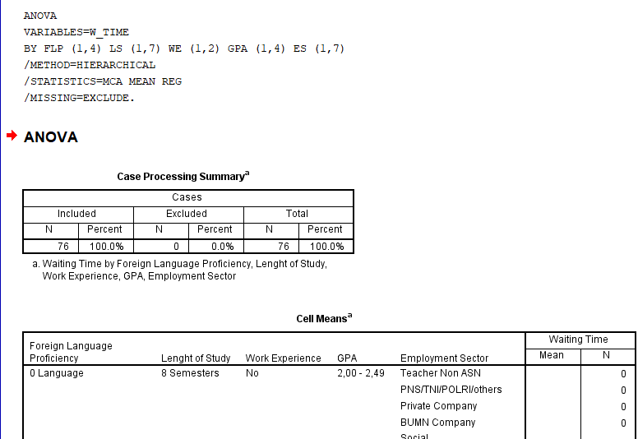

Too long

