LAMPIRAN
Table 1.
Deskriftif variable demographic characteristics of the women and men
Characteristic |  | Women  (n=286) |  | Men (n=359) |  | χ² Value
 |  | n | % | n | % | χ² Value
Work experience | > 5th | 76 | 21.10 | 95 | 29.20 | 266.4***
Work experience | 5-10th | 113 | 45.10 | 118 | 33.40 | 266.4***
Work experience | >10th | 108 | 33.80 | 124 | 37.40 | 266.4***
Job-status | PNS | 235 | 68.90 | 268 | 70.50 | 57.69***
Job-status | Non | 73 | 31.10 | 69 | 29.50 | 57.69***
Note: *** p <0.001.
Table 2.
ANOVA comparisons for men and women for the psychological well-being scales.
 | Women (n=286) |  | Men (n=359) |  | F_{(1.3398)} | d-value
 | M | SD | M | SD | F_{(1.3398)} | d-value
Sa | 26.35 | 5.20 | 25.11 | 4.18 | 12.81** | 0.12
Prwo | 27.29 | 5.68 | 24.87 | 5.49 | 4.35* | -0.06
Autonomy | 36.39 | 6.12 | 36.85 | 5.89 | 5.62** | 0.07
Envi m | 27.38 | 4.45 | 27.49 | 4.54 | 0.65 | 0.04
Pi life | 27.86 | 5.81 | 28.16 | 4.78 | 2.73 | 0.06
Pgrowth | 28.37 | 5.63 | 27.80 | 4.33 | 8.78** | -0.11
Note: Sa: Self-acceptance, Prwo: Positive relations with others, Envi m: Environmental mastery, Pi life: Purpose in life, Pgrowth: Personal growth, * = p < 0.05; ** = p < 0.01. d-value = Cohens’s d, Means (M), standard deviations (SD)
Table 3.
Work climate x gender
 |  | Cat_work climate |  |  | Total
 |  | Low | Medium | High | Total
JK | Women | 19 | 105 | 162 | 286
JK | Men | 20 | 179 | 160 | 359
Total |  | 39 | 284 | 322 | 645
Table 4.
Bivariate correlations between psychological well-being scores for female and male groups and traits of femininity and masculinity.
 | Women |  | Men
 | Masculinity | Femininity | Masculinity | Femininity
Sa | 0.30*** | 0.16*** | 0.21*** | 0.17***
Prwo | 0.20*** | 0.19*** | 0.18*** | 0.11***
Auto | 0.34*** | -0.04 | 0.20*** | -0.09
Envi m | 0.30*** | 0.18*** | 0.32*** | 0.18***
Pi life | 0.29*** | 0.15*** | 0.48*** | 0.25***
Pgrowt | 0.19*** | 0.21*** | 0.41*** | 0.30***
Note: Sa: Self-acceptance, Prwo: Positive relations with others, Envi m: Environmental mastery, Pi life: Purpose in life, Pgrowth: Personal growth, *** = p<0.001

Table.5
Model summary hierarchical regression psychological well-being measure for the women’s and men’s group and work climate
Women’s group
 | Model 1 |  |  | Model 2 |  |  | Model 3
 | β | t-value |  | β | t-value |  | β | t-value
Job-status | -0.14 | -4.69** |  | -0.10 | -3.46** |  | -0.11 | -3.77**
Work experience | 0.02 | 0.20 |  | -0.03 | -1.49 |  | -0.01 | -0.03
Masculinity |  |  |  | 0.48 | 15.77** |  | 0.31** | 14.39**
Femininity |  |  |  | 0.21 | 5.86** |  | 0.13** | 6.10*
Work climate |  |  |  |  |  |  | 0.14 | 5.54**
Adjusted R² | 0.05 |  |  | 0.20 |  |  | 0.18
R² Change | 0.05 |  |  | 0.14 |  |  | 0.15
ANOVA  (F-value, df) | 6.54 (4.1794)*** |  |  | 58.89(62.792)*** |  |  | 46.02(81.567)***
Men’s group
 | Model 1 |  |  | Model 2 |  |  | Model 3
 | β |  | t-value | β |  | t-value | β |  | t-value
Job-status | -0.10 |  | -2.39* | -0.09 |  | -0.42 | -0.11 |  | -2.98
Work experience | -0.05 |  | -3.09 | -0.05 |  | -1.99 | 0.07 |  | -1.59
Masculinity |  |  |  | 0.45 |  | 14.22** | 0.29 |  | 10.02**
Femininity |  |  |  | 0.19 |  | 4.88** | 0.15 |  | 4.75**
Work climate |  |  |  |  |  |  | 0.14 |  | 5.55***
Adjusted R² | 0.08 |  |  | 0.21 |  |  | 0.19
R² Change | 0.08 |  |  | 0.19 |  |  | 0.15
ANOVA  (F-value, df) | 5.65 (3.1683)*** |  |  | 46.79(31.672)*** |  |  | 35.13(70.455)***
Note: β = Standardized regression coefficient. R² = percentage of explained variance. * = p < 0.05; **= p < 0.01; ***= p < 0.001.
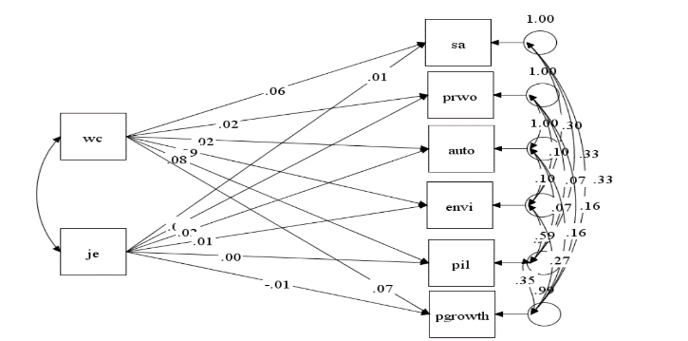

Figure 1. Diagram variants multivariate

